UK POP PHENOM GRIFF ANNOUNCES FIRST HEADLINING TOUR OF NORTH AMERICA

WATCH THE BREAKOUT STAR’S “ONE NIGHT” VIDEO HERE

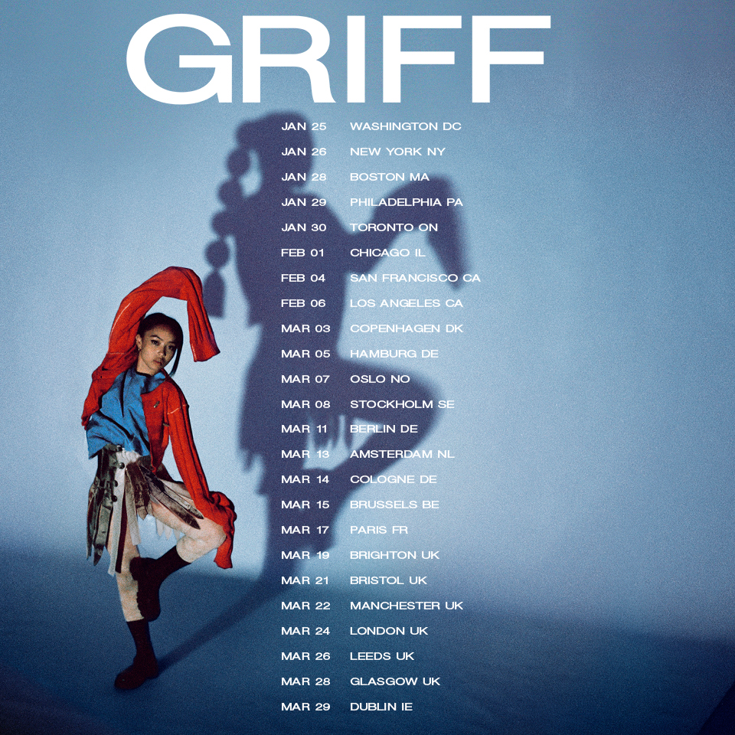
“Griff is Pop’s Next Powerhouse” - Vogue
"GRIFF is the hottest new artist to come out of the UK since Dua Lipa." - V Mag
“…the hottest thing out of the UK since beans on toast.”- Flaunt

November 2, 2021 (Los Angeles, CA) – Today, UK pop phenomenon Griff announces her first headlining tour of North America. The 20-year-old, recently selected for Billboard’s prestigious 21 Under 21 list, kicks off the eight-date trek in Washington, DC, on January 25, 2022. The tour includes shows at iconic concert venues like New York’s Bowery Ballroom and The Roxy in Los Angeles. Tickets go on-sale this week. Artist presales begin Wednesday, November 3 at 9am local time and end Thursday, November 4. General onsale begins Friday, November 5 at 9am local time. For more information, go HERE.

2021 has been a blockbuster year for the breakout star from Hertfordshire, England. After being shortlisted for BBC’s Sound of 2021, Griff—real name Sarah Griffiths—released her debut mixtape One Foot in Front of the Other in June. Featuring the hit single “Black Hole,” the project peaked at number 4 on the UK album chart. She built on that momentum in August with the release of the intricate, emotional banger “One Night.”

Inspired by Whitney Houston and The Weeknd, the uptempo track is about Griff’s ongoing struggle with anxiety. So far, the buzzworthy song has amassed more than 11 million cumulative streams and was heavily promoted during the newcomer’s stint as MTV’s Global Push Artist in September. That honor came after GQ selected Griff to represent the UK in their Voices of the Future campaign as a local artist “shaping the zeitgeist and defining the sounds of tomorrow.”

Born to Chinese and Jamaican parents, Griff started making songs using her brother’s Logic. She taught herself how to produce in secret, which made the release of her 2019 debut EP, The Mirror Talk, a surprise to classmates. The singer, songwriter, producer, and DIY fashion designer remained busy in 2020, releasing multiple singles, including collaborations with electronic duo Honne and superstar producer/DJ Zedd. She also took over London’s Tate Modern for her first livestream.

Throughout 2021, she’s only seen more accomplishments and acclaim. She made her TV debut in the U.S. on Late Night With Seth Meyers and in the UK on Later...With Jools Holland, before reaching all new heights at the BRIT Awards—where she won the coveted ‘Rising Star’ Award, following in the footsteps of Adele, Sam Smith, Florence and the Machine, Ellie Goulding, Jorja Smith, and more. Watch her stunning post-apocalyptic performance HERE. Griff is currently lighting up the stages on her headline tour in the UK. Already deemed one to watch by basically every tastemaker that matters, Griff will surely only see her star continue to rise as she embarks on this trek across the US.

2022 TOUR DATES
Jan 25 - Washington, DC - Songbyrd DC
Jan 26 - New York, NY - The Bowery Ballroom
Jan 28 - Boston, MA - The Sinclair
Jan 29 - Philadelphia, PA - The Foundry at The Fillmore
Jan 30 - Toronto, ON - Velvet Underground
Feb 01 - Chicago, IL - Schubas
Feb 04 - San Francisco, CA - Rickshaw Stop (Popscene)
Feb 06 - Los Angeles, CA - The Roxy Theatre

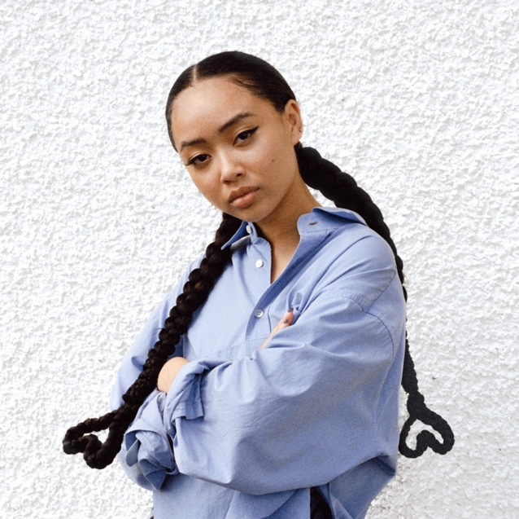

FOLLOW GRIFF:
Instagram | Twitter | Facebook | YouTube | TikTok | Press Materials

For more information, please contact:
Darren Baber | Warner Records
Darren.Baber@warnerrecords.com

Regional: Jenny Huynh | Warner Records
Jenny.Huynh@warnerrecords.com
