CRITICALLY ACCLAIMED SONGSTRESS GRIFF PUTS ONE FOOT IN FRONT OF THE OTHER ON DEBUT MIXTAPE OUT TODAY
PERFORMS “BLACK HOLE” ON THE LATE SHOW WITH STEPHEN COLBERT TONIGHT!
SELECTED AS LATEST SPOTIFY RADAR ARTIST – WATCH EXCLUSIVE DOCUMENTARY HERE
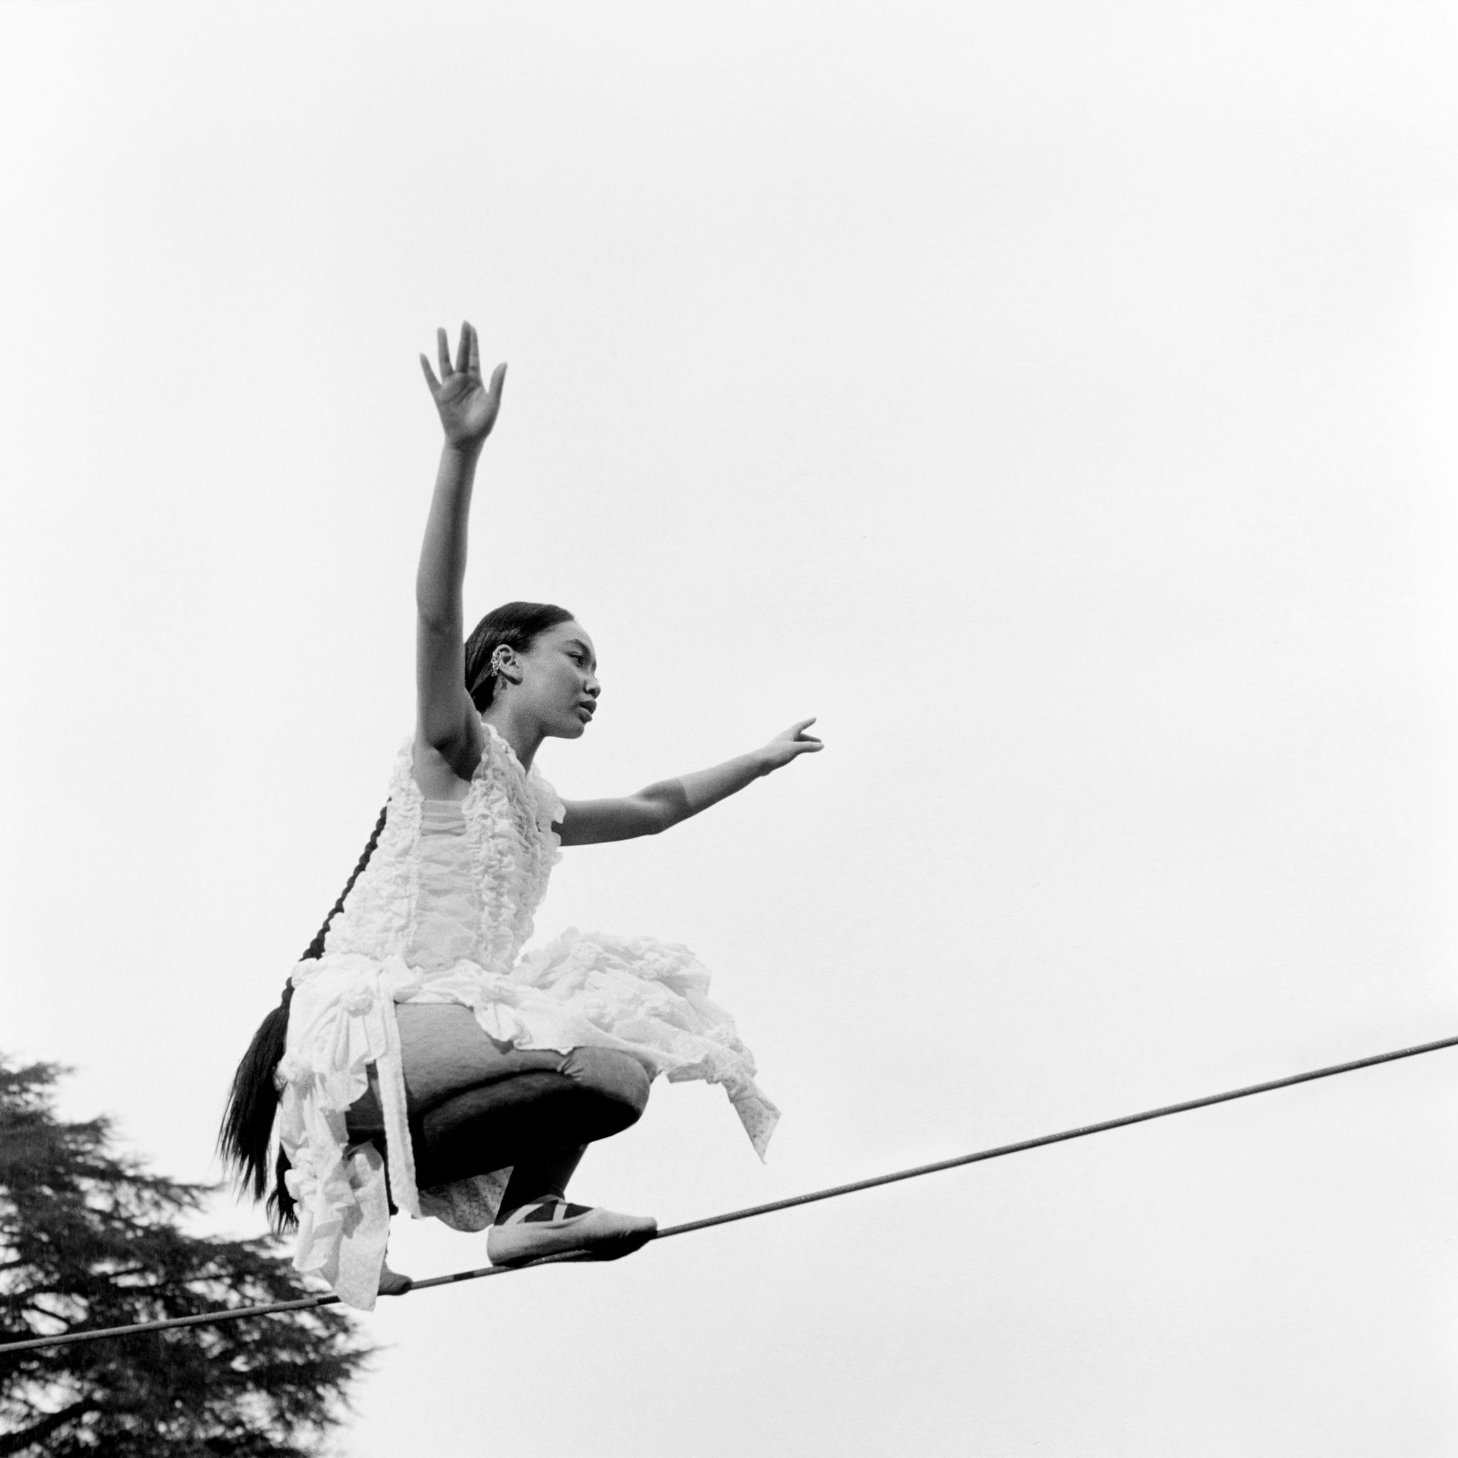
“Griff is Pop’s Next Powerhouse” - Vogue

"GRIFF is the hottest new artist to come out of the UK since Dua Lipa." - V Mag

“…the hottest thing out of the UK since beans on toast.”- Flaunt

June 18th, 2021 (Los Angeles, CA) – After inciting buzz on both sides of the pond and racking up over 200 million streams thus far, breakout UK star Griff unveils her debut mixtape One Foot In Front Of The Other via Warner Records today. Listen HERE.

Griff celebrates its arrival with a performance of the rising single “Black Hole” on The Late Show with Stephen Colbert tonight. “Black Hole” continues to scale charts worldwide, recently becoming her first Top 20 entry in the UK and garnering over 60 million-plus audio and video streams.

Griff notably produced One Foot In Front Of The Other almost entirely by herself at home and the release is another step towards superstardom for the young artist. The project includes “Black Hole,” the previously released title track which Billboard proclaimed “demonstrates Griff’s understanding of how to turn vulnerabilities into arena-ready anthems,” “Shade of Yellow,” which was released earlier this week and three brand new songs. Full track listing below.

Spotify recently handpicked Griff as its latest RADAR emerging artist and the first to be featured with the support across the UK and the U.S. Check out Griff’s official RADAR documentary which premiered yesterday on Bustle HERE.

The release One Foot In Front Of The Other follows Griff’s historic BRIT Awards debut last month where she performed “Black Hole” and won the coveted ‘Rising Star’ Award, following in the footsteps of Adele, Sam Smith, Florence and the Machine, Ellie Goulding, Jorja Smith and more. Watch her stunning post-apocalyptic performance HERE.

Born to Chinese and Jamaican parents just outside of Watford, England, Griff began making music by borrowing her brother’s Logic: teaching herself how to produce songs in secret from her classmates, many of whom didn’t find out until she released her 2019 debut EP The Mirror Talk. The singer, songwriter, producer and DIY fashion designer has shown the type of creativity and curiosity that can still flourish even under challenging circumstances. In 2020, during the pandemic, she released multiple singles, collaborated with electronic duo Honne and superstar producer/DJ Zedd, led her voice to the Disney and Make a Wish annual holiday campaign, took over London’s Tate Modern for her first ever livestream, and founded her own popular ‘Against the Clock’ video series. Griff has not slowed down in 2021. She began the year shortlisted for the BBC’s Sound of 2021 poll, she made her TV debut in the U.S. on Late Night With Seth Meyers and in the UK on Later...With Jools Holland, before gracing all new heights at the BRIT Awards ahead of the release of One Foot In Front Of The Other.

Griff continues her road to superstardom with a headline UK and Europe tour kicking off in October and more to come soon.

One Foot In Front of the Other track listing:
- Black Hole
- One Foot in Front of the Other
- Shade of Yellow
- Heart of Gold
- Remembering My Dreams
- Earl Grey Tea
- Walk

###
For more information, please contact:
Darren Baber | Darren.baber@warnerrecords.com

Follow GRIFF
Press Materials | YouTube | Instagram | Twitter | Facebook

