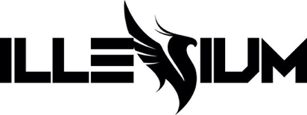
GRAMMY® AWARD NOMINATED DJ/PRODUCER ILLENIUM ANNOUNCES BIGGEST HEADLINE SHOW OF HIS CAREER TRILOGY: COLORADO ON JUNE 17, 2023 AT EMPOWER FIELD AT MILE HIGH IN DENVER, CO

THREE SETS – ONE NIGHT

NEW SINGLE “ALL THAT REALLY MATTERS” FEAT. TEDDY SWIMS HITS FRIDAY, JULY 29

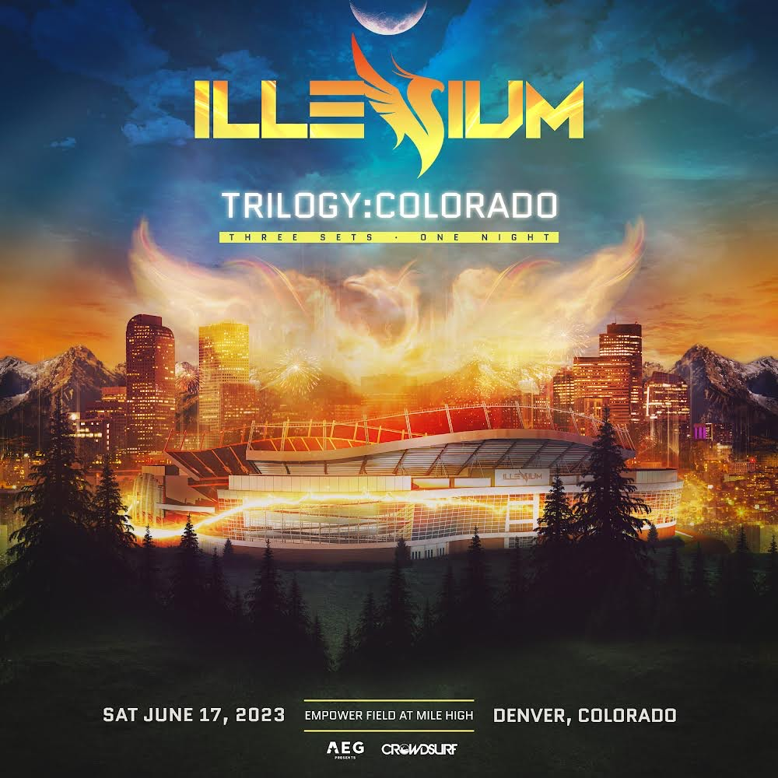

July 18, 2022 (Los Angeles, CA) – Gearing up for the biggest evening of his career thus far, GRAMMY® Award-nominated artist ILLENIUM will headline Trilogy: Colorado at Empower Field at Mile High in Denver, CO on Saturday, June 17, 2023. He takes the stage in the 76,125-capacity stadium for three unique sets over one night. Fans can sign up for early access to tickets HERE. General on-sale goes live Friday, July 29th at 12:00pm MDT.

This marks the second TRILOGY show following his record-breaking 2021 headliner at Allegiant Stadium in Las Vegas, NV. TRILOGY remains close to ILLENIUM’s heart as it represents a rapturous evening of three sets. Returning to Denver, this has all the makings of the ultimate homecoming for the Colorado-based DJ/producer. It promises to be one for the history books.

Maintaining his prolific creative output, he will unveil his next single “All That Really Matters” featuring Teddy Swims on Friday, July 29. The pairing of ILLENIUM’s inimitable and unpredictable production and Teddy Swims’ traffic-stopping soulful vocals proves undeniable, to say the least.

ILLENIUM recently uncovered FALLEN EMBERS (Remixes), the powerhouse remix companion to his 2021 fourth full-length album, FALLEN EMBERS, which earned him the Billboard Music Award for Top Dance/Electronic Album, and garnered his first GRAMMY® Award nomination in the category of Best Dance/Electronic Album.

Prior, ILLENIUM released standout singles “Shivering” featuring Spiritbox, “Story of My Life” with Sueco and Trippie Redd, and “Wouldn’t Change A Thing” featuring Thirty Seconds To Mars – which marked the first new music from the band in three years.

This year, ILLENIUM headlined Hangout Music Festival, EDC Las Vegas, Sunset Music Festival, and Bonnaroo, with Outside Lands up next. He also performed two-nights at The Gorge Amphitheatre and has an ongoing Vegas residency at OMNIA Nightclub and Tao Beach Dayclub. This December, ILLENIUM will bring his Ember Shores festival back to Cancun, Mexico, where he will perform three unique sets among a specially curated lineup – buy tickets HERE. More tour dates listed below.

Impressively, ILLENIUM’s total career streams have now eclipsed 5 billion and counting. With more music on the horizon, ILLENIUM cements his status as one of dance music’s most innovative and audacious producers.

TOUR DATES:
Aug 5 – 6 – Breakaway Music Festival – Bonner Springs, KS
Aug 5 – 7 – Outside Lands – San Francisco, CA
Sep 3 – North Coast Music Festival – Bridgeview, IL
Dec 2 – 4 – Ember Shores Festival – Cancun, Mexico
Jun 17, 2023 – Trilogy: Colorado – Denver, CO

Follow ILLENIUM:
Official | Instagram | Twitter | TikTok | YouTube | Press Materials

ILLENIUM Contacts:
Darren Baber | Warner Records
Darren.Baber@warnerrecords.com

Regional: Jenny Huynh | Warner Records
Jenny.Huynh@warnerrecords.com

