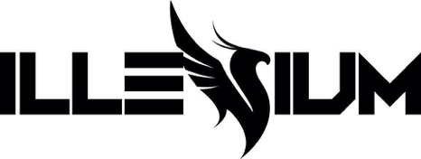

ILLENIUM TEAMS UP WITH THIRTY SECONDS TO MARS FOR BRAND NEW SINGLE “WOULDN’T CHANGE A THING”

ANNOUNCES FALLEN EMBERS DELUXE EDITION ON OCTOBER 22

BOASTS 5 NEW TRACKS – PRE-ORDER HERE

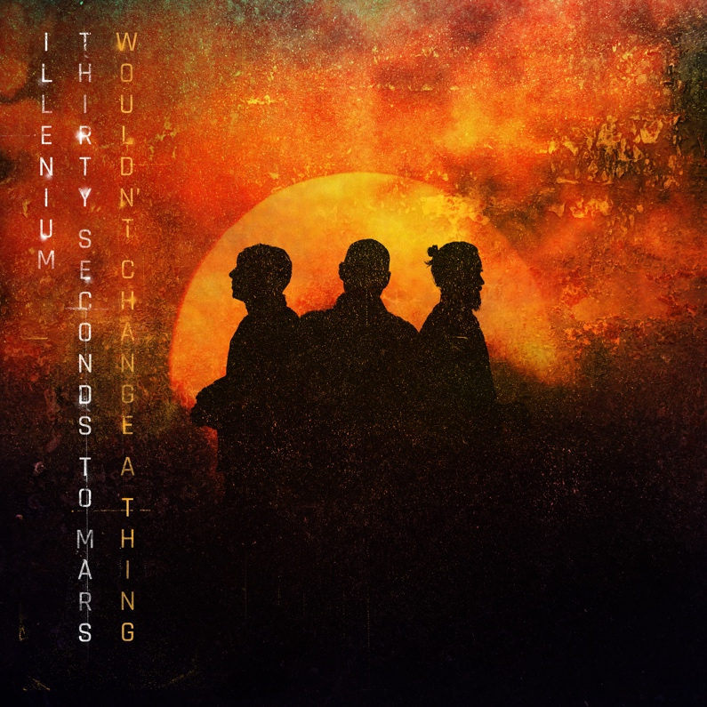
October 15, 2021 (Los Angeles, CA) – Multiplatinum cross-genre phenomenon, artist, producer, and DJ ILLENIUM unveils his latest single entitled “Wouldn’t Change A Thing” [feat. THIRTY SECONDS TO MARS]. The song notably marks the first new music from legendary, record breaking band THIRTY SECONDS TO MARS in three years. Listen to “Wouldn’t Change A Thing”—HERE. Watch the Visualizer—HERE.

“Wouldn’t Change A Thing” sets the stage for the Deluxe Edition of ILLENIUM’s fourth full-length album, FALLEN EMBERS, on October 22, 2021. It will be the inaugural release under his newly minted deal with Warner Records.

Pre-order and pre-save FALLEN EMBERS (DELUXE EDITION)—HERE.

The single fuses ILLENIUM’s immersive and cinematic production with a heavenly and hypnotic vocal melody from THIRTY SECONDS TO MARS frontman Jared Leto. Backed by Shannon Leto’s powerful drums, icy synths pulsate in the background before a shuddering dancefloor-ready groove takes hold. Meanwhile, Jared Leto projects the hook loud and clear, “No matter what happens, she’s a fatal attraction to me. I wouldn’t change a thing.” In the accompanying Visualizer, images of flames, rain, and sparks underline the track’s emotional intensity, bringing the words to life.

For the Deluxe Edition, ILLENIUM notably reupped, reloaded, and recharged this opus with five new songs. Among the new material, Virtual Riot expands “Blame Myself” [with Tori Kelly] with a new Remix, heightening the tension and release with an unpredictable glitchy breakdown. From the frenetic bounce of “Hurt Like This” to the guitar-laden crunch of “Superhero,” ILLENIUM presents the most complete and comprehensive vision of Fallen Embers now.

Continuing a historic run of dates this year, ILLENIUM takes over Masonic Temple Theatre in Detroit, MI as part of his latest headline tour. This leg will be highlighted by a three-night stand at Bill Graham Civic Auditorium in San Francisco November 24-26 and back-to-back shows at The Armory in Minneapolis, MN December 10-11.

Check out the full confirmed itinerary below.

Tallying over 400 million streams, the original FALLEN EMBERS boasted a series of anthems, including “Nightlight” (150M global streams), “Hearts on Fire” with Dabin feat. Lights (60M global streams), “First Time” feat. iann dior (50M global streams), “Sideways” with Valerie Broussard and Nurko (25M global streams), and “Heavenly Side” with Matt Maeson (5M global streams).

Impressively, his career total streams have now eclipsed 5 billion and counting.
Earlier this year, ILLENIUM performed a four-set show at The Las Vegas Raiders’ Allegiant Stadium, making him the first artist to ever perform at the venue. The first three sets at the show commemorated his previous 3 albums – Ashes, Awake, and Ascend. The night ended with a final set, bringing closure to the story of the previously mentioned albums and starting a new one with Fallen Embers. Throughout the summer, he also shined at festivals such as Lollapalooza, Breakaway Music Festival, Life Is Beautiful, and more.
Now, he illuminates electronic music brighter than ever with Fallen Embers Deluxe Edition and much more to come.
Get ready!

TOUR DATES
10/15 Detroit, MI Masonic Temple Theatre
10/16 Chicago, IL Navy Pier
10/21 Las Vegas, NV Omnia Las Vegas
10/29 San Diego, CA Dream Eaters
11/6 Los Angeles, CA Head In The Clouds Festival
11/24 San Francisco, CA Bill Graham Civic Auditorium
11/26 San Francisco, CA Bill Graham Civic Auditorium
11/27 San Francisco, CA Bill Graham Civic Auditorium
12/03 Cancun, Mexico Ember Shores
12/09 Kansas City, MO Cable Dahmer Arena
12/10 Minneapolis, MN The Armory
12/11 Minneapolis, MN The Armory
12/30 Dallas, TX Lights All Night
12/30 Philadelphia, PA Hijinx Festival

ABOUT THIRTY SECONDS TO MARS:
Thirty Seconds to Mars, comprised of Jared Leto and Shannon Leto hail from Los Angeles, CA. The band's eponymous debut album, 30 Seconds to Mars, was released in 2002 and remains a cult favorite. They went on to achieve worldwide success with the release of their second album A Beautiful Lie (2005), which sold over 5 million copies. Their next release was This Is War in 2009. The recording process of the album was marked by a legal dispute with record label EMI that eventually became the subject of the award winning and acclaimed documentary film Artifact (2012). Thirty Seconds to Mars then released the fourth album, Love, Lust, Faith and Dreams (2013), to critical and commercial success. Their fifth album, America (2018), included the hit songs Walk on Water, Dangerous Night and Rescue Me. The band has sold over 15 million albums worldwide and sells out arenas and stadiums globally. Thirty Seconds to Mars has received numerous awards and accolades throughout their career, including a dozen MTV Awards, a Billboard Music Award and a Guinness World Record for the Longest Running Tour in history. Thirty Seconds to Mars are currently working on their highly anticipated 6th studio album.

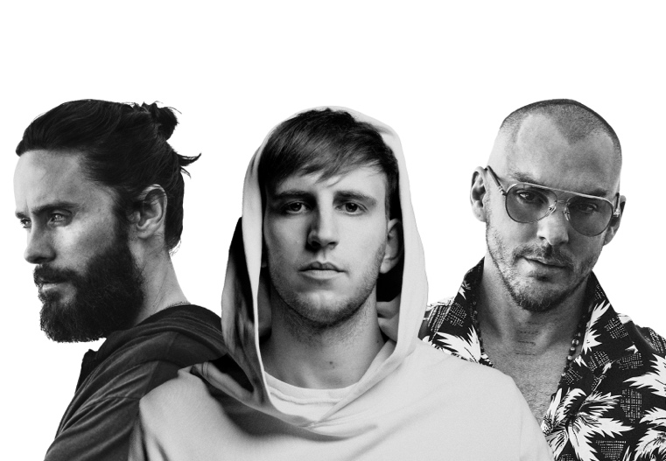

Follow ILLENIUM:
Official | Instagram | Twitter | Tik Tok | YouTube | Press Materials

For more information, contact:
National: Darren Baber | Warner Records
Darren.Baber@warnerrecords.com

Regional: Jenny Huynh | Warner Records
Jenny.Huynh@warnerrecords.com

