**SAWEETIE DROPS NEW TRACK “PISSED”**

|  |
| --- |
|  |

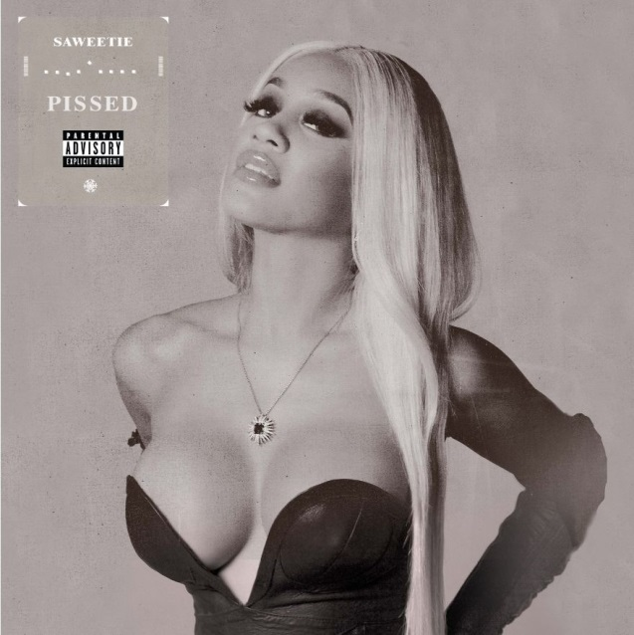

**November 30, 2018 (Los Angeles, CA)** – Continuing her breakthrough year as hip-hop’s hottest new leading lady, **Saweetie** drops her latest single entitled **“Pissed”** (produced by Cronkite) today. Get it [HERE](https://wbr.lnk.to/Pissed) via **ICY**/**Artistry Records/Warner Bros. Records**.

Propelled by a bombastic orchestral choir chant of her name, the rapper quickly slips into sassy and spirited verses, illuminating her deft wordplay and hard-hitting rhymes with throwback fire. It culminates on a catchy chant that’s immediately quotable. Produced by Cronkite, it stands out as another massive anthem.

**“Pissed”** arrives hot on the heels of her **London On Da Track** collaboration, **“Up Now”** [feat. **G-Eazy** & **Rich The Kid**], which surpassed 8 million Spotify streams and clocked upwards of 7.8 million YouTube/VEVO views for the [music video](https://www.youtube.com/watch?v=h0ipGRw1Ev4). Meanwhile, it earned looks from *Complex*, *Rap-Up*, and more.

**Saweetie** never stops making headlines. She recently made her major tour debut with **Drake** and **Migos** and shared the stage with **Cardi B**. In addition, she lent her voice for **David Guetta**’s **“I’m That Bitch**.**”**

Right now, **Saweetie** is putting the finishing touches on her highly anticipated next release, due out very soon. Her energy can be felt loud and clear on **“Pissed**.**”**

**ABOUT SAWEETIE:**

Flaunting nineties rhyme reverence, fashion-forward fire, and endless charisma, **SAWEETIE**—born **Diamonté Harper**—can go bar-for-bar with the best of ‘em, and fans and critics immediately recognized and responded to that. Within six months, she cracked 100 million cumulative streams, garnered a gold plaque, and earned the praise of *Billboard*, *Fader*, and *Noisey* as *Los Angeles* *Times* pegged her as *“one to watch this year*.*”* Drawing on a passion for poetry and numerous years of rapping in the car, she turned her love for words into vivid verses during 2018 on the ***High Maintenance*** EP.

Born in Santa Clara of African-American and Chinese-Filipino descent and raised in Sacramento, the California native went from MVP status as a high school volleyball champ to becoming a shining student at USC. Initially, she deferred her rap dreams to achieve a degree in Communications before being discovered at a Downtown Los Angeles Puma event by current manager Max Gousse [Beyoncé, YG, Ty Dolla $ign]. At Artistry Studios, they produced her 2017 knockout viral smash **“ICY GRL**.**”** Driven by a bulletproof flow and one clever line after another, it racked up 50 million YouTube views in a few months and over 31 million Spotify streams between the original and Kehlani remix, achieved a gold certification from the RIAA, and soared to #1 on [Musical.ly](http://musical.ly/). She also earned the early endorsement of gatekeepers such as *Vibe*, *XXL*, *HipHopDX*, and *MTV*. Touting a new partnership with **Warner Bros. Records** and **Artistry Records** for her label **Icy**, she’s rewriting the rule book and breaking the stereotype of the female emcee. Armed with tracks like **“B.A.N.”** and **“Good Good**,**” *High Maintenance***features production courtesy of Zaytoven, Hassan, Saweetie, Cash Money AP, and Gousse.

As a businesswoman, she teamed with Sprayground, Reebok, and Fashion Nova for high-profile partnerships. Meanwhile, everyone from David Guetta to Dua Lipa has enlisted her for guest spots. As a fashionista, Next Models signed her for modeling, and she graced the cover of *Wonderland*in addition to appearing in *C.R. Fashion Book*, *Notion*, and *VFiles*. Represented by CAA, she launches a full-scale headline tour this fall and readies her full-length debut for release soon.