SAWEETIE X LONDON ON DA TRACK PREMIERE NEW SINGLE “UP NOW” FEATURING G-EAZY & RICH THE KID AS ZANE LOWE'S WORLD RECORD ON APPLE MUSIC'S BEATS 1
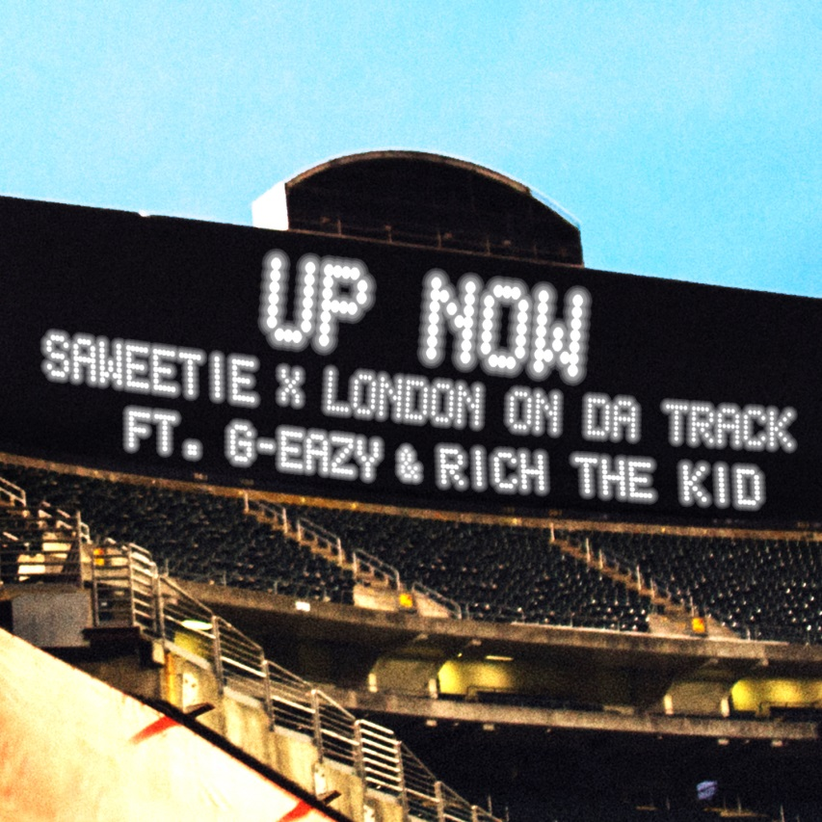

August 22, 2018 (Los Angeles, CA) – Taking 2018 by storm, gold-selling California rapper SAWEETIE drops her latest single in collaboration with super producer London On Da Track, “Up Now” [feat. G-Eazy & Rich The Kid], today. Zane Lowe handpicked the song as his latest coveted "World Record" and personally debuted the track globally to over 100 countries on Apple Music Beats 1. Zane Lowe also conducted an exclusive interview with Sawetie & London On The Track. Get it HERE via ICY/Artistry Worldwide/Warner Bros. Records. It’s lighting up iTunes charts and social media straight out of the gate. This is just the beginning.

“Up Now” stands out as an event-level banger produced by none other than London On Da Track [Gucci Mane, Waka Flocka Flame, Young Thug]. The incredible visual, directed by Mike Ho, stars multi-platinum superstar and fellow Northern California luminary G-Eazy, who delivers a dynamic verse, while Atlanta’s Rich The Kid lends his own fire to the powerhouse single. However, it’s Saweetie’s surefire spitting that ignites “Up Now” as she elevates her game to a new level alongside some of hip-hop’s hottest superstars. In good company, she’s right where she belongs!

This marks the first collaboration between Saweetie x London. The Atlanta producer is responsible for numerous multiplatinum chart-topping hits for everyone from Post Malone and Drake to Rich Gang and 50 Cent.

Following her EP High Maintenance, the single sets the stage for the release of her highly anticipated full-length debut, coming soon. 2018 is the year of Saweetie.

ABOUT SAWEETIE:
Flaunting nineties rhyme reverence, fashion-forward fire, and endless charisma, SAWEETIE—born Diamonté Harper—can go bar-for-bar with the best of ‘em, and fans and critics immediately recognized and responded to that. Within six months, she cracked 100 million cumulative streams, garnered a gold plaque, and earned the praise of Billboard, Fader, and Noisey. as Los Angeles times pegged her as “one to watch this year.” Drawing on a passion for poetry and numerous years of rapping in the car, she turned her love for words into vivid verses during 2018 on the High Maintenance EP.

Born in Santa Clara of African-American and Chinese-Filipino descent and raised in Sacramento, the California native went from MVP status as a high school volleyball champ to becoming a shining student at USC. Initially, she deferred her rap dreams to achieve a degree in Communications before being discovered at a Downtown Los Angeles Puma event by current manager Max Gousse [Beyoncé, YG, Ty Dolla $ign]. At Artistry Studios, they produced her 2017 knockout viral smash “ICY GRL.” Driven by a bulletproof flow and one clever line after another, it racked up 50 million YouTube views in a few months and over 31 million Spotify streams between the original and Kehlani remix, achieved a gold certification from the RIAA, and soared to #1 on Musical.ly. She also earned the early endorsement of gatekeepers such as Vibe, XXL, HipHopDX, and MTV. Touting a new partnership with Warner Bros. Records and Artistry Records for her label Icy, she’s rewriting the rule book and breaking the stereotype of the female emcee. Armed with tracks like “B.A.N.” and “Good Good,” High Maintenance features production courtesy of Zaytoven, Hassan, Saweetie, Cash Money AP, and Gousse.

As a businesswoman, she teamed with Sprayground, Reebok, and Honeybum for high-profile partnerships. Meanwhile, everyone from David Guetta to Dua Lipa has enlisted her for guest spots. As a fashionista, Next Models signed her for modeling, and she graced the cover of Wonderland in addition to appearing in C.R. Fashion Book, Notion, and VFiles. Represented by CAA, she launches a full-scale headline tour this fall and readies her full-length debut for release soon.

About London On Da Track
London On Da Track is one of the most sought after producers in hip-hop, creating an in-demand sound made up of his signature bounce, a singular mood, and moving keys. His resume includes Drake’s (“Sneakin’” ft. 21 Savage), Tyga’s (“Hookah”), Richgang’s (“Lifestyle”), Young Thug’s (“Check”, “Killed Before”), T.I.’s (“All About The Money”) and many more. Most recently he produced Roddy Rich’s “Die Young,” Post Malone’s “92 Explorer,” Derez Deshon’s “Hardaway” and Kodak Black’s “Roll In Peace” ft. XXXtentatcion, which is RIAA certified double platinum.

In August 2017, London penned a deal with RCA Records in a transition to a forward facing artist. Since signing, London adds to his accomplishments the release of his debut single, “No Flag” featuring Nicki Minaj, 21 Savage, and Offset, which streamed over 60 million times worldwide and was featured on Spotify’s New Music Friday and Rap Caviar upon release. London followed up with the release his second track: “Whatever You On” ft. Young Thug, Jeremih, YG and Ty Dolla $ign, which has been streamed nearly 20 million times worldwide.
London also produced and is featured on A$AP Rocky x 21 Savage x Gucci Mane’s “Cocky.” Featured in the trailer and throughout the film, “Cocky” was the lead single from the motion picture, Uncle Drew. Raved about by Pitchfork, Noisey, FADER, Complex, Rolling Stone and more, “Cocky” has been streamed over 20 million times worldwide.

London has also performed at major festivals across the country including Electric Daisy Carnival in Las Vegas, Ultra in Miami, Lollapalooza in Chicago. He will also play Bumbershoot in a few weeks before embarking on his European tour.

