VOCAL DYNAMO TEDDY SWIMS SHINES ON BRAND NEW EP TOUGH LOVE OUT NOW – LISTEN HERE

WATCH HIS PERFORMANCE OF “LOVE FOR A MINUTE” ON LATE NIGHT WITH SETH MEYERS HERE

REVEALS MUSIC VIDEO FOR “LOVE FOR A MINUTE” – WATCH HERE

TOUGH LOVE WORLD TOUR LAUNCHES IN MARCH

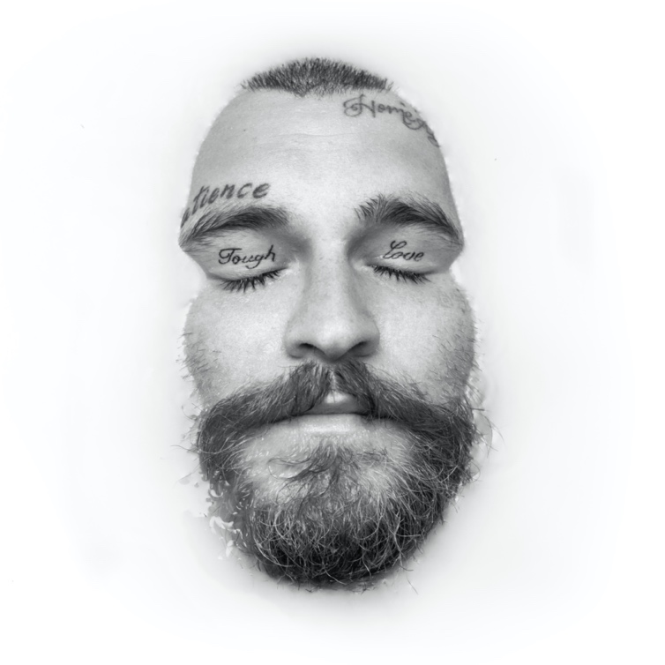

January 21, 2022 (Los Angeles, CA) – Genre-blurring vocal powerhouse Teddy Swims presents his anxiously awaited Tough Love EP, out today. Get Tough Love HERE and watch the music video for the latest single “Love For A Minute” HERE.

The six-track project has ignited a groundswell of excitement among audiences. Prior to its arrival, Tough Love captured #1 on the iTunes Pre-order Chart. On Wednesday, Teddy took the stage on Late Night with Seth Meyers for a show-stopping performance of “Love For A Minute”—check it out HERE.

Elsewhere on the EP, “For The Rest Of Your Life” opens with Teddy’s sultry voice slyly echoing, "Girl you like Gillette. You the best a man can get,” over a simmering groove. Meanwhile, he flexes his towering range on the piano-driven ballad “Amazing.” It also includes previously released tracks such as the genre-blurring banger “911,” the anthemic “Please Turn Green,” and “Simple Things”—which he performed on The Today Show and The Late Late Show With James Corden.

The full tracklisting is below.

Next up, he hits the road on his Tough Love World Tour. The tour kicks off in Ft. Lauderdale on March 24th (buy tickets here). Check out the full itinerary below.

Teddy has impressively racked up nearly 400 million global streams in addition to attracting over 2 million YouTube subscribers and 1.6 million TikTok followers.

The hitmaker born Jaten Dimsdale, who first went viral by posting covers on social media, released his debut Unlearning EP to critical acclaim in 2021. Rolling Stone praised his “silky voice that slides right into country, hip-hop, and classic soul,” while American Songwriter applauded the rising star’s “arena-worthy anthems.” The project produced the hit “Bed on Fire,” which was recently transformed into a duet with country artist Ingrid Andress. Throughout the year, he performed “My Bad” on The Kelly Clarkson Show, “Bed on Fire” on The Late Show With Stephen Colbert, and “Simple Things” on The Late Late Show With James Corden. He also got into the holiday spirit with his A Very Teddy Christmas EP lit up by his rendition of “This Christmas,” dressed as Santa.

We all could use some Tough Love from Teddy Swims in 2022!

Tracklisting:
- 911
- Please Turn Green
- For the Rest of Your Life
- Amazing
- Love For A Minute
- Simple Things

2022 TOUGH LOVE US TOUR DATES:
March 24 - Fort Lauderdale, FL - Culture Room SOLD OUT
March 25 - Tampa, FL - The Orpheum SOLD OUT
March 27 - New Orleans, LA - House of Blues
March 29 - Houston, TX - Warehouse Live
March 30 - Dallas, TX - Canton Hall
March 31 - Austin, TX - Scoot Inn
April 2 - Phoenix, AZ - Crescent Ballroom
April 3 - San Diego, CA - Observatory North Park
April 5 - Los Angeles, CA - Fonda Theater
April 6 - San Francisco, CA - The Fillmore
April 8 - Portland, OR - Wonder Ballroom SOLD OUT
April 9 - Seattle, WA - Showbox SOLD OUT
April 12 - Salt Lake City, UT - The Complex - Grand
April 13 - Englewood, CO - Gothic Theatre
April 15 - Minneapolis, MN - Fine Line Music Café SOLD OUT
April 16 - Chicago, IL - Metro
April 17 - Indianapolis, IN - Deluxe at Old National Center SOLD OUT
April 19 - Columbus, OH - Newport Music Hall
April 20 - Pittsburgh, PA - Mr. Smalls Theatre
April 22 - Cleveland, OH - House of Blues
April 23 - Detroit, MI - St. Andrews Hall
April 24 – Toronto, ON – The Opera House SOLD OUT
April 27 - Boston, MA - Royale
April 29 - New York, NY - Webster Hall
April 30 - Philadelphia, PA - Theatre of Living Arts (TLA)
May 1 - Washington, DC - 9:30 Club
May 3 - Raleigh, NC - Lincoln Theatre
May 4 - Asheville, NC - The Orange Peel
May 6 - Nashville, TN - Basement East SOLD OUT
May 7 - Atlanta, GA - Buckhead Theatre SOLD OUT
May 8 – Atlanta, GA – Buckhead Theatre

ABOUT TEDDY SWIMS:
After dedicating his life to music as a kid, Teddy Swims—a.k.a. Atlanta native Jaten Dimsdale—unassumingly knocked on the door of stardom and claimed the payoff of a decades-long grind in 2019. Broadcasting covers from a bedroom studio, he lit up the Internet with hundreds of millions of views and a following of over 6 million. That was just the first step though. Teddy fashioned a show-stopping signature style out of soaring soul, intimate R&B, rock energy, and hip-hop swagger all uplifted by his earthquaking vocals. Leaving tastemakers such as American Songwriter, Billboard, Flaunt, and Idolator and idols like Shania Twain speechless, Rolling Stone christened him a 2021 "Artist To Watch.” During this time, he went from singing covers of his favorite artists on YouTube to performing his own original music The Kelly Clarkson Show and The Late Show with Stephen Colbert. Teddy continues to spread his wings, unveiling his 2021 debut graphic novel, Teddy Swims: Swimmy and the Valley of the Last Song [Z2 Comics] and hitting the road with GRAMMY® Award-winning Zac Brown Band for a series of stadium gigs. In between, he released his 2021 debut EP Unlearning to critical acclaim. However, he only picks up the pace with the Tough Love EP in 2022 supported by his massive “Tough Love” World Tour.

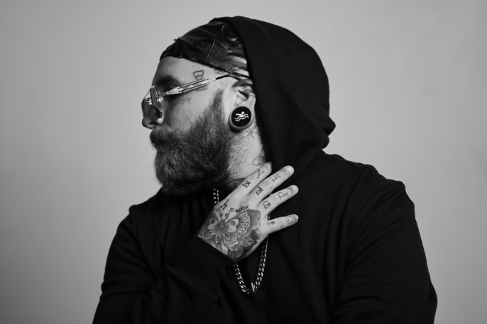
Photo credit: The Work of JAR

FOLLOW TEDDY SWIMS:
Official | Twitter | Instagram | Facebook | YouTube | Press Materials

For more information, please contact:
Darren Baber | Warner Records
Darren.Baber@warnerrecords.com

Regional: Jenny Huynh | Warner Records
Jenny.Huynh@warnerrecords.com
