SHARES THE NEW SINGLE “ILLUMINOUS”
LISTEN HERE
WATCH HERE

FIRST EVER U.S. PERFORMANCES INCLUDE
SXSW, LOS ANGELES & NEW YORK CITY

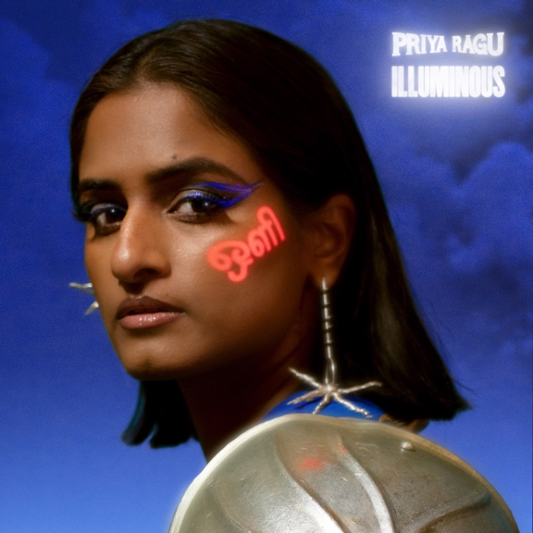

“Priya Ragu’s music isn’t like any R&B you’ve heard before.”
– Vogue

“Priya Ragu seamlessly blends her groovy R&B sensibilities with the staple sounds of Indian music”
– Refinery29

March 3, 2022 (Los Angeles, CA) – The UK’s Tamil-Swiss vocalist, songwriter, and producer Priya Ragu continues her ascent today by sharing blissful new single “Illuminous.” The track finds Priya elevating the joyous Raguwavy vibe that made her critically adored debut mixtape damnshestamil so special into something even more life-affirming. Her Tamil heritage once again proudly takes center-stage, most notably in her distinctive vocal cadence which weaves effortlessly through silky R&B and vibrant electro beats to create a unique sonic tapestry. “Illuminous” premiered last night as BBC Radio 1’s “Hottest Record in the World,” and the accompanying video was directed by Silence, whose credits include Sigrid, IAMDDB and Yxng Bane. In a playful yet surreal and stylised video, Priya is depicted as four different characters – each of which abstractly represents Priya's personality, strength and confidence at this moment in time.
Listen to “Illuminous” HERE and watch the video HERE.

Priya says, “I believe we are all beings of light. It’s a journey that starts before we enter this world and continues while we have this human experience, and then remains after we leave this earth. I also believe that we all have this one true unique gift that could bring us back to our true selves. Once you have found that, the light within you shines so bright that you become invincible. This is how I feel at this stage in my life and with this song I want to encourage others to find that one thing. Apart from all that, it’s also a turn up song, so you know what you gotta do!”

As ever, “Illuminous” was written by Priya with production from her brother and creative collaborator Japhna Gold.

Up next, Priya will head stateside for her debut U.S. performances – kicking things off at The Echo in Los Angeles on March 15, playing multiple showcases at SXSW, and finally performing at Elsewhere in Brooklyn on March 22. Details and tickets are available at priya-ragu.com.

Priya Ragu’s back story is just as fascinating as her music. She was born in Switzerland after her parents fled Sri Lanka’s civil war in the early ‘80s, but they constantly connected her to the culture of her homeland. As she grew up, Priya was equally inspired by western pop – the Fugees, Brandy, Nina Simone, and more – but kept her musical ambitions hidden due to her parents’ initial disapproval. Eventually, however, she couldn’t hold back any longer. Mentored by the American rapper Oddisee, Priya dedicated herself to her music and earned international attention for Good Love 2.0, which she followed with her debut mixtape damnshetamil last fall.

Follow Priya Ragu:
YouTube | TikTok | Instagram | Facebook | Twitter

For more information, please contact:
Ceri Roberts | Warner Records
Ceri.Roberts@warnerrecords.com

