

September 6, 2019

https://pagesix.com/2019/09/06/celebrities-front-row-at-new-york-fashion-week-2019/#62

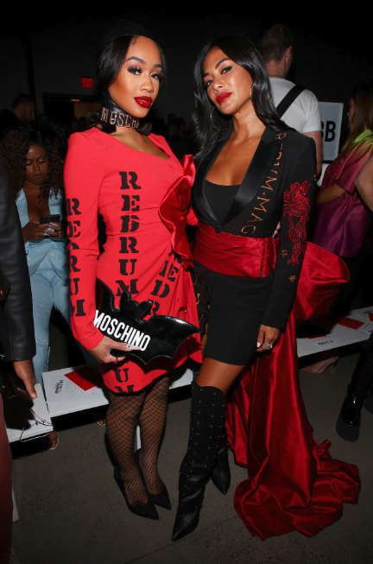


https://pagesix.com/2019/09/06/celebrities-front-row-at-new-york-fashion-week-2019/#75

