**SINGER/SONGWRITER & ACCLAIMED GUITARIST PATRICK DRONEY SHARES LONGTIME FAN FAVORITE “YOURS IN THE MORNING”**

[**LISTEN HERE**](https://PatrickDroney.lnk.to/YoursInTheMorning)

**WATCH THE NEW VIDEO** [**HERE**](https://PatrickDroney.lnk.to/YITM_mv)

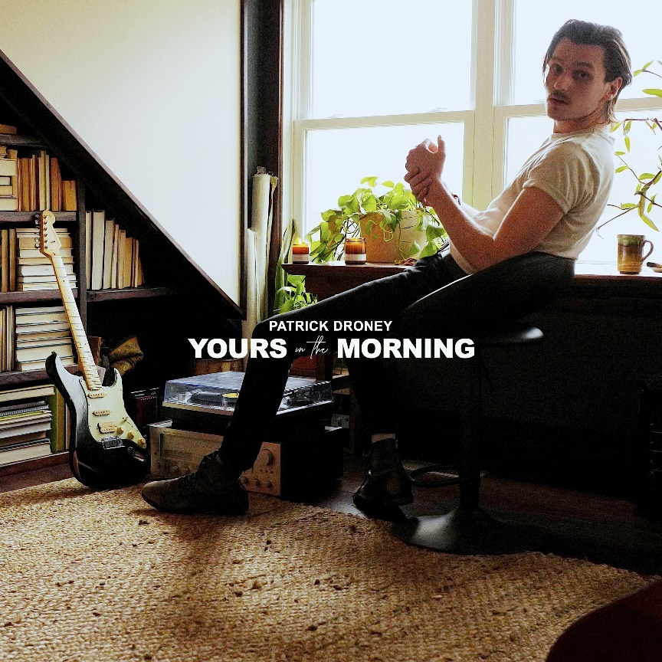

**February 12, 2021 (Los Angeles, CA)** – As a follow up to his acclaimed EP *State of the Heart*, singer/songwriter/celebrated guitarist Patrick Droney returns with new track “Yours In The Morning,” a longtime fan favorite from the road that is now officially available on streaming platforms for the very first time. Released alongside an official video, the new self-produced track is the first taste of Patrick’s forthcoming debut album – stay tuned for details coming soon.

Patrick explains, *“This song has become a live staple. One that I’m excited to finally share. It’s about recognizing the moment while you’re in it and taking a chance before you miss it. Kind of like asking, “what if, because what if?” After not being in a room with my band for much longer than I ever expected, it was a joy to be able to capture that energy and rush we get from the stage and finally put it down on tape. I hope it makes you feel like you can go for whatever is making you ask - what if?”*

**About Patrick Droney:**

Blessed with a gift for soulful, 21st-century pop melodies and armed with guitar skills that nod to past masters, Pennsylvania-born Patrick Droney creates songs that feel timeless and new all at once. He picked up a six-string before he started grade school and received the Robert Johnson Foundation's Next Generation Award by the tender age of 12, securing cosigns from legends like James Brown and B.B. King. After following music from the Clive Davis Institute at NYU to sunny L.A. to Nashville, Droney dropped a self-titled debut EP in 2018, establishing himself as a master of both incendiary R&B grooves (["Stand and Deliver"](https://nam04.safelinks.protection.outlook.com/?url=https%3A%2F%2Fwww.youtube.com%2Fwatch%3Fv%3DWJj8PTi_Fm8&data=02%7C01%7CPatrice.Compere%40warnerrecords.com%7C14d4b031a5a445b0d75f08d86a23f874%7C8367939002ec4ba1ad3d69da3fdd637e%7C0%7C0%7C637376050003759158&sdata=jNa4cIzX1O4nSBE%2FEsNKJKD94mrjNjBESfsDj7MMDoo%3D&reserved=0)) and dreamy pop songs (["High Hope"](https://nam04.safelinks.protection.outlook.com/?url=https%3A%2F%2Fwww.youtube.com%2Fwatch%3Fv%3DTqtEGt6wuJk&data=02%7C01%7CPatrice.Compere%40warnerrecords.com%7C14d4b031a5a445b0d75f08d86a23f874%7C8367939002ec4ba1ad3d69da3fdd637e%7C0%7C0%7C637376050003769153&sdata=4bN%2BoAeD9pDHDiZ5t2Ck8GVY1UcvLX%2F6UOYBsDy0EBM%3D&reserved=0)) that soar with transcendent guitar, landing him performances at a sold-out Barclays Center for Tidal X and on *Late Night with Seth Meyers*, plus a deal as a Fender ambassador. Now signed to Warner Records with more than 50 million streams to date, he most recently unveiled the *State of the Heart* EP, which earned acclaim from the likes of *American Songwriter*, *SPIN*, *Ones To Watch*, and more. He is currently in the studio working on his next album, due out in 2021.

# # #

**For further information on Patrick Droney:**

Jaime Rosenberg / [Jaime.Rosenberg@warnerrecords.com](mailto:Jaime.Rosenberg@warnerrecords.com)

Rick Gershon / [Rick.Gershon@warnerrecords.com](mailto:Rick.Gershon@warnerrecords.com)

**Follow Patrick Droney:**

[Instagram](https://www.instagram.com/patrickdroney/?hl=en) | [YouTube](https://www.youtube.com/user/patrickdroney/featured) | [Twitter](https://twitter.com/patrickdroney) | [Facebook](https://www.facebook.com/patrickdroney/) | [Website](https://www.patrickdroneymusic.com/)

**Press materials:**

[press.warnerrecords.com/patrickdroney](http://press.warnerrecords.com/patrickdroney/)

