PRIYA RAGU UNVEILS NEW SINGLE + LYRIC VIDEO “FORGOT ABOUT”

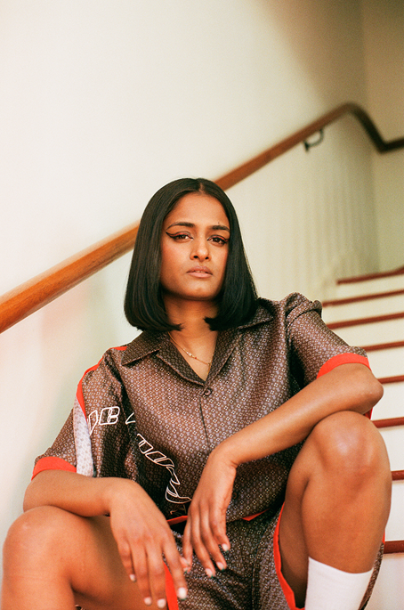
Photo Credit: Matilda Hill-Jenkins

“the East-West hybrid she promises at her best.”
-The New York Times

“Priya Ragu’s music isn’t like any R&B you’ve heard before.”
-VOGUE

“Priya Ragu seamlessly blends her groovy R&B sensibilities with the staple sounds of Indian music for ‘Good Love 2.0,’ a song that will no doubt turn your living room into a dance floor.”
- Refinery29

May 11, 2021 (Los Angeles, CA)— Tamil-Swiss vocalist, songwriter and producer Priya Ragu shares her new single “Forgot About” today via Warner Records. The track premiered on BBC Radio 1’s “Future Sounds” with Annie Mac; listen HERE and check out the official lyric video HERE.

“‘Forgot About’ is about being in love with that ‘forever’ person, who has feelings for you, but it’s not quite love,” says Priya. “It’s about being afraid of letting go, because you know that you'll never meet someone like this again in your lifetime – so you decide to carry them always in your heart.” The track follows the single “Chicken Lemon Rice” and Priya’s label debut “Good Love 2.0” along with remixes of the track by Swedish electronic music group Little Dragon, Joe Goddard of Grammy and Mercury Prize-nominated synth-pop group Hot Chip and iconic DJ Honey Dijon.

Priya’s first major collaboration is also imminent. She features on “Goodbye My Love,” a song on Jungle’s forthcoming third album Loving In Stereo, out in August. The album represents the first time the iconic UK production duo have worked with guest vocalists, with Priya being one of just two featured artists who have contributed to the record.

Priya Ragu was born and raised in Switzerland after her parents escaped from the Sri Lankan civil war in the early ‘80s. Although now incredibly proud and supportive of her career, Priya’s parents initially didn’t want her to listen to Western pop and were keen for her to get married as she reached adulthood. She made her musical ambitions covert, sneaking out to jam sessions and open mic nights, before decided to fully pursue them by moving to America with the help of her friend, the rapper Oddisee. Working remotely with her brother Japhna Gold, the pair created a number of tracks which would provide the launchpad for where she is today.

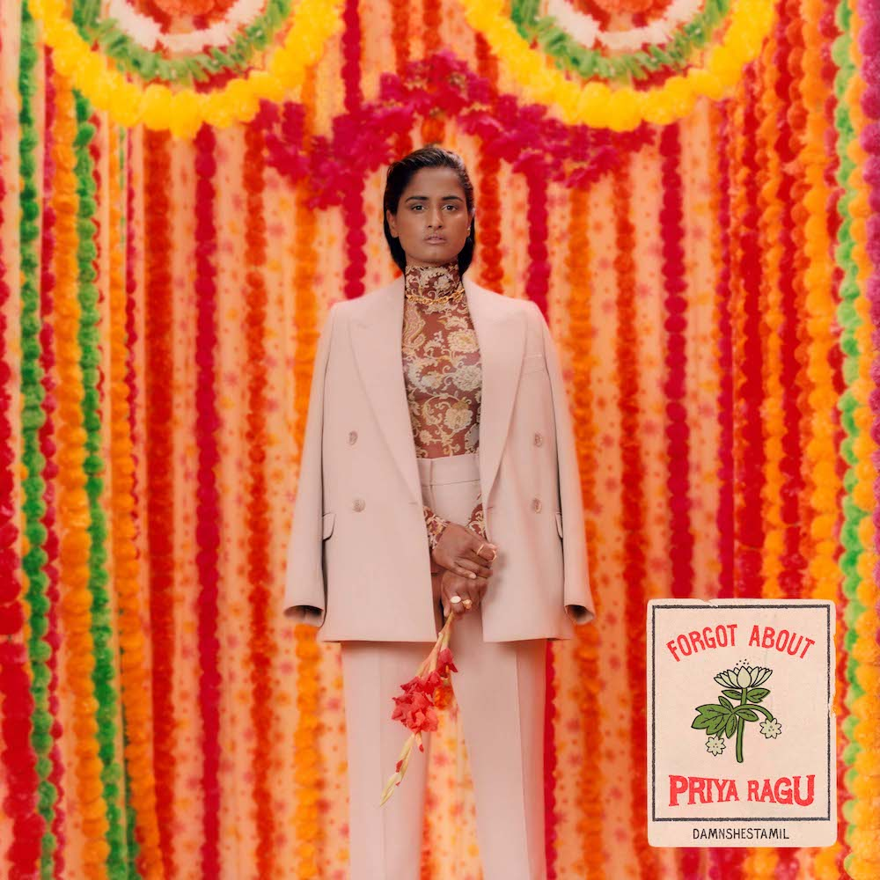
Single Artwork

PRIYA RAGU
Instagram | Spotify | Twitter | YouTube

###
For further information on Priya Ragu, contact:
Ceri Roberts / Warner Records
Ceri.Roberts@warnerrecords.com

Cami Opere, Reid Kutrow, Carla Sacks / Sacks & Co.
Cami.Opere@sacksco.com / Reid.Kutrow@sacksco.com / Carla@sacksco.com

