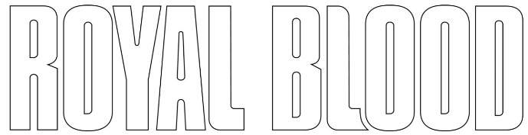

ANNOUNCE EXTENSIVE 2022 NORTH AMERICAN TOUR IN SUPPORT OF TYPHOONS

TICKETS ON SALE DECEMBER 3rd

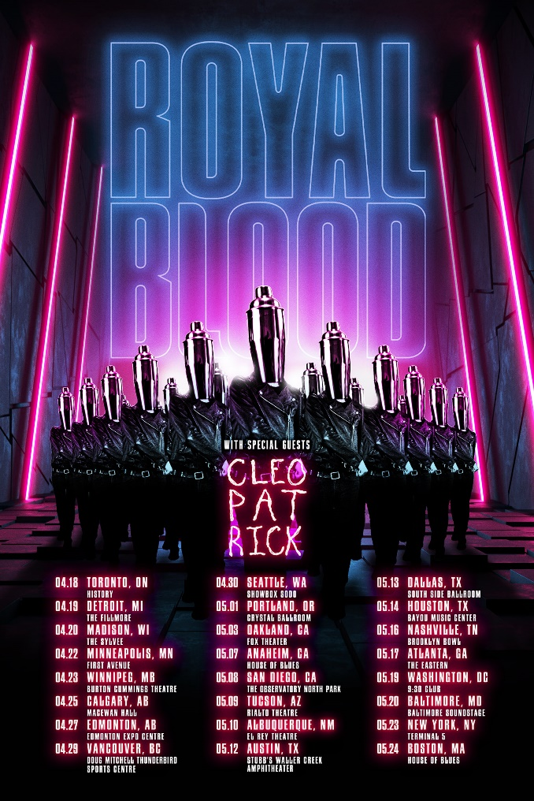

November 30, 2021 – (Los Angeles, CA.) Today, UK rock legends Royal Blood announce their long-awaited 2022 North American tour in support of their internationally acclaimed third album Typhoons. The coast-to-coast trek is set to begin April 18, in Toronto and closes out in Boston on May 24. Fan pre-sale begins December 1, at 10:00AM local time. Those on the band’s mailing list will receive a passcode to participate in the pre-sale. General on-sale begins December 3 at 9:00AM local time. Click here for further details.

The singles and videos leading up to the album’s April 2021 release ("Trouble’s Coming," "Typhoons," "Limbo," and "Boilermaker") created an overwhelming global impact which led to Typhoons being called the duo’s best work to date and one of the defining rock albums of 2021. Upon the album’s release, Royal Blood had already accrued over 50 million streams and the biggest US airplay of their career crashing into the Rock and ALT charts climbing consistently over the course of 30 weeks to reach the #1 position. Critical response has been impressive:

“The new album is even tighter and more focused, a neater distilation of Royal Blood. Could this signal a future new path? Whatever it means, this is a band to watch.” – Associated Press
“Royal Blood bring big riffs to the dancefloor…headbang-worthy bass and drum attack.” -- Rolling Stone

“Typhoons incorporates a wider tonal palette. Royal Blood shifted gears and embraced a more polished sonic profile… a triumphant moment for the band.” – American Songwriter

“What makes Royal Blood so appealing is how many different elements just two musicians are able to pull into one unified front…tense, modern rhythms that ebbs with its start-stop/push-pull mentality…a cosmic voyage in duality” – Loudwire
Mike Kerr (vocals, bass, keys, piano) and Ben Thatcher (drums) share their excitement for the upcoming tour: “Delighted and thrilled to the core to announce our tour of North America! We cannot wait to be reunited with you all.”

Royal Blood N. American 2022:
cleopatrick will support on all dates

Apr 18 Toronto, ON History
Apr 19 Detroit, MI The Fillmore
Apr 20 Madison, WI The Sylvee
Apr 22 Minneapolis, MN First Ave
Apr 23 Winnipeg, MB Burton Cummings Theatre
Apr 25 Calgary, AB MacEwan Hall
Apr 27 Edmonton, AB Edmonton Expo Centre
Apr 29 Vancouver, BC Doug Mitchell Thunderbird Sports Centre
Apr 30 Seattle, WA Showbox SoDo
May 01 Portland, OR Crystal Ballroom
May 03 Oakland, CA Fox Theater
May 07 Anaheim CA House Of Blues
May 08 San Diego, CA The Observatory, North Park
May 09 Tucson, AZ Rialto Theatre
May 10 Albuquerque, NM El Rey Theatre
May 12 Austin, TX Stubbs Walker Creek
May 13 Dallas, TX South Side Ballroom
May 14 Houston, TX Bayou Music Center
May 16 Nashville, TN Brooklyn Bowl
May 17 Atlanta, GA The Eastern
May 19 Washington, DC 9:30 Club
May 20 Baltimore, MD Baltimore Soundstage
May 23 New York, NY Terminal 5
May 24 Boston, MA House Of Blues

About Royal Blood:
Mike Kerr (vocals/bass) and Ben Thatcher (drums) formed Royal Blood in Brighton, England, and released their self-titled double-Platinum debut album in 2014. It’s thrilling and visceral sound of bass played like a lead guitar with thunderous drums immediately engaged a huge audience. Their reputation continued to explode with the similarly successful follow-up, 2017’s How Did We Get So Dark?

To date, each of Royal Blood’s three studio albums have topped the UK charts, in the process selling over 3 million albums worldwide. Their acclaim has included the BRIT Award for “Best British Group” plus further accolades at the NME and Kerrang! Awards along with a Mercury Prize nomination. They’ve made a major international impact, hitting the Top 10 in a further seven territories and peaking at #2 on the US Alternative Album chart, three #1 hits at Rock Radio, plus four Top 20 records at Alternative Radio and commanding critical praise in influential media outlets such as Rolling Stone, Loudwire, Guitar World and many more. The duo has long been considered one of the most exciting live bands in the world. They have toured with Foo Fighters and Queens of the Stone Age and have gone on to become festival headliners and have toured the globe numerous times and have performed at every major music festival. With the April 2021 release of TYPHOONS, Royal Blood elevated to the next level. Its lead single, “Trouble’s Coming” and the title track, have amassed millions of streams, huge support at Radio 1, topped the US Rock charts, added to a number of key streaming playlists and performed masterfully on The Late Late Show with James Corden. Royal Blood will tour the world in 2022.

# # #

Contacts:
Rick Gershon at Warner Records
rick.gershon@warnerrecords.com

Regional: Jenny Huynh at Warner Records
jenny.huynh@warnerrecords.com

Follow Royal Blood:
Website | Facebook | YouTube | Twitter | Instagram | Spotify | Apple Music | Press Materials

