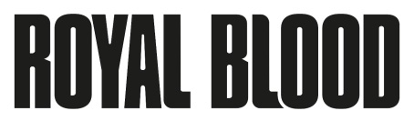
SHARE NEW VIDEO FOR HIT SINGLE “TROUBLE’S COMING”

WATCH HERE
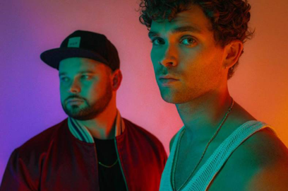

October 23, 2020 (Los Angeles, CA) - Royal Blood are back. The taut rhythms and electrifying riffs that burst from their current hit single “Trouble’s Coming” herald a bold evolution in their sound as they stride confidently towards next year’s release of their highly anticipated third album. Click here to view and share the video. Click here to stream the track.

Just weeks after its release, it’s already approaching 6 million streams. The duo landed on the cover of ROCK THIS, Spotify’s flagship global rock playlist, while breaking the Top 20 at the Alternative and Active Rock formats in the US. Add support from alternative radio everywhere, plus global media attention spanning Rolling Stone, NME, Spin, Clash and much more. Royal Blood are set to make the biggest impact of an all-conquering career.

Today, Royal Blood share the official video for “Trouble’s Coming.” Their granite-heavy bass and drums attack is now flavored by insistent grooves inspired by Daft Punk, Justice and Phillipe Zdar. The video was directed by Dir. LX, best known for his work on U.K. rap and grime icons such as Dave, Bugzy Malone and Kojo Funds, and takes his cues from Mike Kerr’s ominous lyrics to create a video that pulsates with foreboding atmospherics and cinematic, neo-noir flair.

“Trouble’s Coming” proved to be the turning point in the creative process. It concisely tees up what to expect from the record: a very organic infusion of their visceral hard rock sting with a dance-tinged rhythm that grooves rather than pummels.

In the space of just two albums, Royal Blood have ascended to become one of the world’s biggest and most vital rock bands. The Brighton, England duo have scored two U.K. #1 albums - their self-titled double-Platinum, self-titled debut from 2014 and 2017’s How Did We Get So Dark? – in the process of selling 2 million albums worldwide. Their acclaim has included the BRIT Award for Best British Group plus further accolades at the NME and Kerrang! Awards as well as a Mercury Prize nomination. What’s more, they’ve made a major international impact, hitting the Top 10 in a further seven territories and peaking at #2 on the U.S. Alternative Album chart. Further U.S. success has included three #1 hits at Rock Radio, plus four Top 20 records at Alternative Radio.

A huge draw in the live arena, Royal Blood’s most recent full-scale U.K. and Ireland headline tour saw them perform in front of 100,000 people, including 30,000 over three sold-out nights at London’s cavernous Alexandra Palace. Key festivals have included Coachella, Lollapalooza, Glastonbury (where they famously discovered, mid-set, that their second album had debuted at #1), Reading and Leeds Festivals. Highlights of their extensive international touring include huge North American tours with Queens of the Stone Age and Foo Fighters, plus headline shows as far afield as Los Angeles, Tokyo and Sydney.

Royal Blood: Mike Kerr (vocals, bass, keys, piano) and Ben Thatcher (drums)

Contact Rick Gershon at Warner Records rick.gershon@warnerrecords.com

Follow Royal Blood:
Website | Facebook | YouTube | Twitter | Instagram | Spotify | Press Materials

