SHARE THE NEW VIDEO FOR “TYPHOONS”
WATCH IT HERE

THE TITLE TRACK FROM THEIR NEW ALBUM WHICH FOLLOWS ON APRIL 30TH

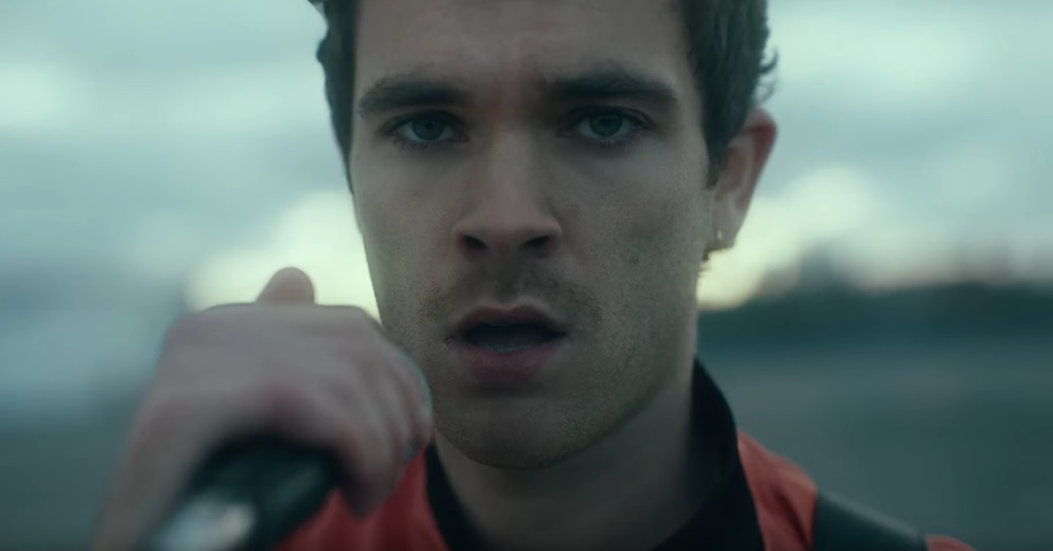
(Still from “Typhoons” Video)

January 28, 2021 (Los Angeles, CA) - Today, U.K. rock duo Royal Blood release the new official video for “Typhoons,” the title track from their forthcoming third full-length album and the follow up to their ground-breaking single “Trouble’s Coming,” their first new music in nearly three years. “Typhoons” boldly magnifies a new direction for Mike Kerr and Ben Thatcher as they add greater depth and danceability to their signature hard rocking sound.
Click here to view and share “Typhoons.”

Royal Blood’s relentless return continues as they unveil the official video for “Typhoons” which feature the duo performing on the rooftop of a carpark next to London’s Queen Elizabeth Olympic Park. As the sky darkens, the sounds attract crowds of people to join them. As a storm erupts, the band are surrounded: a typhoon looms large over them, its movements mirrored by the intense, spiralling reaction of the throng below.

The video represents their first collaboration with Quentin Deronzier. Renowned for his visuals for Drake, Orelsan and Kanye West, the director puts a new slant on Royal Blood’s aesthetic, adding otherworldly cinematics and inner-city style. It also feels like an apt stylistic successor to the "Trouble’s Coming" video, which was directed by Dir. LX (Dave, Bugzy Malone, Kojo Funds).

The release “Trouble’s Coming” this past September was an incendiary statement of intent that signalled the return of Royal Blood. Together with “Typhoons” presents an arresting introduction to their highly anticipated third album Typhoons, which follows on April 30th. It represents a natural evolution in their sound, flavoring the raw attack that made their self-titled debut album so thrilling, visceral and original with rhythmic influences from Daft Punk, Justice, and Philippe Zdar of Cassius. Click here to watch their recent performance of “Trouble’s Coming” on The Late, Late Show with James Corden.

Critical praise for Royal Blood continues to swell around the world:

“’Typhoons’ opening track — the duo’s new track ‘Typhoons’ finds Royal Blood reconnecting with the electronic music acts that inspired their 2014 debut album, namely Daft Punk, Cassius and Justice.” – Rolling Stone

“Swaggering.” - NME

“There's a storm a brewing and Royal Blood are bringing it your way.” - Loudwire

“Mesmerising.” - Kerrang!

The Typhoons album is available to pre-order here, and will be released on digital, vinyl and CD formats. The official Royal Blood store offers a deluxe vinyl edition that will be limited to a one-time run of 8000 copies worldwide. The deluxe edition features a translucent pink / opaque black 12” housed in a metallic foil gatefold sleeve and will be packaged with an exclusive 7” single containing the extra track “Space” and an etched B-side. It will be completed by a large format booklet and an individually numbered 12” art print with alternative art that’s exclusive to this set.

# # #
Royal Blood: Mike Kerr (vocals, bass, keys, piano) and Ben Thatcher (drums)

For more information please contact:
Rick Gershon at Warner Records rick.gershon@warnerrecords.com

Follow Royal Blood:
Website | Facebook | YouTube | Twitter | Instagram | Spotify | Apple Music | Press Materials

