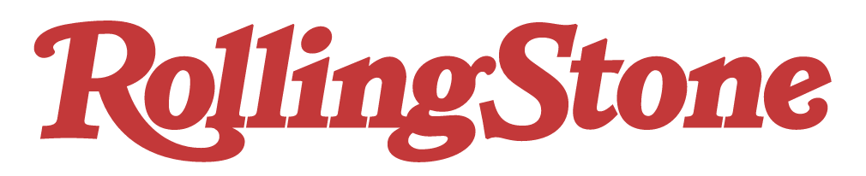

November 2020

https://www.rollingstone.com/charts/breakthrough/

