

**RETURN TO LIVE PERFORMANCE ON *THE LATE LATE SHOW WITH JAMES CORDEN***

**“TROUBLE’S COMING” ROCKS LATE NIGHT TV IN THE US**



(Still photo courtesy of The Late Late Show with James Corden/CBS TV)

**November 20, 2020 (Los Angeles, CA) –** Mighty U,K. rock duo[**Royal Blood**](https://www.royalbloodband.com/)have returned to live performancelast night with a triumphant bang, playing their current hit single “**Trouble’s Coming”** on ***CBS’s The Late Late Show with James Corden*** who referred to them as, “my band, magnificent and exceptional.”

Adding keyboards and backing vocals to their newly dance-infused sound propelled **Royal Blood** to greater sonic heights for their first live performance in over two years that Corden called “Absolutely brilliant.” Click [**here**](https://www.youtube.com/watch?v=Zb3efvg_GLw) to view their performance and [**here**](https://www.youtube.com/watch?v=lQPMMTSa1tc&list=RDCMUCJ0uqCI0Vqr2Rrt1HseGirg&start_radio=1&t=0) for the introduction.

[**“Trouble’s Coming,”**](https://www.youtube.com/watch?v=uURsMKMloM8) **Royal Blood’s** first new music since 2017’s chart-topping second album, ***How Did We Get So Dark?,*** was released September 24th and has already exceeded 6 million streams and impacted rock, pop and Alternative radio charts around the world including Radio’s 1’s A-List in the U.K. and the US Top 20 Alternative and Active Rock charts and still going strong as we head into the Holiday season.

**“Trouble’s Coming”** tees up what to expect from **Royal Blood’s** third album --set for release on Warner Records this Spring -- a very organic infusion of their visceral hard rock sting with a disco-tinged rhythm that grooves rather than pummels and immediately drew rave reviews:

Trouble’s Coming’ adds a bit of glitz to their grit. It pulls in influences from Daft Punk and Justice, turning Royal Blood’s usually hammering sound into something much groovier.” ***– Consequence Of Sound***

“Mike Kerr happens to be one of the biggest riff merchants on planet Earth… an altogether groovier take on the Royal Blood formula. We simply must inform you that Royal Blood are back.” ***– Guitar World***

“We don’t have anywhere to strut our stuff these days but if we did, we’d be out there stomping around to this delicious new release from Royal Blood. *‘Trouble’s Coming’* is cloaked in a menacing glamour. Trouble may be coming but when it sounds this good, who’s complaining?” ***– E!***

More from **Royal Blood** soon!

**# # #**

**Royal Blood: Mike Kerr** (vocals, bass, keys, piano) and **Ben Thatcher** (drums)

**Contact Rick Gershon** at **Warner Records** [**rick.gershon@warnerrecords.com**](mailto:rick.gershon@warnerrecords.com)

**Follow Royal Blood:**[**Website**](https://www.royalbloodband.com/) **|** [**Facebook**](https://www.facebook.com/RoyalBloodUK/) **|** [**YouTube**](https://www.youtube.com/channel/UCNkhZlHm1ccjIcDyt7W1Opg) **|** [**Twitter**](https://twitter.com/royalblooduk?ref_src=twsrc%5Egoogle%7Ctwcamp%5Eserp%7Ctwgr%5Eauthor) **|** [**Instagram**](https://www.instagram.com/royalblooduk/?hl=en) **|** [**Spotify**](https://open.spotify.com/artist/2S5hlvw4CMtMGswFtfdK15) **|** [**Press Materials**](https://press.warnerrecords.com/royalblood/)

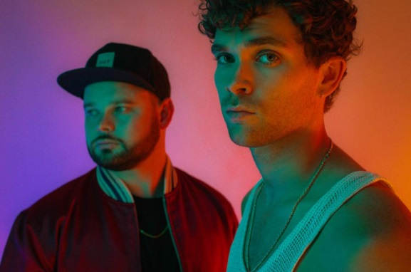

(Click [**here**](https://press.warnerrecords.com/royalblood/) for hi-res artwork; Photo Credit: Dean Martindale)

