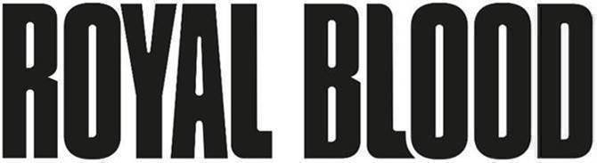

**TO PERFORM AT ROBLOX’S 2021 BLOXY AWARDS THIS SATURDAY MARCH 27,**

**NOON PST**



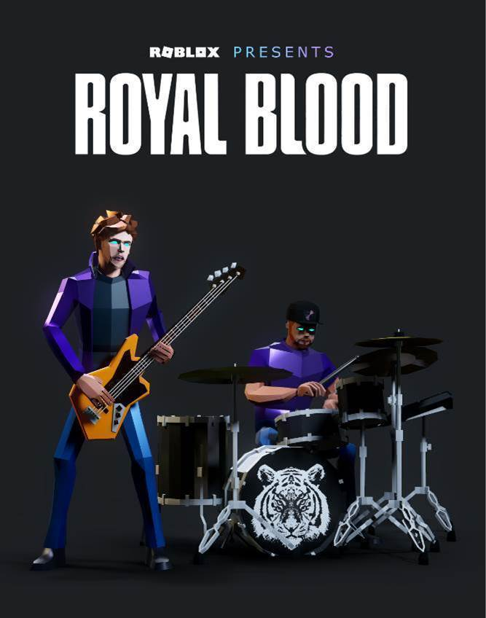

*The UK rock band, in collaboration with* ***Warner Records****, will appear as avatars for a premiere performance of their new single* **“Limbo,”** *among other top songs*

**Click** [**here**](https://app.frame.io/reviews/46b34405-28cc-4d28-a1da-86408f134be4/8b9b7bf7-c0e2-45ed-a7b7-773b9a37005a) **for animated Poster**

**Click** [**here**](https://youtu.be/rcRgGxTPxSc) **for animated trailer**

**Los Angeles, CA (March 24, 2021)** – [**Roblox**](http://corp.roblox.com) (NYSE: RBLX), a global online platform bringing millions of people together through play, announced today that the British rock duo, [**Royal Blood**](https://www.royalbloodband.com/typhoons/), will perform a three-song virtual concert during the **2021 Bloxy Awards**. **The Bloxy Awards**, **Roblox’s** celebration of the passion, talent, and creativity of the Roblox community of creators and players, will take place on **March 27th at Noon PDT** on the Roblox Platform. The concert, produced in collaboration with Warner Records, will mark the first live performance of **Royal Blood’s** new single, **“Limbo.”**

The Bloxy Awards experience is open to all and takes attendees through four distinct environments on a voyage across the Roblox Metaverse. Each experience will spotlight multiple category winners, and midway through feature an exclusive virtual performance from Royal Blood in a space-themed concert venue.

“We are thrilled to perform virtually in front of the Roblox community,” said **Mike Kerr** and **Ben Thatcher** of **Royal Blood**. “This promises to be a real cosmic experience. Strap yourselves in - we look forward to seeing you there.”

“The creativity of the Roblox community powers the experiences on our platform, and the social connections players make while sharing these experiences are deeply enriched by music.” said **Jon Vlassopulos**, **Vice President and Global Head of Music for Roblox**. “We're thrilled to host Royal Blood as we celebrate the talent of our creators with the greater Roblox community in this immersive, out-of-this-world Metaverse experience.”

“Royal Blood have always been a forward-thinking band and so it is fitting that they play inside Roblox this year and introduce a whole new audience to their incredible sound,” said **Phil Christie, President, Warner Records UK.**

After the show premieres on March 27th at Noon PDT, the Bloxy Awards will replay every hour between **March 27th** and **April 6th** inside the Bloxy experience on Roblox. A full version of the show will also be recorded and uploaded to YouTube 10 days after the first show airs.

**Royal Blood’s** upcoming performance underscores Roblox’s commitment to provide artists and labels a unique, creative, and highly immersive way to engage with millions of their fans in the Metaverse. The range of immersive Roblox music experiences, from launch parties to virtual concerts, gives artists and labels a way to engage fans with exclusive performances and virtual merchandise, as well as games, quizzes, chats, Q&A’s and more.

**About Roblox:**

Roblox’s mission is to build a human co-experience platform that enables shared experiences among billions of users. Every day, more than 32 million people around the world have fun with friends as they explore millions of immersive digital experiences. All of these experiences are built by the Roblox community, made up of over eight million creators. We believe in building a safe, civil, and diverse community—one that inspires and fosters creativity and positive relationships between people around the world. For more information, please visit [**corp.roblox.com**](https://corp.roblox.com/)**.**

**About Royal Blood:**

**Mike Kerr** (vocals/bass) and **Ben Thatcher** (drums) formed **Royal Blood** in Brighton, England, and released their self-titled double-Platinum debut album in 2014. The band’s thrilling and visceral sound of bass played like a lead guitar with thunderous drums immediately engaged a huge audience. Their reputation continued to explode with the similarly successful follow-up, 2017’s ***How Did We Get So Dark?***

To date, **Royal Blood** have achieved two UK #1 albums, in the process selling over 2 million albums worldwide. Their acclaim has included the *BRIT Award* for “Best British Group” plus further accolades at the *NME* and *Kerrang!* Awards as well as a Mercury Prize nomination. What’s more, they’ve made a major international impact, hitting the Top 10 in a further seven territories and peaking at #2 on the US Alternative Album chart. Further US success has included three #1 hits at Rock Radio, plus four Top 20 records at Alternative Radio and commanding critical praise in influential media outlets such as *Rolling Stone, Loudwire, Guitar World* and many more.

The duo is just as big an attraction in the live arena. In 2017 they played three sold-out nights at London’s Alexandra Palace to a total of 30,000 people. They’ve also hit festivals such as Coachella and Glastonbury, toured with Foo Fighters and Queens of the Stone Age, and headlined shows as far afield as Los Angeles, Tokyo and Sydney.

**Royal Blood’s** upcoming third album ***TYPHOONS*** is set to elevate them to the next level when it’s released on **April 30th**via Warner Records. Its lead single, **“Trouble’s Coming”** and the title track, have amassed millions of streams, huge support at Radio 1, topped the US Rock charts and adds to a number of key streaming playlists. Along with masterful performance of **“Trouble’s Coming”** on [**The Late Late Show with James Corden**](https://www.youtube.com/watch?v=XLmx2xLuKCc) **Royal Blood** are poised to attain even greater global heights in the months ahead. At present, the current single **“Typhoons”** is set to repeat the success of **“Troubles Coming”** as its already #2 “Most Added” at Rock Radio and #3 “Most Added” at Alt Rock Radio in the US upon release.

**About Warner Records:**

Warner Records has stood as a beacon of artistic freedom and creative expression for the past six decades, releasing some of the most culturally influential and innovative music of our time. Headquartered in the vibrant arts district in downtown Los Angeles, CA, Warner Records is home to an impressive generation of artists, among them Dua Lipa, Gary Clark Jr., Bebe Rexha, Neil Young, Saweetie, Michael Bublé, NLE Choppa, Anitta, Josh Groban, Deftones, Wale, Red Hot Chili Peppers, Andra Day, Muse, Lukas Graham, Chika, Mastodon, Bryce Vine, Linkin Park, Ali Gatie, Royal Blood, David Guetta, Omar Apollo, Disturbed, Sub Urban, RÜFÜS DU SOL, and many more. Beginning in 1958 as the label arm of the famed movie studio, things began to take shape in the early ‘60s with artists like the Everly Brothers, Peter Paul & Mary, and comedian Bob Newhart. With the acquisition of Frank Sinatra’s Reprise Records in 1963, the Warner Records mantra of “the music first” took hold, leading to the signing of such groundbreaking artists as Prince, the Kinks, Grateful Dead, Van Morrison, James Taylor, Rod Stewart, Black Sabbath, Van Halen, and many more.

**About Warner Music Group:**

With a legacy extending back over 200 years, Warner Music Group (WMG) today brings together artists, songwriters, and entrepreneurs that are moving entertainment culture across the globe. Operating in more than 70 countries through a network of affiliates and licensees, WMG’s Recorded Music division includes renowned labels such as Asylum, Atlantic, Big Beat, Canvasback, Elektra, Erato, First Night, Fueled by Ramen, Nonesuch, Parlophone, Reprise, Rhino, Roadrunner, Sire, Spinnin’, Warner Records, Warner Classics, and Warner Music Nashville. WMG’s music publishing arm, Warner Chappell Music, has a catalog of over one million copyrights spanning every musical genre, from the standards of the Great American Songbook to the biggest hits of the 21st century. Warner Music Group is also home to ADA, the independent artist and label services company, as well as consumer brands such as Songkick, the live music app; EMP, the merchandise e-tailer; and UPROXX, the youth culture destination. Follow Warner Music Group on [Instagram](https://nam04.safelinks.protection.outlook.com/?url=https%3A%2F%2Fwww.instagram.com%2Fwarnermusic%2F%3Fhl%3Den&data=04%7C01%7CMajeda.Hussein%40wmg.com%7C57d72bbd104842423ba308d8df3327de%7C8367939002ec4ba1ad3d69da3fdd637e%7C0%7C0%7C637504758103578004%7CUnknown%7CTWFpbGZsb3d8eyJWIjoiMC4wLjAwMDAiLCJQIjoiV2luMzIiLCJBTiI6Ik1haWwiLCJXVCI6Mn0%3D%7C1000&sdata=xdqHi1xjhmewyRAJHxTstayw7vumTAbE7%2FQz7r2JT5A%3D&reserved=0), [Twitter](https://nam04.safelinks.protection.outlook.com/?url=https%3A%2F%2Ftwitter.com%2Fwarnermusic%3Fref_src%3Dtwsrc%255Egoogle%257Ctwcamp%255Eserp%257Ctwgr%255Eauthor&data=04%7C01%7CMajeda.Hussein%40wmg.com%7C57d72bbd104842423ba308d8df3327de%7C8367939002ec4ba1ad3d69da3fdd637e%7C0%7C0%7C637504758103578004%7CUnknown%7CTWFpbGZsb3d8eyJWIjoiMC4wLjAwMDAiLCJQIjoiV2luMzIiLCJBTiI6Ik1haWwiLCJXVCI6Mn0%3D%7C1000&sdata=W9OITJhwh7l95flNFg5VafAhN7H70kTo1U%2B4%2FXqYdxI%3D&reserved=0), [Facebook](https://nam04.safelinks.protection.outlook.com/?url=https%3A%2F%2Fwww.facebook.com%2Fwarnermusicgroup%2F&data=04%7C01%7CMajeda.Hussein%40wmg.com%7C57d72bbd104842423ba308d8df3327de%7C8367939002ec4ba1ad3d69da3fdd637e%7C0%7C0%7C637504758103587962%7CUnknown%7CTWFpbGZsb3d8eyJWIjoiMC4wLjAwMDAiLCJQIjoiV2luMzIiLCJBTiI6Ik1haWwiLCJXVCI6Mn0%3D%7C1000&sdata=9eCzcMiuAv0QwXieXQeZ6CfWRYlovxNs0EsAPDoqisk%3D&reserved=0), and [LinkedIn](https://nam04.safelinks.protection.outlook.com/?url=https%3A%2F%2Fwww.linkedin.com%2Fcompany%2Fwarner-music-group&data=04%7C01%7CMajeda.Hussein%40wmg.com%7C57d72bbd104842423ba308d8df3327de%7C8367939002ec4ba1ad3d69da3fdd637e%7C0%7C0%7C637504758103587962%7CUnknown%7CTWFpbGZsb3d8eyJWIjoiMC4wLjAwMDAiLCJQIjoiV2luMzIiLCJBTiI6Ik1haWwiLCJXVCI6Mn0%3D%7C1000&sdata=bn2h3uOuhUkyrZg5PrE3k0A%2BidAZKcGW5huCK9xenjE%3D&reserved=0).

**Royal Blood:**

**Mike Kerr** (vocals, bass, keys, piano) and **Ben Thatcher** (drums)

**Follow Royal Blood:**

[**Website**](https://www.royalbloodband.com/) **|** [**Facebook**](https://www.facebook.com/RoyalBloodUK/) **|** [**YouTube**](https://www.youtube.com/channel/UCNkhZlHm1ccjIcDyt7W1Opg) **|** [**Twitter**](https://twitter.com/royalblooduk?ref_src=twsrc%5Egoogle%7Ctwcamp%5Eserp%7Ctwgr%5Eauthor) **|** [**Instagram**](https://www.instagram.com/royalblooduk/?hl=en) **|** [**Spotify**](https://open.spotify.com/artist/2S5hlvw4CMtMGswFtfdK15) **|** [**Press Materials**](https://press.warnerrecords.com/royalblood/)

**FOR MORE INFORMATION CONTACT:**

**Roblox Corporation**

Brian Jaquet  [bjaquet@roblox.com](mailto:bjaquet@roblox.com)

**Warner Records**

Laura Swanson (Los Angeles) [laura.swanson@warnerrecords.com](mailto:laura.swanson@warnerrecords.com)

Rick Gershon (Los Angeles) [rick.gershon@warnerrecords.com](mailto:rick.gershon@warnerrecords.com)

Morad Khokar (London) [Morad.khokar@warnerrecords.com](mailto:Morad.khokar@warnerrecords.com)

**Warner Music Group**

Jo Bartlett [jo.bartlett@warnermusic.com](mailto:jo.bartlett@warnermusic.com)

Majeda Hussein [majeda.hussein@wmg.com](mailto:majeda.hussein@wmg.com)

