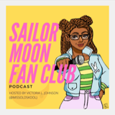

July 27, 2020

hyperurl.co/sailormoonfanclub
Apple Podcasts: https://podcasts.apple.com/us/podcast/ep-20-saweetie/id1501975271?i=1000486290485
Spotify: https://open.spotify.com/episode/0VT6Onbmw8Ggx2UQizz4vO
YouTube: https://youtu.be/SW_DxW2ZweQ

