ELECTRONIC PRODUCER RELEASES VISUALS TO DEBUT SINGLE ‘DUO’, PREMIERED ON THE FADER.

TAKEN FROM HIS HIGHLY ANCTIPICATED FORTHCOMING EP ‘IV’

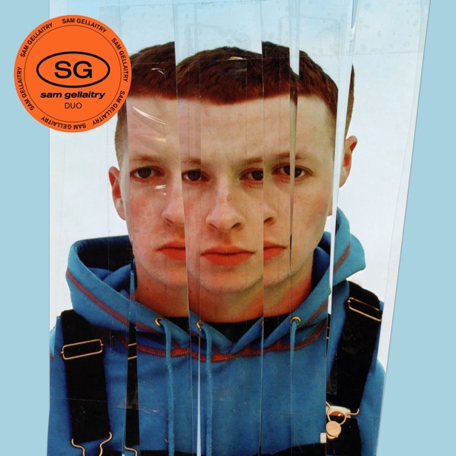

Scottish electronic artist & producer Sam Gellaitry releases his debut single ‘Duo’, out via FFRR/Parlophone Records alongside psychedelic visuals. WATCH HERE. Presenting to us the first track from his highly anticipated, forthcoming EP, ‘Duo’ gives us the first taste of a project where we see Sam’s own vocals used over the smooth syncopated bass guitar and snare sound introduced on the track. With an amalgamation of sounds presented, ‘Duo’ offers a merging of electro, dance, and French house, fused together with an undertone of 70s disco sensibilities. Presented with high octane and eclectic visuals, the video directed by Ethan + Tom (Shrink, BADGIRLS$, Flohio), transitions rapidly through a scene of animated and inverted versions of the star before viewers are taken along on a psychedelic-feeling thrill ride, synonymous of the track itself. Taking us on along on this new trip – one that can only be described as an exciting new chapter, we are being introduced to a “new season of Sam” following on from his three previous EP’s: ‘Escapism’ (2015), ‘Escapism II’ (2016) and ‘Escapism III’ (2017), the star is back from hiatus and ready to show the world a new side of him in which uses vocals to further express himself, and all that he’s experienced in life.

On ‘Duo’, Sam stated: “It feels like I’m dropping my first ever song. such a crazy feeling to go from hiding behind instrumentation to finally finding my voice. it’s super liberating being able to explore more refined soundscapes by using my vocals as the glue. i return to my roots with Duo by venturing into a more funk oriented sonic and I’m going to continue to showcase all my past and present tastes that have brought me to this point musically.”

With an influx of new music on the way from Sam, and with prior support from key tastemakers such as i-D, The Fader, The Boiler Room and BBC Radio 1, this release, and the ones to follow are set to mark an impressive reemergence for this 24-year-old musical phenomenon who’s set to take the remainder of 2021 by storm.

About Sam Gellaitry

Sam Gellaitry views the world through palettes of vivid colour. A C minor scale becomes purple, plum and grape. C-sharp minor is cool and blue. Nighttime is best evoked in dark F minor reds and D minor induces rich forest green. His music is a journey through experience, circumstance and surroundings, told through his impressive, synesthesia-informed knowledge of different musical tones.

For him, songwriting and producing has always connected to a process of pairing and contrasting different tones – “using the notes to create different sensations – like tension or relief in your head.” In practice, this technique has seen him experiment with high-definition club music, crisp hip hop production, dabs of orchestral instrumentation and more, via ‘Escapism’ – three EPs released in the mid to late 2010s that cemented him as one of the most varied and visually strong producers of his generation.

Born far away from key electronic music hubs like LA, Glasgow and London, Sam, now 23, grew up in Stirling – an old town in central Scotland that’s rich in medieval history and visually stunning views. Living here lead Sam’s older brother to happy hardcore – a kind of hard dance music born from the UK and Europe’s breakbeat and rave scenes – which in turn lead to Sam learning to produce.

YouTube granted unfettered access to the world’s electronic scenes, with the array of sounds pushing Sam to pick up production in his early teens. He dove into Daft Punk’s robotic space realm where looped up disco samples reigned supreme and LA producers Samiyam and Flying Lotus were early inspirations. But no matter the genre, one thing remained constant: the idea that music can take your imagination on a voyage through colour, place and sound, via combinations of notes.

His first breakthrough song – 2014 single “powder” – bridged the gap between hip-hop and electronica, treading delicately as it glitched between maxi-and-minimalism. It sat in his favourite key too, with its instrumentation diving between hues of blue and green. “It reminds me of being a hyper sixteen year old making music,” he says today. The track took off and sent Sam’s music on a journey, taking him from an unknown beatmaker to a Soulection – and later, XL Recordings – signee.

‘Escapism’ released in 2015, with ‘Escapism II’ (2016) and ‘Escapism III’ (2017) coming after. The series showcased a young producer picking and choosing his way through a lavish buffet of sound and picked up nods from many of his peers in the electronic scene, like Kaytranada and Flume.

Sam has always used instruments to convey voices – high pitched flute sounds to evoke falsetto sounds and female vocals, for example, or top lines made from melodics. But after taking a break for a few years since the release of ‘Escapism III’, he decided the time was right to start singing on his own music.

“Me singing is just another instrument that I can use. I’m at an age now where I feel ready to talk and tell people what I’ve experienced in life. It’s perfect timing in that sense,” he says.

“I’ve done three EPs. I’m at the point now where I’m like – I want all the smoke. Now I’m comfortable singing on my songs, I want to go back to each point in my musical journey and tap into it. I’m using the voice as my anchor, then tapping into other sonics that have influenced me.”

Coming alongside this new phase of Sam’s career is an embrace of both his Scottish heritage and his unparalleled and unadulterated passion for creativity. He’s getting a tartan made up which features the prominent colours he sees in music – the blues, the greens, and everything between. The idea is to feature the tartan on kilts and capes and clothes released via Sam’s new Viewfinder label – a creative venture unifying his love of music (he’s just signed his first artist), photography and fashion.

Ultimately, this next phase of Sam’s career comes back to why he does it all in the first place. He loves creating and playing around with different colours. It’s like a form of magic: a source of respite, release and happiness. “I want all my work to paint a joyful image of the process of creation,” he explains. As he prepares to ready his debut album, his forthcoming EP is the next step on Sam Gellaitry’s colourful journey.

Follow Sam Gellaitry

Instagram | Twitter | Facebook | Soundcloud

For more information, please contact:
Darren Baber | Warner Records
Darren.Baber@warnerrecords.com

