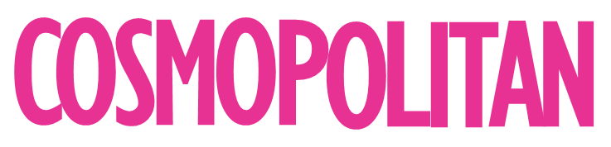
June 25, 2019
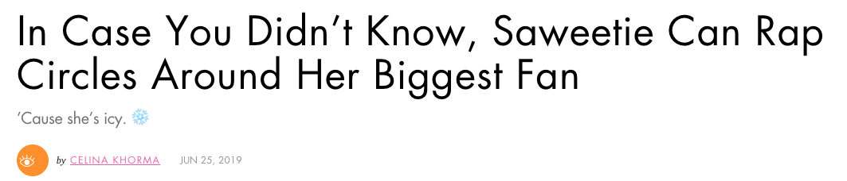
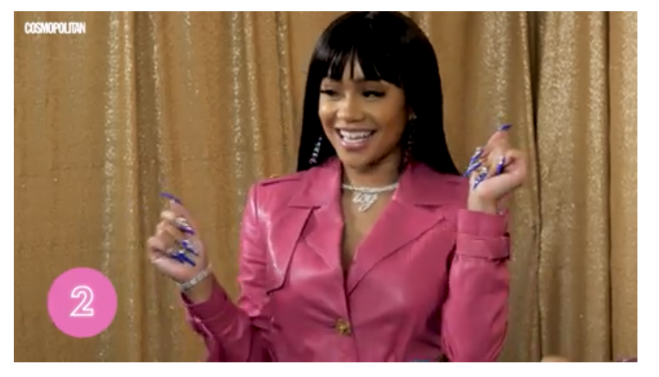
The ICY GRL herself, Saweetie, dropped by our studio to go head-to-head against her superfan and prove she’s the queen. Saweetie’s got bars for days, but our superfan happens to know EVERYTHING about her—who will win?! TBH, these two flow so well together that I momentarily forgot this was even a competition.
Saweetie’s music is pretty much banger after banger, so remembering her lyrics is a breeze—for both of ’em. But plot twist: Superfan Esther seems to know more about Saweetie personally than even Saweetie herself does. (Like, seriously, if you can name your fave celeb’s birthday faster than they can...I salute you. That’s a damn gift.)
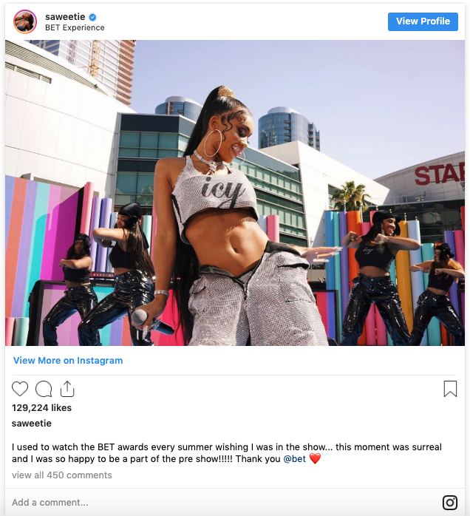

As a reminder, Saweetie went viral in 2017 after releasing “ICY GRL,” her remix to the throwback jam “My Neck, My Back.” (Also, wait, how is it 2019 already?!) Since her breakout hit, she has gone on to collab with notable artists like Quavoand Kehlani and has been blessing our ears with nothing but bops. If you want proof, go ahead and listen to her latest song, “My Type.” LISTEN NOW
The rap star has, in true fashion, proven that she can’t stop, won’t stop. Her single “Addiction” with Lil Wayne and BIG K.R.I.T. dropped just yesterday, and I’m already...addicted? Help. LISTEN NOW
Ugh, this video makes me hard-core wish I were BFFs with Saweetie. Can I get a selfie with her too? Can we go get our nails done together? Swap closets? No? Okay, fine, I’ll just live vicariously through Esther for now.

