June 19, 2019

https://i-d.vice.com/en_us/article/7xgqxe/rapper-saweetie-on-making-moves-and-what-it-means-to-be-icy

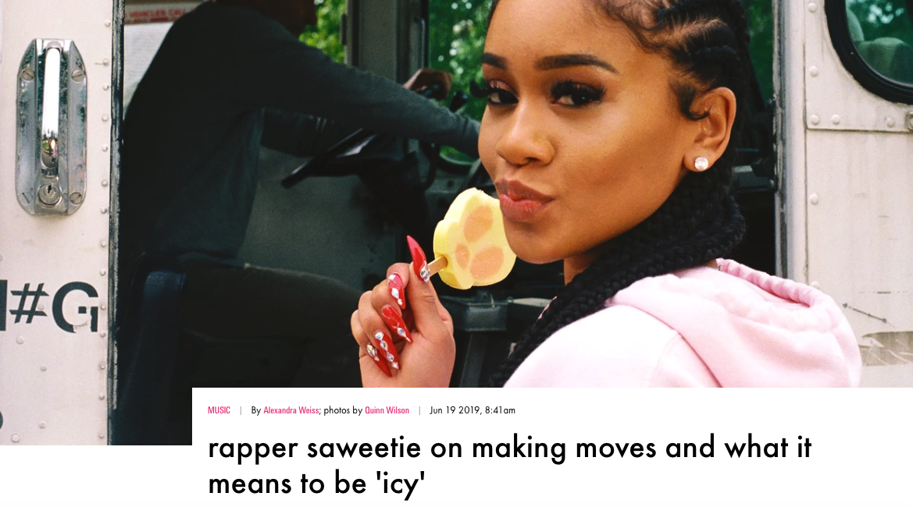

“I’ve had so many people try to tell me who I am. That’s why I made 'ICY' — to serve as inspiration for girls who are watching me."
In our modern world of social media and Snapchat filters, very few people are exactly who they present themselves to be. Then there is Saweetie. The 25-year-old Bay Area native became one of the most exciting rappers in hip-hop IRL largely because of her raw internet presence, from her MySpace to her Soundcloud, where she released the unapologetic "Icy Girl" that went viral in 2017.
With last year's release of her debut EP High Maintenance and tracks like “Pissed,” Saweetie has made it clear she’s a hard working “big cat bitch” with expensive taste and a sense of humor, eager to call out her critics while pursuing her goals and destroying what she sees as misconceptions about her. “I feel like people box me in thinking I’m some college girl who can’t be freaky,” she tells me, not through her lyrics, but over the phone last month. Armed with a degree from USC, Saweetie’s “always making moves,” she raps, “that's how I keep my sanity.”
Her latest move is ICY, a seven-song EP that includes a club banger called “My Type,” and two tracks with her boyfriend, Quavo. It’s a departure not in that she’s any less reflective and open about her offline reality (in fact, she’s unapologetic in her honesty, sharing the ups and downs of her career and relationship with the Migos rapper), but the songs feel darker, more aggressive. More Saweetie.

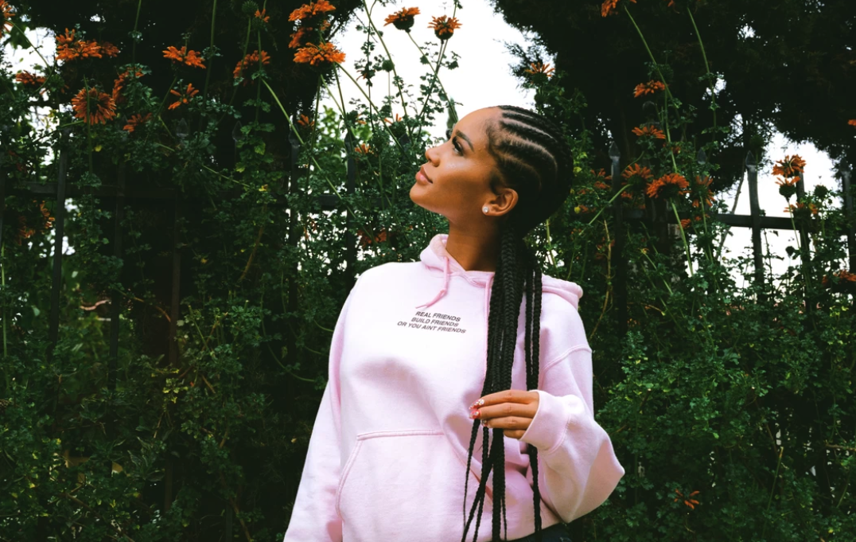
“I’ve had so many people try to tell me who I am,” she says at the end of our call. “That’s why I made ICY — to serve as inspiration for girls who are watching me. The more music I put out, the more my brand will be my own. Then it’ll just be like, ‘That’s Saweetie.’”
Below, the rapper sounds off to i-D on her latest release and what it means to be icy.
Tell me about your new EP, ICY .
To me, ICY is very different — it’s more like an attitude that’s very unapologetic and sassy. So, the record is really about independence, and being very boss-like. Not to sound super into myself, but I really like to listen to my own songs, and I felt like I was missing something, you know? I needed some stuff that could be played in the club or while you were wildin’ with your friends in the car or getting ready. I was tired of listening to other people to get that kind of energy, which is why a lot of the songs on the EP are more aggressive, the beats are a little more high tempo.
If ICY has a more honest, no fucks vibe, what would you consider High Maintenance
They’re both very me, but still very different, and I know a lot of people were taken aback by it. But I feel like for the majority of my life, there have been so many things I wish I could’ve done that I didn’t. So, it’s like, why not just do everything now? Especially now that I have the resources — I have great producers, my writing is getting better — so I really thought, ‘Fuck it. I dont give a fuck what they say. If they feel like it's not for them, then it's not for them.’ Luckily, most of my fans love it, but in the end, this is all about me and just having fun.
With music especially, I think if you're doing it for other people — or for reasons other than because you love it — it's just never going to turn out quite right. And with rap, in particular, authenticity is such an important part of being an artist.
It definitely is, and I've seen a lot of reviews and people talking about me, calling me fake, and saying this EP is too different, but honestly it was just me letting you step into my world, giving you insight as to what be poppin’ off between me and my mans. It was just me being unapologetically myself — like a conversation I’d have with one of my homegirls.

Is it scary to open up like that in your work? Then, if someone doesn’t like it, does it feel like they don’t like you?
One-hundred percent. My art is a part of me, so if you don't like my work, then you don’t like me. But I feel like that's just the give and take of being an artist. I mean, it has a lot of pros, but having a lot of people have opinions about what you're doing is scary, and I’ve had real conversations with myself — yes, I talk to myself — asking, ‘Is this really the path you want to take?’ But it's like, if I'm listening to this shit all day, why not make it? And if I’m making music, why not share it? If they like it, they’ll like it, and if they don’t, they should go listen to somebody else.
How do you describe your sound?
I’m still figuring that out. I’d like to start singing a lot more, and I'd like to lock in with one producer, because I feel like when you find your team, that's really when you can create your own sound, like Drake did with 40. But right now, I’m really just focusing on my delivery because I’ve struggled with it for so long. I get tongue-tied sometimes and my annunciation is weird, which I think comes from having a speech problem as a child that I never really addressed. So, I’m working on that and my stage presence — I’m actually at rehearsal right now. You know, some people are born with that shit, but unfortunately, I wasn’t, which means I really have to work at my craft. At the end of day, I just want to be a good performer, and as I continue working on the things that make an artist great, my sound will come naturally. Does that make sense?

Definitely. When did you know you wanted to be a performer?
I knew I wanted to be an artist when I was 15, but I only realized I wanted to be a performer last year — the two are completely different. I enjoy writing music and I enjoy recording, but once you’re on that stage, it’s a whole different world. But it's a beautiful thing when it's mastered.
Are you a perfectionist?
Yes, girl! It has its pros and cons. I watch my videos and think, ‘Oh no, this needs to be worked on and this needs to be perfected.’ But I’m hard on myself because I don’t want to disappoint people who pay money to see me. They want a show, otherwise they could just listen to the album.
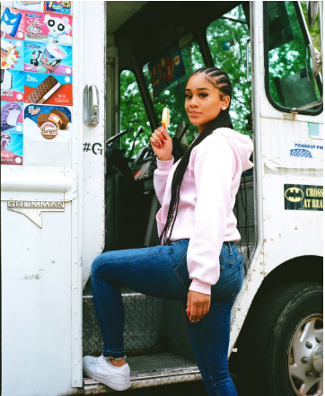

You said you knew you wanted to be an artist when you were 15. What happened then?
I’ve always enjoyed writing and I love bringing words to life, but I used to have a really hard time expressing myself. For some reason, it was easier for me to do it with poetry. Once I realized that rap is basically poetry over a beat, I realized, ‘This is what I want to do forever.’ It really was a lightbulb moment for me, because before that, I didn’t really have any aspirations, I didn’t know what I was passionate about. With rap, I really found my purpose.
From there, you ended up going a different route and pursuing your degree. Why?
When you’re coming from a small town like Sacramento, career options are limited and I knew I I didn’t want to stay at home — I wanted to get out quickly. So, I went to San Diego State. Once I’d had enough of college, I applied to USC thinking, ‘If I’m supposed to be in college, you will accept me. If not, I’m going to drop out and move to LA.’ But USC ended up accepting me and my ass stayed in school, which is why I turned to social media to pursue my music career.
Right, I read you started on MySpace. How much of an impact do you think it’s had on your career?
I don’t know what I would be doing if it wasn’t for social media. I probably wouldn’t have gotten here at all, or at least it would’ve taken me a lot longer. It’s so instant and you don't have to go through anyone else — you can literally do everything on your phone — so it gives you access to things you wouldn't see otherwise. But it’s kind of annoying, too. Like, do you listen to Drake’s music? I think it’s in “Pound Cake” that he says, ‘All that new shit is here today gone tomorrow,’ and that’s exactly what it’s like today, which is why I have to work so hard — because there's so many other people out there.
Your boyfriend, Quavo, is also a rapper. Being able to watch his experience so closely, do you notice many differences between how you’re treated within the industry?
I just I notice that male artists link up with each other more than female artists — that's one thing that I’m like, ‘Damn, I wish we did that more.’ It’s just really organic for them rather than this kind of ‘Oh, here’s another girl that's rapping.’ We also get compared a lot. That’s why it's so important for me to just keep working hard and being consistent.
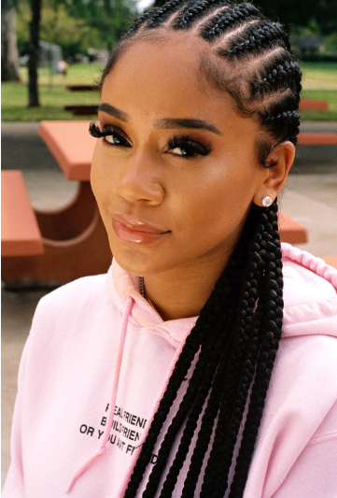
What makes you stand out?
That’s a good question. I don’t know, I’m from the Bay [Area] and I feel like people from there are just real — who we are in our music is who we really are in person.
An Icy Girl.
Exactly! Being an Icy Girl means being a bossed up, independent woman. I worked my ass off and hustled like hell to get where I am, and I’m still hustling. My goal is really to motivate people by showing them that — that you can do anything in life if you get on your shit. Go to school, make music, whatever. Life is short, just go out there and get the bag, girl. That’s it.

