SOFÍA VALDÉS RETURNS WITH NEW EP
IN BLOOM

ACCOMPANIED BY MUSIC VIDEO FOR THE TITLE TRACK “IN BLOOM”

WATCH VIDEOS FOR “CARBON COPY” AND “I HATE THE BEATLES” DIRECTED BY SATCHEL LEE

“an eclectic singer-songwriter who’s a total vibe.” - BILLBOARD

“Valdés crafts music that feels like it was somehow made using beach sand and turquoise water, her voice a comforting breeze over smooth melodies.” - INTERVIEW MAGAZINE

“Valdés’ music is often subtle, calm—cozy, even. But still waters run deep.” - AMERICAN SONGWRITER

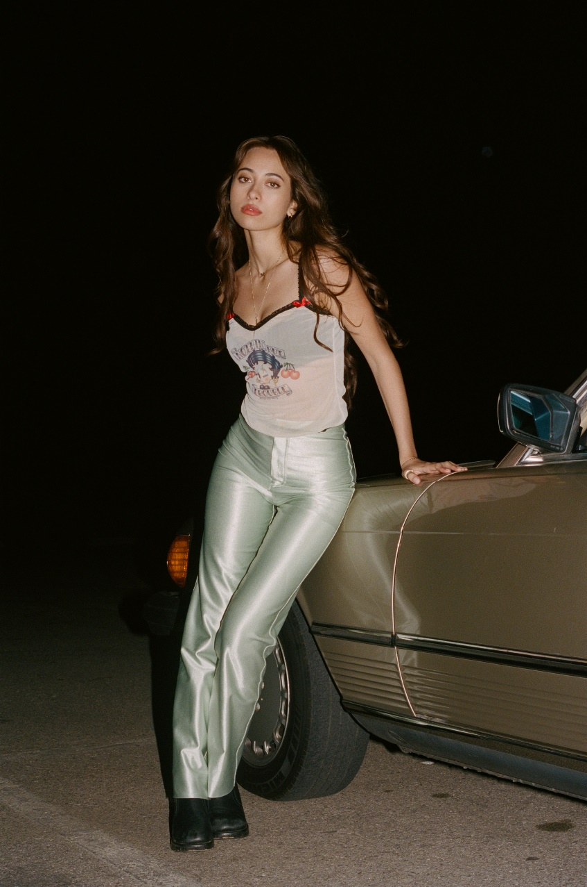
PHOT CREDIT: SATCHEL LEE

May 13, 2022 (Los Angeles, CA) – Panamanian singer-songwriter Sofía Valdés, returns with new 5 track EP, In Bloom via Warner Records. The bilingual title track, “In Bloom” is accompanied by a visual directed by Satchel Lee, that features Sofia amongst a floral backdrop with an angelic glow that emits the sentiment of the song - growth from siatuations that are no longer of value. In Bloom picks up where her debut album Ventura left off with Valdés growing and maturing as an artist and young woman through personal relationships and her outlook on life.

Speaking on the new music, Sofia says, “For me, In Bloom means standing your ground and not letting anyone take you away from that moment. I was finding myself while I was writing the songs. I was going through a roller coaster of emotions which in every phase of it I felt like I was changing which I needed in order to pass the page. The song ‘In Bloom’ is a character that I made for myself. Someone I wanted to be like and look up to. This person that’s confident, firm, beautiful and proud.”

Sofia took her career to new heights in 2021, releasing her highly-acclaimed debut album Ventura, earning praise from W Magazine, Interview Magazine, V Magazine, etc. expanding her talents beyond music, she partnered with renowned luxury brand, Chanel, serving as a brand ambassador for their Latin American market and performing a set for NPR "World Cafe” from her home in Panama. She’s since had a successful festival run that included Outside Lands in San Francisco and Lollapolooza in Chicago. At only 20 years old, and already taking the next leap in her career with In Bloom, Sofia is rapidly becoming a force to be reckoned with.

LISTEN TO IN BLOOM
https://SofiaValdes.lnk.to/inbloom

WATCH THE VIDEO FOR “IN BLOOM”
https://sofiavaldes.lnk.to/inbloomvideo


PHOTO CREDIT: SATCHEL LEE

FOLLOW SOFÍA VALDÉS
INSTAGRAM
FACEBOOK
YOUTUBE
TIK TOK
WEBSITE

FOR PRESS INQUIRIES
Patrice Compere / Warner Records patrice.compere@warnerrecords.com

