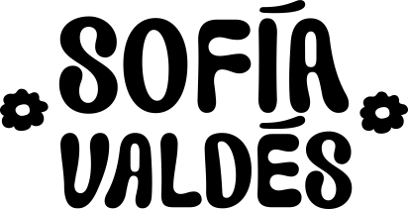

PANAMANIAN SINGER/SONGWRITER SOFÍA VALDÉS DEBUTS WITH DREAMY “LITTLE DID I KNOW”

Watch "Little Did I Know" Video Here

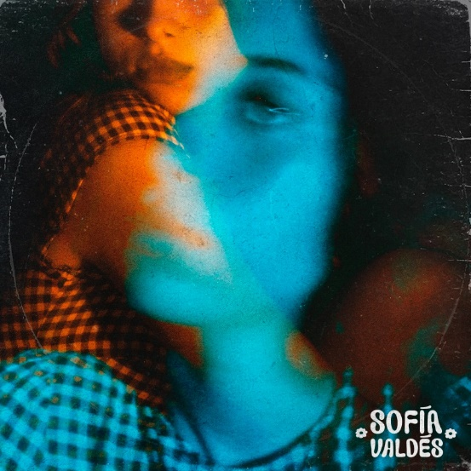

September 4, 2020 (Los Angeles, CA) — Panamanian singer/songwriter Sofía Valdés is ready to share her poignant, dreamy pop music with the world on her debut song “Little Did I Know,” out today on Warner Records, and the first taste of her forthcoming Ventura EP. The song is released alongside an intimate video that Valdés self-shot while quarantined in Panama.

Listen/Share “Little Did I Know”
https://SofiaValdes.lnk.to/LittleDidIKnow

Watch/Share Video for “Little Did I Know”
https://SofiaValdes.lnk.to/LittleDidIKnow_mv

The song — a bittersweet farewell — showcases the 20-year-old artist’s warm, wistful vocals and her gift for distilling complex emotions in minimalist touches: a delicate acoustic strum, a touch of woozy reverb, a personal lyrical detail. The song’s rhythm swings and sways like the last slow dance between former lovers. “I wrote ‘Little Did I Know’ coming out of a really dark place,” says Valdés. “The song is about a very close person In my life that I am not close to anymore. I’m able to reflect on the past and be relieved I got out of a toxic situation with a toxic person before things got worse.”

Musically, “Little Did I Know” is just a taste of Valdés’ vast influences. In some ways, the singer has been preparing for her debut since first picking up a guitar at age 8, but music has always been in her blood. Her great-grandfather was legendary Cuban musician Miguelito Valdés, and her great-great grandmother was Silvia De Grasse, a Panamanian singer who once performed with Louis Armstrong. Growing up, Valdés learned English by listening to pop, before expanding her palate with British folk, ’60s Motown, ’70s soul, classical, and bossa nova. As a blossoming bilingual songwriter, she’s come to embrace all of this inspiration, subtly weaving it into a sound that’s refreshingly light and lush.

The release of “Little Did I Know” is just the beginning. Valdés is preparing to unveil her debut EP, Ventura, which she also co-produced. The writing and recording process has brought her even closer to her roots. “The deeper I get into working on my music, the more I realize how much it’s connected to the music that people in my family were making a long time ago,” she says. “Now I want everyone to know that my culture is amazing, that I’m so proud of it, and that everyone else should be proud of their culture too.”

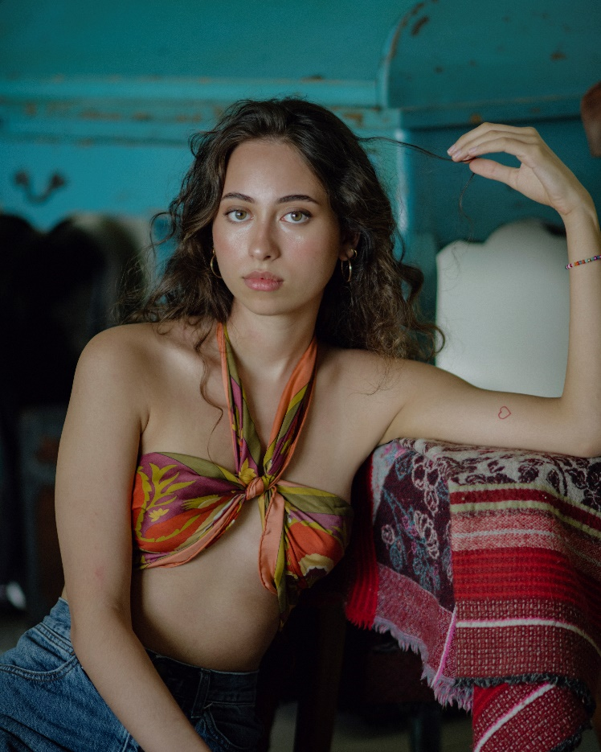
Photo Credit: Val Schnack

For more information on Sofia Valdés, please contact Jaime Rosenberg:
Jaime.Rosenberg@warnerrecords.com

Or visit:
Website Instagram Facebook Twitter YouTube

