MAX TEAMS WITH FLETCHER FOR EVOCATIVE
NEW VERSION OF HIT “BUTTERFLIES”

LISTEN TO “BUTTERFLIES” FEAT. FLETCHER HERE

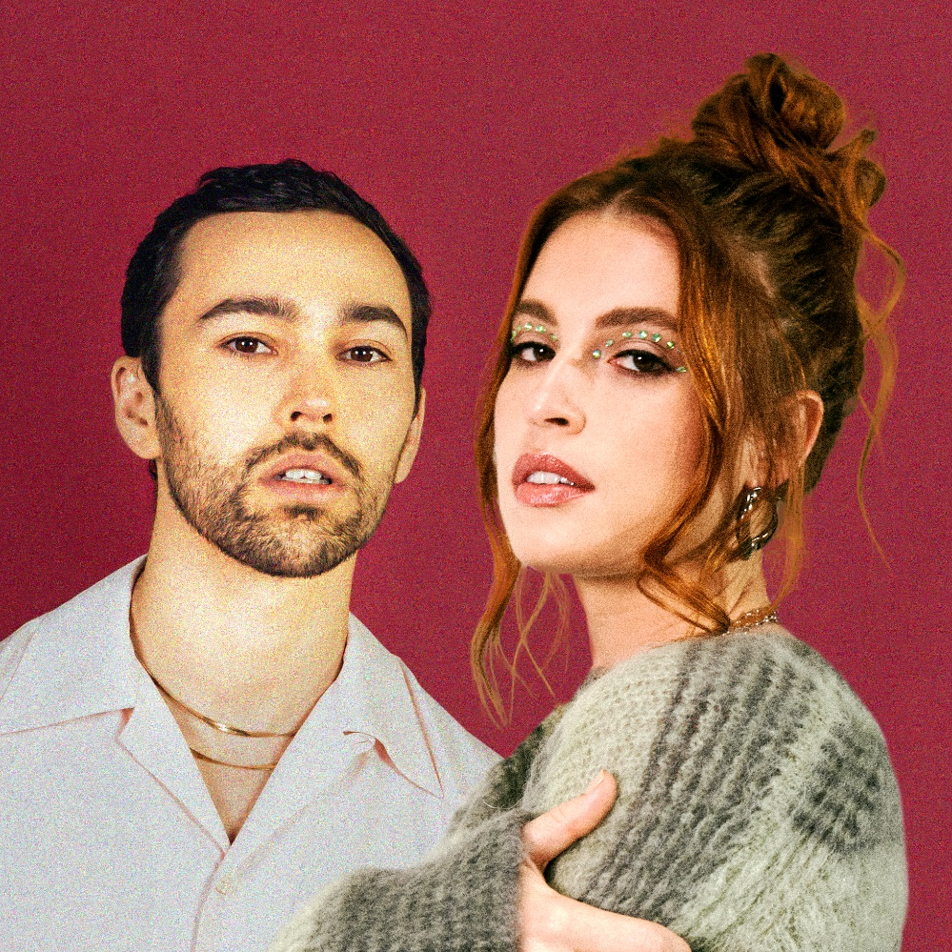

December 10, 2021 (Los Angeles, CA) – Multi-platinum pop singer/songwriter MAX returns today with a loving, emotional new version of his hit “Butterflies” with boundary-pushing, critically acclaimed singer/songwriter FLETCHER. The smash single—MAX’s Warner debut—originally arrived in June with a tender guest turn from labelmate Ali Gatie, and this new rendition only magnifies the power of the intimate ballad. Listen to the new version HERE.

The romantic ode was written as a lasting reminder of MAX’s affection for his wife, Emily, penned after the couple decided to renew their wedding vows. “Essentially, it’s about falling deeper and deeper in love with my wife,” MAX explained when the song was originally released. The new version preserves MAX’s soft declarations of devotion, but the song feels even more bright and beautiful with FLETCHER’s heart-stopping harmonies and introspective emoting. “You know that crazy feeling that you get in your stomach on a roller coaster?” she asks. The love captured in the song is just as exciting and undeniable.

“Butterflies” has had the same effect on millions of people in just six short months. The track has accumulated over 80 million global streams and scored a spot in the top 20 at Hot AC radio, not to mention syncs on Love Island, MTV’s Siesta Key, and more. MAX has also performed the song on The Bachelorette, Jimmy Kimmel Live, and Kelly & Ryan. The official music video, which traces the course of MAX and his wife’s love story, now boasts nearly five million views on YouTube. The song has also appeared on a number of influential playlists, including Spotify’s Pop Rising and Chill Pop, as well as Apple Music’s New in Pop and Breaking Pop.

This isn’t the first time that MAX has made infectious, introspective songs that have resonated with audiences. His breakthrough ballad “Lights Down Low” featuring gnash went 3X Platinum and spent 28 weeks on Billboard’s coveted Hot 100 chart, peaking at No. 20 in March 2018. Last fall, the New York native followed that up with his album Colour Vision, which cracked the Billboard 200. This new version of “Butterflies” hints at one of the core aspects of MAX’s music: He’s always evolving. Though he’s always authentic and unfiltered, he’s looking for new ways to share more of himself—a desire that’s sure to help him connect with even more fans soon.

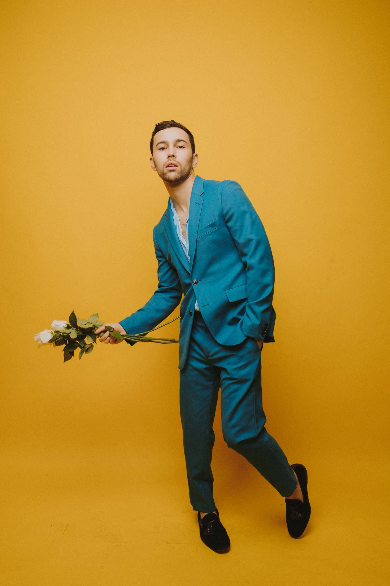
Photo Credit: Ashley Osborn

ABOUT MAX:
MAX’s music is fueled by authenticity. From his unfiltered, heart-on-sleeve lyrics to his handcrafted visuals, the breakout pop star invites you to be part of his world, sharing the highs, lows, and every neon-hued emotion in-between. He’s been labeled a “young pop god” by GQ and dubbed a “top pop star to watch” by Billboard, and it’s no wonder: He broke through in 2016 with the ubiquitous, triple-platinum “Lights Down Low.” The track shot to #1 at Hot AC radio and went platinum in a number of countries. Since then, MAX has amassed more than 1.5 billion streams, released a number of other multi-platinum songs, dropped the pop-expanding Colour Visions album, and collaborated with everyone from Suga of BTS to Chromeo to Hayley Kiyoko. With his irresistible Warner Records debut, “Butterflies” with Ali Gatie, MAX affirmed so much of what makes his songs special, from the easy inventiveness of his sound to his staggering lyrical transparency. MAX wrote the emotional ballad about renewing his wedding vows, making it a sequel to “Lights Down Low,” which famously doubled as a marriage proposal. Wide-eyed and sincere, it’s the kind of love song that smitten couples will slow dance to for years to come. “I want to dive deeper on both ends — with raw, honest songs like ‘Butterflies’ and the more experimental fare of Colour Vision,” he says. Now, with Warner Records at his back, MAX will have the best of both worlds, propelling his authentic vision further than ever before.

ABOUT FLETCHER:
Praised by leading outlets like TIME, Wonderland, Harper’s Bazaar, Interview Magazine, GQ, The Guardian, and more, FLETCHER hails from Asbury Park, New Jersey, where she cultivated her passion for music and her unforgettably candid storytelling. After graduating from NYU’s famed Clive Davis Institute for Recorded Music, FLETCHER carved out a distinct space for herself in pop music, and in 2019 released her debut EP you ruined new york city for me via Capitol Records. The widely lauded EP features her breakthrough hit “Undrunk,” a track that spent several weeks on the Billboard Hot 100, scored the #1 spot on Spotify’s Viral Chart, emerged as the fastest-rising song at pop radio from a new artist in the past five years, and earned FLETCHER a nomination for iHeartRadio’s Best New Pop Artist. Over the years, FLETCHER has sold out several headline tours and landed impressive slots at Lollapalooza, Bonnaroo, Life is Beautiful, and other major festivals. Released in September 2020, FLETCHER’s EP THE S(EX) TAPES hit No. 1 on iTunes across all genres and drew acclaim from outlets like Teen Vogue, SPIN, PAPER, and many others. An unfiltered look into FLETCHER’s world, the EP is a collection of magnetic and moody pop songs about feeling like you‘ve found your forever person before you find yourself and, as a result, needing to uncover the parts of you that remain unknown. The EP’s lead single “Bitter” has now surpassed 175 million global streams. She was also recently nominated for a 2021 GLAAD Media Award for Outstanding Breakthrough Music Artist. One of FLETCHER’s latest tracks, “Last Laugh” is available now on the soundtrack to the Academy Award-winning film Promising Young Woman. FLETCHER’s television performances include “The Tonight Show Starring Jimmy Fallon,” “TODAY” and “Ellen.” FLETCHER will embark on a sold out North American headlining tour in February 2022.

FOLLOW MAX:
Website | Facebook | Twitter | Instagram | YouTube

FOLLOW FLETCHER:
Website | Twitter | Instagram | TikTok | YouTube

For more information, please contact:
Yash Zadeh | Warner Records
Yashar.Zadeh@warnerrecords.com

Ceri Roberts | Warner Records
Ceri.Roberts@warnerrecords.com
