WAYNE COYNE OF THE FLAMING LIPS TO LAUNCH LOVE YER BRAIN CUSTOM CANNABIS BRAND ON APRIL 20

THE FLAMING LIPS ANNOUNCE A VERY SPECIAL SPACE BUBBLE SHOW IN OKLAHOMA CITY ON APRIL 20th PERFORMING ACCLAIMED NEW ALBUM
AMERICAN HEAD IN ITS ENTIRETY FOR THE FIRST TIME
TICKETS GO ON SALE MARCH 26th AT 10AM

New Video for “At The Movies On Quaaludes” Directed By Clark Duke Out Now
Watch Here

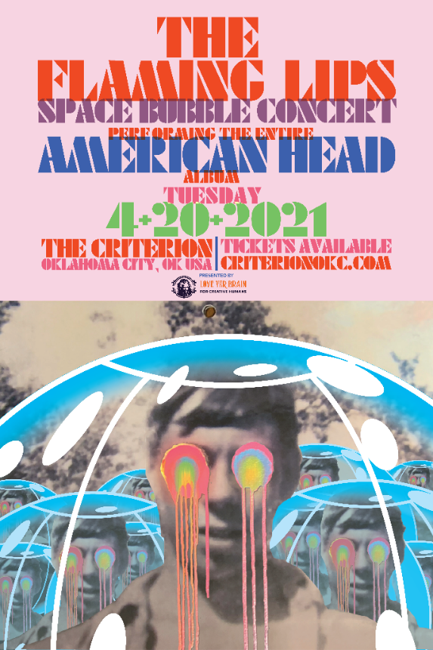
(Click here for live images from Space Bubble Concerts)

March 24, 2021 (Los Angeles, CA) – Wayne Coyne of The Flaming Lips announces his own custom brand of cannabis products called Love Yer Brain set to launch on April 20th. Focused on unlocking creativity, Love Yer Brain (named after the song of the same name from 1987’s OH MY GAWD) was created to use cannabis and other plant-based tools in a powerful and positive way...to help people. Love Yer Brain edibles represent the highest quality, potency, and consistency available, and Coyne is thrilled to have medical marijuana patients from his home state of Oklahoma be the first to experience his THC-infused brain-shaped gummies. The gummies will be available in 100mg and 250mg packs, in watermelon, green apple, and raspberry flavors at select Oklahoma dispensaries. Visit loveyerbrain.com for more details.

To celebrate the launch, The Flaming Lips have confirmed a special 420 Space Bubble concert
on April 20th at The Criterion in Oklahoma City, OK. Tickets go on sale this Friday March 26th at 10:00AM CT. Tickets and additional information are available at criterionokc.com.

After nine sold out Space Bubble Concerts, the band opted for a very special set performing their critically acclaimed 2020 concept album, American Head, from top-to-bottom for the first time during the show and Love Yer Brain will sponsor the proceedings. It promises to be an unforgettable evening as the band bring the new record to life on stage. Local health and safety standards will be strictly observed for this full-production live Lips event. Click here for Coyne’s explanation on just how the shows work. Get in your bubble and get ready to experience The Flaming Lips like never before.

Today, The Lips release a new video for American Head album track, “At The Movies On Quaaludes,” directed by American actor/director Clark Duke and features super 8 footage of his brother while still attending college and fits the somber yet buoyant ebb/flow of the track. Clark directed the film “Arkansas” which features several Lips songs as the soundtrack. Clark says, “AMERICAN HEAD, for me, is about nostalgia. For home, for childhood, for places and events and times you’ll never forget. I stumbled upon this lost, long-forgotten Super8 footage of my brother, Chandler, wandering the state of Arkansas circa 2005. When I watched this eerie, silent film, all I could think about was… The first time I heard AMERICAN HEAD…the first time I made a music video for a band. My favorite band.” Click here to view and share “At The Movies On Quaaludes”.

American Head arrived to widespread critical acclaim last year, emerging as one of the most-celebrated collections in the group’s expansive catalog. Consequence of Sound claimed, “American Head stands alongside The Soft Bulletin and Yoshimi Battles the Pink Robots as one of the very best records The Flaming Lips have recorded,” and Brooklyn Vegan raved, “American Head is their most satisfying record since at least Embryonic.” FLOOD Magazine rated it 8-out-of-10, American Songwriter scored it 4-out-of-5 stars, NME granted 4-out-of-5 stars, and The Needle Drop gave it an 8-out-of-10. Click here to stream American Head.

Click here to view and share “Brother Eye,” and here for “Assassins Of Youth,” from AMERICAN HEAD. Both videos were directed by Wayne Coyne and filmed/edited by Blake Studdard for AtriaCreative.co.
AMERICAN HEAD continues to impress:

“American Head…back to their classic sound…warm-hearted trippiness.” – NPR

“American Head is a gorgeous, lush orchestral album of sheer beauty...a masterpiece.” -- Forbes
“The imaginative innocence, acid trip dreaminess, Beatles-esque psych fitting together like the kind of Lips puzzle only they can assemble.” – SPIN
Contacts:
The Flaming Lips: Rick Gershon at Warner Records
Rick.Gershon@warnerrecords.com

Love Yer Brain: Jim Baudino
press@loveyerbrain.com
http://loveyerbrain.com
https://www.instagram.com/loveyerbrain/

Follow The Flaming Lips
Website | YouTube | Twitter | Instagram | Facebook | Spotify | Publicity Materials

