RISING COUNTRY STAR WARREN ZEIDERS RELEASES INCENDIARY NEW SINGLE “BURN IT DOWN”

LISTEN HERE
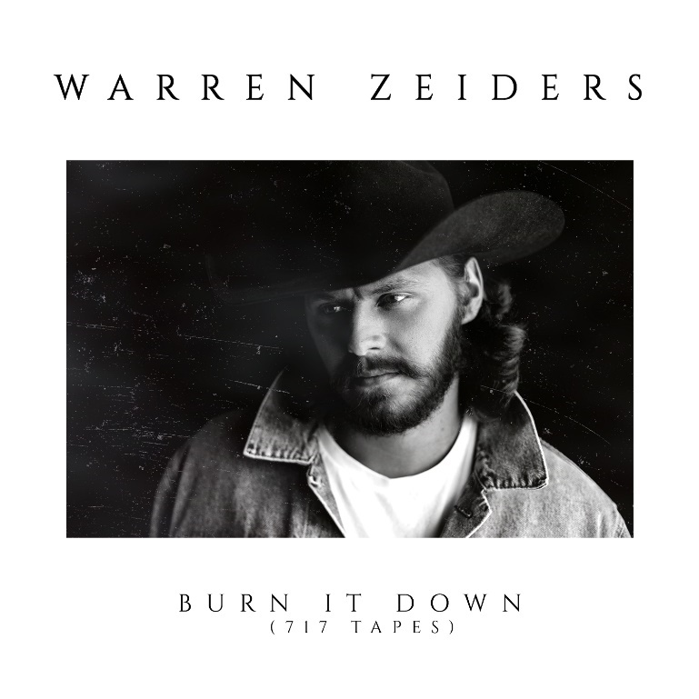
January 21, 2022 (Los Angeles, CA) – Rising country singer/songwriter Warren Zeiders returns to announce his smoldering new single “Burn It Down” available on all DSP’s now. The track comes hot on the heels of his 717 Tapes EP featuring the hit “Ride The Lightning,” which is on the brink of going Gold. The 22 year old Zeiders’ has been teasing the new track on TikTok and has already amassed over 1.8 million views in advance of today’s official release through 717 Tapes. Listen to “Burn It Down” HERE.

The fire-and-brimstone edge of “Burn It Down” does the song’s title justice. Zeiders’ powerful voice and raw guitar ignite as he makes a choice to quit running and raze it all to the ground. “I’d bet everything there’s a lot of folks like me, cutting off the puppet strings and breaking out the gasoline,” Zeiders howls. “But once you strike that match, there ain’t turning back.”

Armed with striking songwriting and a one-in-a-million voice, Zeiders has earned comparisons to artists like Tyler Childers and Jason Isbell for his original work. It’s no surprise he’s inspired a massive social media following, garnering over 200 million views on TikTok and over 33 million streams across platforms. Check out Zeiders’ debut 717 Tapes EP, featuring all original songs, right HERE. Stream the recently released full-band version of “Ride the Lightning” HERE, and click HERE to view and share the official video of the original version. And yet, all these stunning releases and purely organic successes show that, somehow, Warren Zeiders is here to stay.

ABOUT Warren Zeiders:
Warren Zeiders’ distinctive, high energy country music is powered by a steady supply of youthful grit, honesty, and muscle. Hailing from central Pennsylvania, the 22-year-old singer/songwriter delivers outlaw sermons in a gravelly voice beyond his years. His music is suited more to the vast wilderness of his home state than the bright lights of Nashville, injecting a healthy dose of Heartland ethos into the honky tonks of Music City. But it’s that space he lives in—between lonesome outsider and magnetic performer—that helps him relate to listeners from all walks of life through songs fueled by unshakeable soul-searching. His original solo acoustic version of “Ride The Lightning” became an instant hit with fans and racked up over 273 million views on TikTok alone. He has amassed over 137 million audio streams and 15.4 million video streams. To date, Zeiders has gone on to command nearly 300 million combined streams and views and has impacted Billboard’s Hot Country Songs charts as his audience continues to grow week by week due to the consistent influx of millions of new streams. More music to come from Warren Zeiders soon.

# # #

Contact Rick Gershon at Warner Records:
rick.gershon@warnerrecords.com

FOLLOW WARREN ZEIDERS:
Facebook | Instagram | Twitter | TikTok | YouTube | Spotify

