RISING COUNTRY STAR WARREN ZEIDERS SIGNS TO WARNER RECORDS
BREAKTHROUGH TRACK “RIDE THE LIGHTNING” GOES GOLD

ZEIDERS MAKES HIS NETWORK TV DEBUT ON THE KELLY CLARKSON SHOW TODAY

NEW SINGLE AND VIDEO “BURN IT DOWN” OUT NOW
LISTEN HERE / WATCH HERE

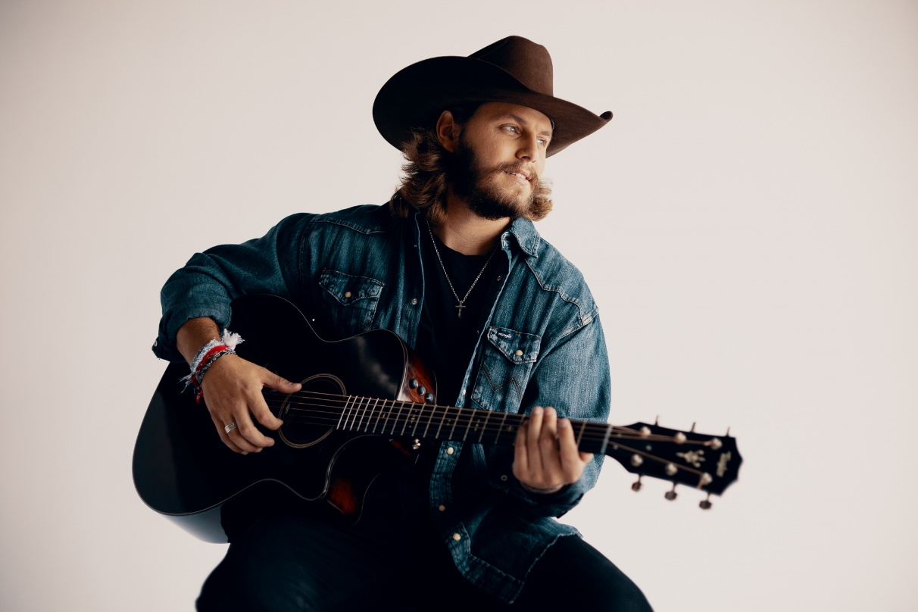
(Click here for Hi-Res image by Chris Phelps)

January 27, 2022 (Los Angeles, CA) – Rising country singer/songwriter Warren Zeiders has officially signed to Warner Records. The 22-year-old Hershey, Pennsylvania native has made an incredible impact on the country scene since he began posting covers and originals on social media and Spotify towards the end of 2020. His 2021 groundbreaking song, “Ride The Lightning,” resonated with fans around the world and has amassed over 72 million global streams to date and in excess of 500 million global TikTok views. As of today, the track has now sold in excess of 500,000 units marking his first Gold Record very early in his career. To celebrate, Zeiders will make his television network debut, performing the song on The Kelly Clarkson Show today. Tune into NBC stations at 2:00PM PT. Click HERE for local listings.

“Warren is a gifted songwriter and storyteller, has the confidence and drive to work harder than anyone, understands all the modern tools at an artist’s fingertips to market and promote themselves, and is just a great human being,” says Aaron Bay-Schuck, co-Chairman & CEO, Warner Records. “We just had the best time getting to know one another and both Tom (Corson) and I felt that Warner Records was a natural fit for Warren.”

Last week, Warren Zeiders released “Burn It Down” hot on the heels of his 717 Tapes EP. Click HERE to listen to “Burn It Down” and HERE to view and share the new official video.

The fire-and-brimstone edge of “Burn It Down” does the song’s title justice. Zeiders’ powerful voice and raw guitar ignite as he makes a choice to quit running and raze it all to the ground. “I’d bet everything there’s a lot of folks like me, cutting off the puppet strings and breaking out the gasoline,” Zeiders howls. “But once you strike that match, there ain’t turning back.”

Armed with striking songwriting and a one-in-a-million voice, Zeiders has earned comparisons to artists like Tyler Childers and Jason Isbell for his original work. It’s no surprise he’s inspired a massive social media following, garnering over 500 million views on TikTok alone. Check out Zeiders’ debut 717 Tapes EP, featuring all original songs, right HERE. Stream the recently released full-band version of “Ride the Lightning” HERE, and click HERE to view and share the official video of the original version. Much more to come from Warren Zeiders soon.

ABOUT Warren Zeiders:
Warren Zeiders’ distinctive, high energy country music is powered by a steady supply of youthful grit, honesty, and muscle. Hailing from central Pennsylvania, the 22-year-old singer/songwriter delivers outlaw sermons in a gravelly voice beyond his years. His music is suited more to the vast wilderness of his home state than the bright lights of Nashville, injecting a healthy dose of Heartland ethos into the honky tonks of Music City. But it’s that space he lives in—between lonesome outsider and magnetic performer—that helps him relate to listeners from all walks of life through songs fueled by unshakeable soul-searching. His original solo acoustic version of “Ride The Lightning” became an instant hit with fans and racked up over 500 million global views on TikTok alone and has just been certified Gold sales status in the US in late January 2022. The track has impacted the Billboard Hot Country Songs charts as his audience continues to grow week by week due to the consistent influx of millions of new streams. Warren Zeiders will tour extensively in 2022.

# # #

Contact: Rick Gershon at Warner Records:
rick.gershon@warnerrecords.com

FOLLOW WARREN ZEIDERS:
Facebook | Instagram | Twitter | TikTok | YouTube | Spotify

