RISING ALT-COUNTRY RENEGADE ZACH BRYAN ANNOUNCES FALL 2021 TOUR DATES

September 22, 2021 (Los Angeles, CA) – Fresh off his honorable discharge from the U.S. Navy, rising alt-country renegade Zach Bryan is hitting the road this fall on his eagerly-awaited Ain’t For Tamin’ Tour. Performing his three most beloved records DeAnn, Elisabeth, and Quiet Heavy Dreams on tour for the very first time, the trek kicks off in St. Louis, Missouri, on October 20, before winding down with two homecoming shows in Tulsa on November 18 and 19. In between, Zach will hit major music cities across the U.S., including Atlanta, Minneapolis, and Chicago. See full list of dates below. Tickets go on sale this Friday, September 24, at 10am CST at zachbryan.com.

The Oklahoma native made his Grand Ole Opry debut back in April, marking a pivotal career milestone in what is certain to be a monumental career. The news of the upcoming dates is sure to please the fans and critics who’ve come to love Zach’s plaintive acoustic strumming and rough-and-tumble storytelling on songs like his breakthrough hit “Heading South.” Now, as he gets ready to take off across the country, a line on that song feels prophetic — it was about a dreamer who defied everyone’s expectations until “the masses screamed the lyrics of a messed up kid,” something that’s sure to happen more and more.

Zach is quickly becoming a studio staple, but with his tour across stories venues throughout the U.S., he’s sure to reach even more fans soon. His story is one of perseverance, toughness, and determination, and he can’t wait to share it with his fans every night on the road.

Zach Bryan Tour Dates:
October 20 St Louis, MO The Pageant
October 22 Knoxville, TN The Shed at Smoky Mountain Harley Davidson
October 23 Atlanta, GA The Eastern
October 26 Raleigh, NC The Ritz
October 27 Pittsburgh, PA Roxian
October 29 Columbus, OH The Bluestone
October 30 Louisville KY Paristown Hall
November 1 Cincinnati, OH Bogart's
November 2 Bloomington, IN Bluebird Nightclub
November 4 Madison, WI The Sylvee
November 5 Des Moines, IA Val Air Ballroom
November 7 Sioux Falls, SD The District
November 8 Minneapolis, MN The Fillmore
November 10 Chicago, IL Park West
November 11 Grand Rapids, MI The Intersection
November 13 Detroit, MI The Majestic Theatre
November 15 Wichita, KS Cotillion Ballroom
November 16 Kansas City, MO Uptown Theater
November 18 Tulsa, OK Cain's Ballroom
November 19 Tulsa, OK Cain's Ballroom
November 27 Houston, TX 713 Music Hall

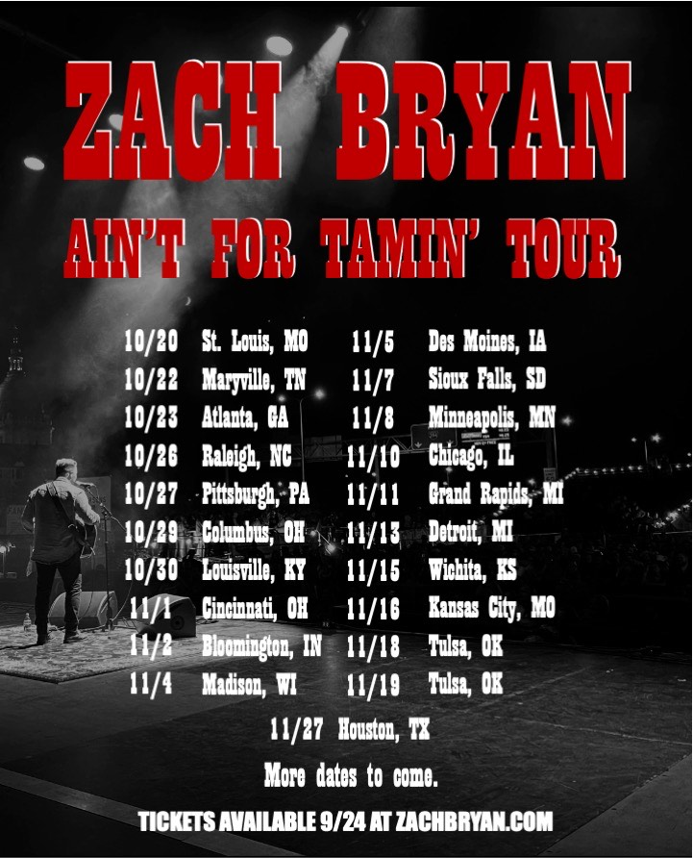

About Zach Bryan:
Zach Bryan is a singer/songwriter from Oologah, Oklahoma, proud of his small-town roots and whose music is fueled by a desire to stay true to himself. His success is found in his raspy voice, a mix of classic folk melody and outlaw country with a raw edge that cuts to the bone. His breakthrough moment makes all that clear as day. In the video for “Heading South,” shot by phone outside of his Navy barracks in humid 95 degree heat, Zach’s passion echoes off the strings of his trusted Guild. Drenched in sweat and belting words that he had written minutes earlier, the moment is authentic, brutal, and real. Millions of fans have now seen that video without any sort of industry assist, and millions more have connected to the tender, sincere songs found on both Zach’s 2019 debut album DeAnn —dedicated to his late mother—and his 2020 follow-up, Elisabeth, an ode to those he loves. Together, the two albums have racked up more than 430M streams and counting, while his social presence has steadily risen as he’s shared more homespun clips, virtual concerts, and personality. He most recently joined forces with six-time GRAMMY-winner Dave Cobb [Chris Stapleton, Sturgill Simpson, Jason Isbell] at Nashville’s legendary Studio A for the release of his two-track collection, Studio A Recordings (Live) and made his Grand Ole Opry debut this past spring. With no signs of stopping or slowing down, Zach’s working on more original music for release soon.

FOLLOW ZACH BRYAN:
Website | Instagram | TikTok | Twitter | YouTube

For more information, please contact:
Rick Gershon | Rick.Gershon@warnerrecords.com
Patrice Compere | Patrice.Compere@warnerrecords.com

