For Immediate Release

DEFTONES ANNOUNCE CO-HEADLINING U.S. TOUR WITH
RISE AGAINST THIS SUMMER

TICKETS ON SALE FRIDAY FEB 10 AT DEFTONES.COM

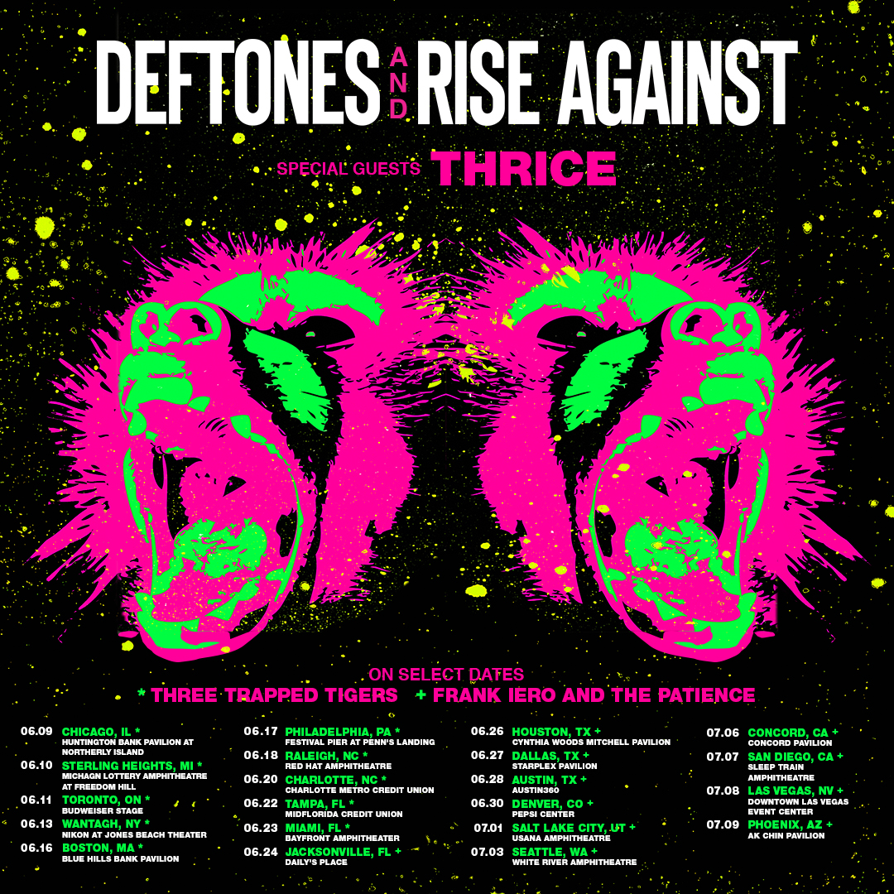

“Gore is easily Deftones’ most engaging record since White Pony, filled with carefully crafted hooks disguised as bridges and transition. As with all of their best music, it sounds like the brutal, beautiful result of the band being passionate enough to rip each other’s heads off.” – Pitchfork

“Deftones take this fascinating battle to the next level” – Newsday

“…heart-wrenching…bright thrash reprieves…Gore, marks experimental-rock gospel...” – Spin

February 6, 2017 (Burbank, CA) — Multiplatinum, Grammy Award-winning alternative-rock band Deftones have announced that they will hit the road for a month-long co-headlining tour this summer with Rise Against. The tour kicks off on June 9th in Chicago and travels across the U.S. before wrapping up in Phoenix on July 9th. Tickets go on sale to the general public this Friday February 10 at 10am (local time) at www.deftones.com.

“We’ve been talking to Rise about touring together for a while now. Finally, everything aligned and we get to spend the summer playing shows with our friends. We couldn¹t be more excited and can't wait to see you at the shows,” said Deftones.

Please see below for all upcoming tour dates.

Deftones are touring in support of their critically acclaimed eighth studio album, GORE, which debuted at No. 2 on the Billboard Top 200 Album chart upon its release in April.

Deftones have released eight studio albums to date and have sold over 10 million albums worldwide. The band is vocalist/guitarist Chino Moreno, guitarist Stephen Carpenter, keyboardist/samplist Frank Delgado, drummer Abe Cunningham, and bassist Sergio Vega.

Deftones upcoming tour dates are as follows:

06/09 Chicago, IL FirstMerit Bank Pavilion
06/10 Detroit, MI Michigan Lottery Theater at Freedom Hill
06/11 Toronto, ON Budweiser Stage
06/13 Wantagh, NY Nikon @ Jones Beach Theater
06/16 Boston, MA Blue Hills Bank Pavilion
06/17 Philadelphia, PA Festival Pier @ Penn’s Landing
06/18 Raleigh, NC Red Hat Amphitheatre
06/20 Charlotte, NC Charlotte Metro Credit Union Amphitheatre
06/22 Tampa, FL MidFlorida Credit Union Amphitheatre
06/23 Miami, FL Bayfront Park Amphitheatre
06/24 Jacksonville, FL Daily’s Place Amphitheatre
06/26 Houston, TX Cynthia Woods Mitchell Pavilion
06/27 Dallas, TX Starplex Pavilion
06/28 Austin, TX Austin360 Amphitheatre
06/30 Denver, CO Pepsi Center
07/01 Salt Lake City, UT USANA Amphitheatre
07/03 Seattle, WA White River Amphitheatre
07/06 Concord, CA Concord Pavilion
07/07 San Diego, CA Sleep Train Amphitheatre
07/08 Las Vegas, NV Downtown Las Vegas Event Center
07/09 Phoenix, AZ Ak-Chin Pavilion

###

For further information, please contact Warner Bros. Records Publicity
Jill Augusto: (818) 953-4368 / jill.augusto@wbr.com

