SAWEETIE INKS MAJOR LABEL DEAL WITH WARNER BROS. RECORDS

LEAD SINGLE & VIRAL SMASH “ICY GRL” OUT NOW

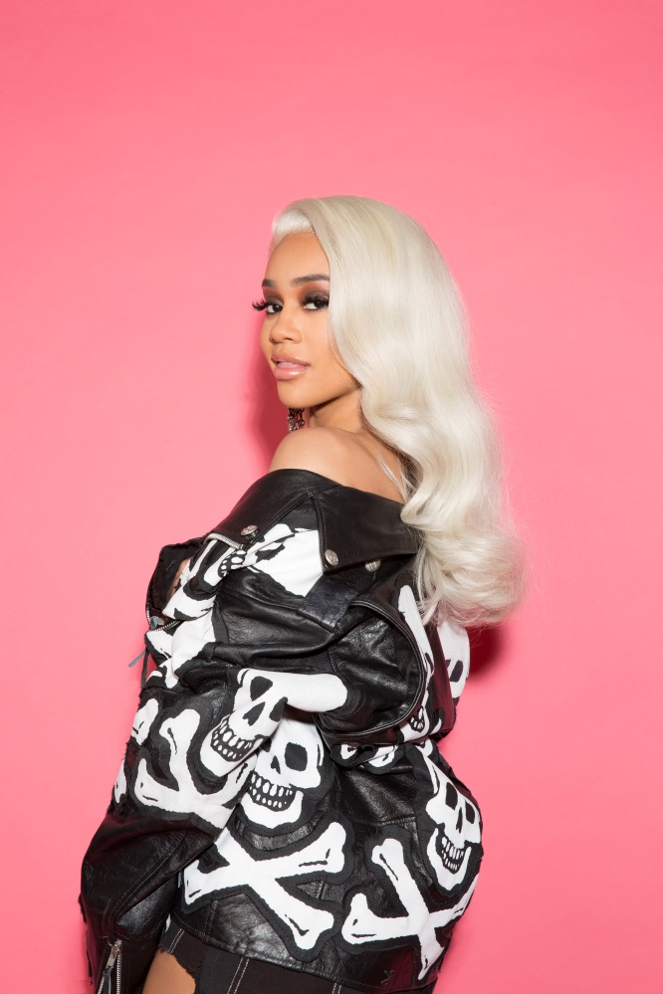

February 14, 2018 (Los Angeles, CA) – After arriving with a bang in late 2017, California rapper SAWEETIE officially announces her next big move. In true boss fashion, she’s signed to her own ICY label imprint in partnership with Artistry Records and Warner Bros. Records. The MC’s buzzing new single “ICY GRL” is available at all digital retailers now. Get it HERE.

“You know you have something special when an artist immediately connects in the way SAWEETIE has,” said Tom Corson, COO & Co-Chairman, Warner Bros. Records. “SAWEETIE’s empowering lyrics, street-smart sensibilities and flawless delivery have perfectly collided to make ‘ICY GRL’ a viral sensation and SAWEETIE an artist to champion. Huge thanks to our partner Max Gousse and Warner’s own Eesean Bolden for bringing SAWEETIE to us. We’re thrilled to help bring her unique talent to the masses.”

Kicking off 2018, she’s been drumming up headlines left and right and sending early shockwaves throughout the culture. Pigeon & Planes touted her amongst its “Best New Artists of the Month: January” and claimed, “She’s confident, a technically impressive rapper, and successfully explores new styles with each passing release.” Rihanna sought her out to star in a high-profile Fenty Beauty ad, which ran during the Super Bowl. Tidal named her its “Rising Artist of the Week” and wrote that “ICY GRL” “drips with the confidence of an MC who’s clocked in more time than the West Coast rhymer has seen” before adding, “her bars are made for self-made bosses from any era.”

Right now, SAWEETIE is putting the finishing touches on her anxiously awaited debut EP—set to arrive March 16.

Additionally, the fashion community as taken notice with early collaborations alongside Tory Burch, Sprayground, and more.

Get to know this boss now!

Flaunting nineties rhyme reverence, fashion-forward fire, and endless charisma, SAWEETIE—born Diamonté Harper—can go bar-for-bar with the best of ‘em. Drawing on a passion for poetry and numerous years of rapping in the car, she turned her love for words into vivid verses. Born in Santa Clara and raised in Sacramento, the California native attended USC. Initially, she deferred her rap dreams to achieve a degree in Communications before being discovered at a Downtown Los Angeles Puma event by industry vet Max Gousse [Beyoncé, YG, Ty Dolla $ign]. At Gousse’s studio, she recorded her 2017 knockout viral smash “ICY GRL.” Driven by a bulletproof flow and one clever line after another, it racked up 10 million YouTube views in under three weeks and over 5 million Spotify streams and soared to #1 on Musical.ly. She also earned the early endorsement of gatekeepers such as Vibe, XXL, HipHopDX, and MTV. Freshly signed to Warner Bros. Records, she’s about to flip rap upside down with her forthcoming debut EP featuring production courtesy of No ID, London On Da Track, Zaytoven, Da Internz, Cash Money AP, and JWhitedidit. As a new CAA signee, she’ll be touring nationally throughout 2018.

Hip-hop’s new leading lady is on the come-up. You’ve been warned.

