DAVID GUETTA UNVEILS NEW DANCEFLOOR ANTHEM “FAMILY AFFAIR (DANCE FOR ME)” – LISTEN HERE

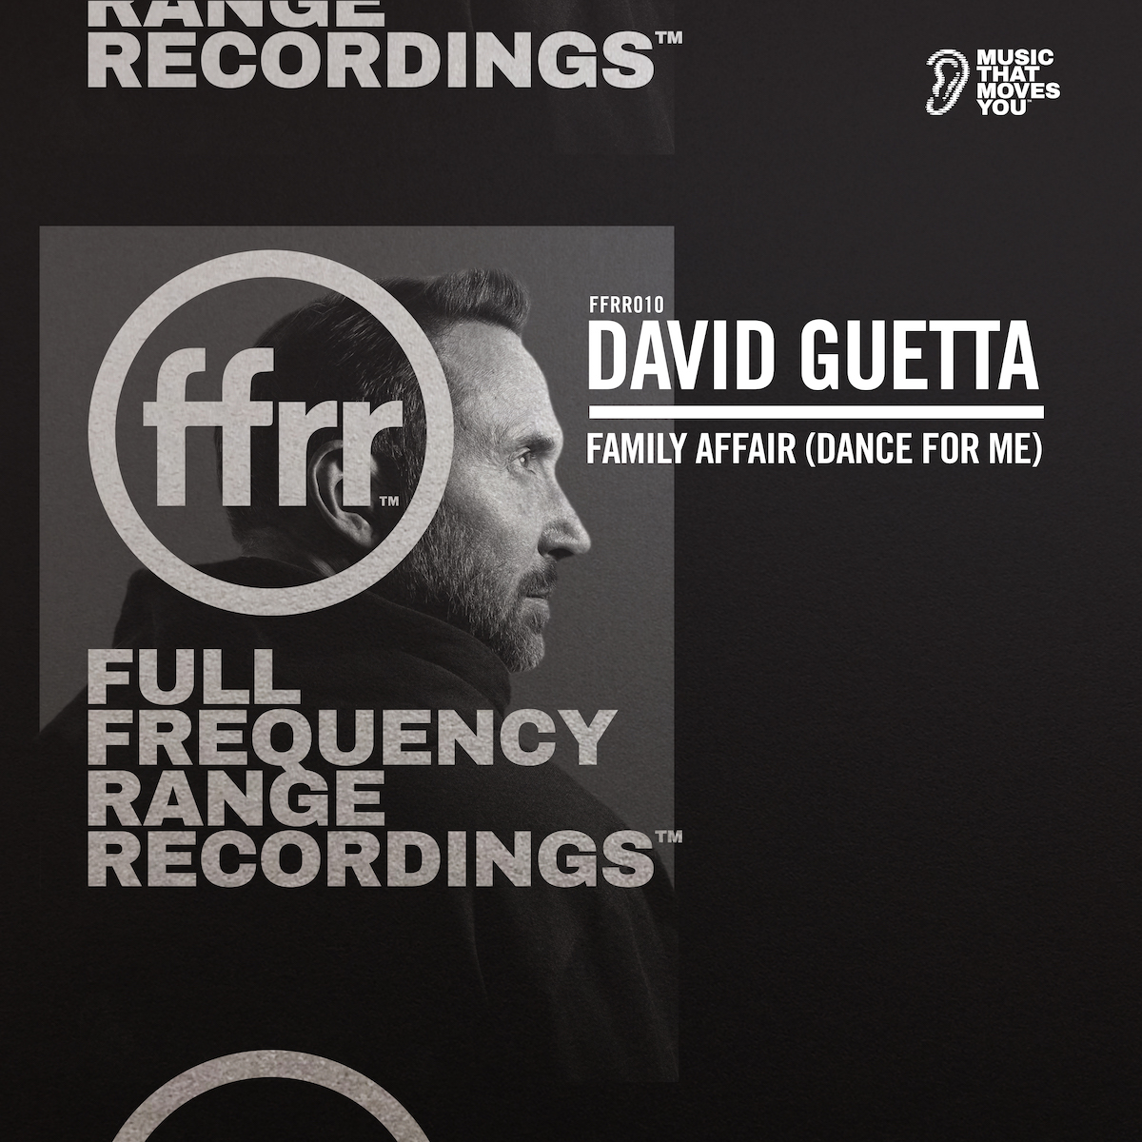

July 15, 2022 (Los Angeles, CA) – Today, musical visionary David Guetta returns with new single “Family Affair (Dance For Me).” Listen HERE via FFRR / Warner Music.

The new dance record features a throwback vocal, tying the track to Guetta’s early music roots and capturing the essence of Mary J Blige’s classic of the same name. “Family Affair (Dance For Me)” is destined to make an impact on nightclubs, dancefloors and festivals all over the world.

It follows the release of the “Crazy What Love Can Do” remix package, which featured innovative reworks from the likes of David Guetta & James Hype, Öwnboss and A7S. Both the remix and the original have amassed over 243 million global streams. The original also topped the radio charts worldwide, peaking at #1 at dance radio in the US and #5 at European radio.

Over the last year, Guetta has also dropped an impressive collection of smash hits in both the pop and dance worlds including “Bed” with Joel Corry and RAYE and a mammoth remix of Shouse’s "Love Tonight," and “Don’t You Worry” with Black Eyed Peas and Shakira. He also celebrated the decade anniversary of his album Nothing But The Beat and teamed up with MORTEN to unveil the Future Rave Remix of his global dance-floor anthem “Titanium” featuring Sia.

David Guetta remains a spearhead of the electronic dance community. In 2019, he started the new Future Rave sound movement in which DJs and fans alike call “the future of EDM.” He also continues to reserve his darkest and deepest tracks for his underground alias Jack Back which represents David’s roots in the club scene. For over 20 years, the DJ has managed to stay on top of the game and not slowing down anytime soon. It is safe to say that at this stage in his career, David knows exactly where to take it next.

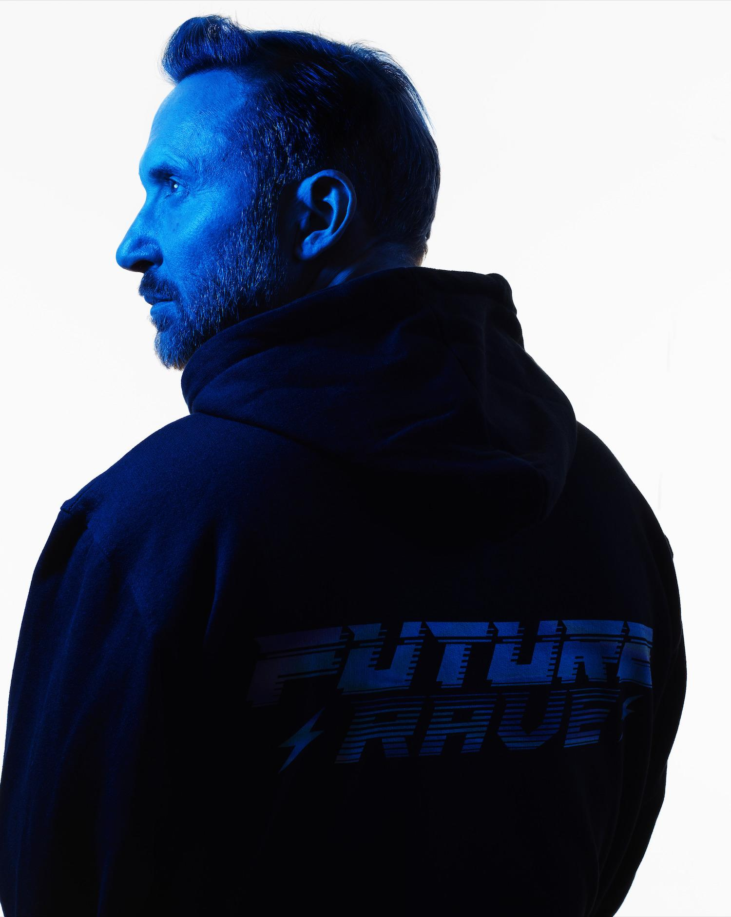
Photo credits: Rankin

Follow David Guetta:
Official | Twitter | Instagram | Facebook | TikTok | Press Materials

For all media inquiries, please contact:
Darren Baber / Warner Records
darren.baber@warnerrecords.com

