SAM GELLAITRY RELEASES NEW SINGLE “SEROTONIN”

VF VOL II MIXTAPE OUT SEPTEMBER 23 INCLUDES “PICTURE IN MY MIND” WITH PINKPANTHERESS -- PRE-SAVE HERE

LISTEN TO “SEROTONIN” HERE

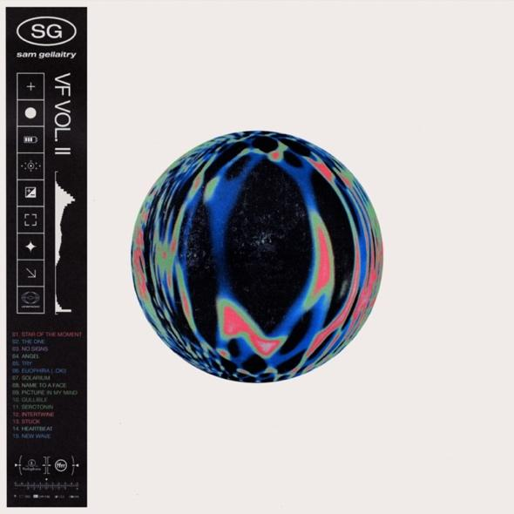

Friday, September 9 (Los Angeles, CA) -- Quickly establishing himself as one of the UK’s most in demand producers, and fresh from the release of his critically acclaimed single “Picture In My Mind” with PinkPantheress, Sam Gellaitry today announces his new single “SEROTONIN” set for release on 9th September via FFRR/Parlophone Records/Warner Records – listen HERE. The single is taken from his upcoming VF Vol II mixtape set for release on September 23 – pre-save HERE.

With hazy guitar riffs and a stripped back production, ‘SEROTONIN’ is an ode to love in the digital age – where texts replace the love letters of old. The track sees Sam pushing the boundaries of his sound, and is written from first-hand experience. “It’s the least like anything I’ve put out,” he says, “I had a lockdown relationship and I didn’t end up meeting the girl. It was all online.” He adds “’SEROTONIN’ is essentially a modern love song with an emphasis on how it feels to be engaging with that certain someone in the digital realm - with phones as our main communication point. I wanted it to be as stripped back as possible with no synthetic sounds to contrast the song’s digital context and to bring in a human touch. “

“SEROTONIN” gives another teaser of Sam’s hotly anticipated upcoming mixtape VF Vol II set for release on September 23. The EP includes his hit song “Picture In My Mind” with PinkPantheress. Sam has come a long way since he began uploading songs to SoundCloud from his bedroom in Stirling, aged just 18. His music is a journey through experience, circumstance and surroundings, told through his impressive, synaesthesia-informed knowledge of different musical tones. Impossible to pigeonhole and with an insatiable appetite for creativity, this talented star is well and truly on the ascent.

Follow Sam Gellaitry
Instagram | Twitter | Facebook | Soundcloud I TikTok

For More Information, Please Contact:

Darren Baber | Warner Records
Darren.Baber@warnerrecords.com

Connor Hunt | Warner Records
Connor.Hunt@warnerrecords.com

