COUNTRY STAR WARREN ZEIDERS LOOKING FOR
“ONE HELL OF AN ANGEL” ON NEW SINGLE/VIDEO OUT NOW

NEW TRACK FEATURED ON 717 TAPES: THE ALBUM, OUT SEPTEMBER 30
LISTEN HERE / WATCH HERE
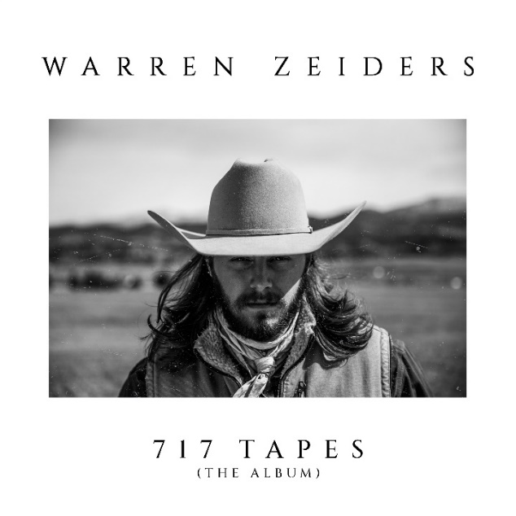
(Click HERE for Hi-res)

August 26, 2022 (Los Angeles, CA) – Today, country music’s fastest rising star Warren Zeiders shares his reflective new love song “One Hell of an Angel.” Listen HERE. The new track—which finds the Hershey, Pennsylvania native searching for redemption —is one of the exclusive, unreleased-until-now tunes from his upcoming full-length, 717 Tapes: The Album, due September 30 via 717 Tapes/Warner Records.

Over smoky acoustic guitars, Zeiders sings emotionally about how the one he loves has the power to change his life. “It’s gonna take a wild one with fire in her eyes to go and cut these ties that bind this soul to the highway to hell I’m heading down,” he sings. “I ain’t saying I can’t be saved, I’m saying it’s gonna take one hell of an angel.” Zeiders comments “I’m truly excited to be sharing my new song, One Hell Of An Angel, with y’all! I believe this song has captured something special and it has allowed me to share a new side of myself artistically and emotionally from a personal level. I believe that we all have an Angel sent to us one day. We may never know when or where it’ll happen. But God has a plan for each and everyone of our lives. In is his timing, our Angel will be sent.”

“One Hell of an Angel” is available now on all DSPs. Click HERE to stream and HERE to view & share the video.

717 Tapes: The Album collects all of Zeiders’ critically acclaimed 717 Tapes singles and EP tracks in a single package including his recently released “Up To No Good.” The album will be rounded out with a handful of as-yet-unheard tracks to boot. Owing to the breakout success of Zeiders’ releases over the past couple of years, the new full-length will nod to the songwriter’s stripped-down beginnings and look toward his future with Warner Records and a full band sound, propelling him to the next chapter of his career and cementing the 717 Tapes legacy.

The announcement comes shortly after Zeiders’ Grand Ole Opry debut, a rite of passage for country’s best and brightest. The legendary institution welcomed him into the fold this past July 9. Just a few weeks before the release of 717 Tapes: The Album, Zeiders will set out on his Up To No Good fall tour, armed with a full band of world-class players, and make his New York City debut on October 27 at Irving Plaza. Support will be provided by Ben Burgess, Megan Moroney, Amanda Kate Ferris, Matt Koziol, Reid Haughton. Click HERE for tickets & concert details.

The 23-year-old burst onto the country music scene in the last year or so, emerging as one of the genre’s fastest rising success stories in recent history. With his brooding tunes and a knowing voice, that belie his years, it’s no surprise that he’s inspired a massive social media following, garnering over 1 billion views on TikTok and over 459 million global streams across platforms.

Zeiders has earned a rep for sharing his searing, authentic songs directly with fans and has collected that work in the critically acclaimed 717 Tapes EPs—you can find volumes 1 and 2 HERE. You can also stream the thrilling full-band take of his RIAA Gold-certified single “Ride the Lightning” HERE and check out the official video HERE. 717 Tapes EP Vol. 2 also contains his most recent single and fan favorite “Wild Horse,” along with “Dark Night” and “Burn It Down.” As he prepares to release 717 Tapes: The Album, and shares new tracks like “One Hell of an Angel,” it’s clear he’s ready to lead his audience in bold new directions as he continues to grow as a songwriter.

“Warren Zeiders is a ‘Wild Horse’ who sings about "the truth.’" – People Magazine

“One-of-a-kind artistry” - Country Swag

717 Tapes: The Album tracklist
1. Ride the Lightning (717 Tapes)
2. Never Look Back (717 Tapes)
3. Boys for Life (717 Tapes)
4. Dirt Road Don’t (717 Tapes)
5. Loving and Hating You (717 Tapes)
6. Wild Horse (717 Tapes)
7. Dark Night (717 Tapes)
8. Southbound (717 Tapes)
9. Ain’t Been Found (717 Tapes)
10. Burn It Down (717 Tapes)
11. Wild Horse
12. Up To No Good
13. One Hell of an Angel
14. Heavy Pour
15. Highway Run

2022 717 Tapes Tour Dates:
Aug 26 Glasgow, KY Plaza Theatre – FREE SHOW

2022 Up To No Good Tour Dates:
# indicates New date
Sep 08 Houston, TX White Oak Music Hall
Sep 09 Fort Smith, AR Temple Live
Sep 10 Stillwater, OK Outside City Limits Festival
Sep 11 Dallas, TX Studio at the Factory
Sep 23 Louisville, KY Mercury Ballroom
Sep 24 Ashland, KY Foxfire Music & Arts Festival
# Oct 06 Albany, NY Empire Live
# Oct 07 Portland, ME AURA
Oct 13 Charlottesville, VA Jefferson Theater
Oct 14 Columbia, SC The Senate
Oct 15 Richmond Hill, GA Great OgeeChee Fest
Oct 20 Chattanooga, TN The Signal
Oct 21 Asheville, NC The Orange Peel
Oct 22 Charlotte, NC The Underground
Oct 26 Boston, MA Paradise Rock Club
Oct 27 New York, NY Irving Plaza
Oct 29 Philadelphia, PA TLA
# Nov 02 Oxford, OH Brick Street Bar
Nov 03 Detroit, MI St. Andrew’s Hall
Nov 04 Columbus, OH Newport Music Hall
Nov 05 Pittsburgh, PA Stage AE
Nov 11 Minneapolis, MN Varsity Theater
Nov 12 Madison, WI Majestic Theatre
Nov 13 Indianapolis, IN Deluxe at Old National Centre
Nov 16 Nashville, TN Brooklyn Bowl
Nov 17 Athens, GA Georgia Theatre
Nov 18 Birmingham, AL Iron City
Nov 19 Huntsville, AL Mars Music Hall

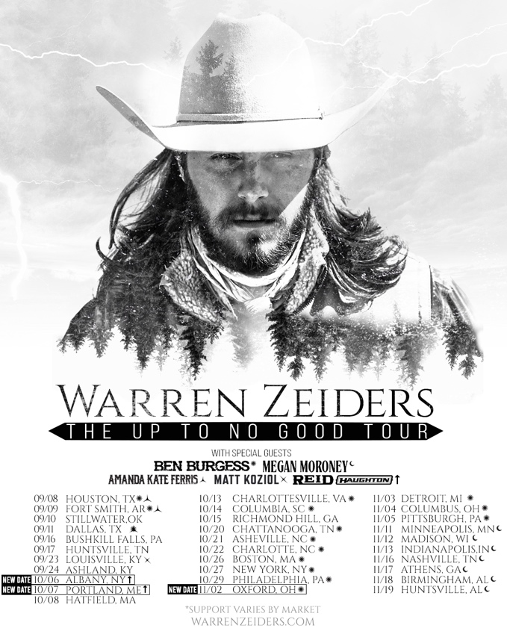

ABOUT Warren Zeiders:
Warren Zeiders’ distinctive, high energy country music is powered by a steady supply of youthful grit, honesty, and muscle. Hailing from Hershey, Pennsylvania, the 23-year-old singer/songwriter delivers outlaw sermons in a gravelly, world-weary voice that bely his young age. His music is suited more to the vast wilderness of his home state than the bright lights of Nashville, injecting a healthy dose of Heartland ethos into the honky tonks of Music City. But it’s that space he lives in—between lonesome outsider and magnetic performer—that helps him relate to listeners from all walks of life through songs fueled by unshakeable soul-searching. His original solo acoustic version of “Ride The Lightning” became an instant hit with fans and racked up over 1 billion global views on TikTok alone and been certified Gold sales status in the US in late January 2022. He has amassed over 459 million streams globally. The track has impacted the Billboard Hot Country Songs charts as his audience continues to grow by the million’s week by week. Warren Zeiders’ has just completed his first live tour – all 14 dates sold out within 72 hours, prompting the newly minted headliner to add more dates to his 717 Tapes Tour featuring a full band this summer. Zeiders’ latest fan favorite single/video, “Wild Horse,” beautifully illustrates his vision of chasing –and realizing-- his dreams in real time. 717 Tapes EP Vol. 2, is available now with a view to release his debut album in the months ahead.

# # #
Warner Records Contacts:
Rick Gershon | rick.gershon@warnerrecords.com
Regional/Tour: Jenny Huynh | jenny.huynh@warnerrecords.com

FOLLOW WARREN ZEIDERS:
Facebook | Instagram | Twitter | TikTok | YouTube | Spotify

