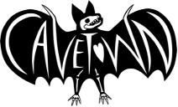
CAVETOWN ANNOUNCES worm food ALBUM
OUT NOVEMBER 4TH

NEW SINGLE AND VIDEO - “1994” - OUT NOW
WATCH HERE

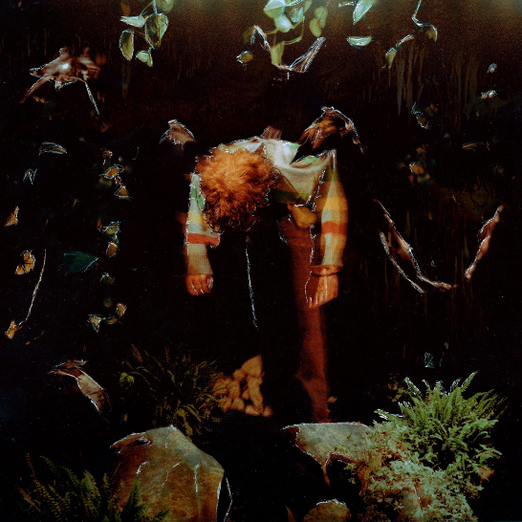
DOWNLOAD ARTWORK AND PRESS PHOTO HERE

Los Angeles, CA (Sept 9th, 2022) - Multi-RIAA Platinum and Gold certified singer/songwriter and producer Cavetown, also known as Robin Skinner, announces a highly anticipated new album worm food coming November 4th. The first single “1994” is out today along with a video co-directed by Skinner - available everywhere now via Sire Records. Earlier today, Cavetown announced more live shows to their touring schedule (all dates below).

CLICK HERE TO WATCH “1994”
CLICK HERE TO PRE-SAVE WORM FOOD

The first full length since 2020’s Sleepyhead, Cavetown delivers his most elaborately realized body of work to date on worm food, shaping his idiosyncratic storytelling into songs that ultimately give voice to our own most intimate emotions. As with all his output, Skinner produced the album on his own at his home studio, holing up in his garage and infusing his understated alt-pop with a powerful new vitality.

The announcement is a long time coming for fans of Cavetown, who have been patiently awaiting news of a new album for over two years. In that time, the popularity of Cavetown songs has continued to snowball, with an ardent community of fans proliferating around the world.

Graced with an exquisitely tender vocal performance from Skinner, “1994” once again reveals his rare ability to spin his unsparing introspection into impossibly catchy rhyme (from the first verse: “I’m tryna love the person I was when I was born/Hating on a kid doesn’t serve me anymore”).

He shares, “1994" is about dealing with perceived guilt and how it can become over-exaggerated in my head. I’m working on defining the line between what's really wrong in a situation versus what is made up in my head, because it’s the parts that aren’t real that I end up feeling quite guilty about.”

He continues, “The lyrics are a message to myself, to help me see that there’s still a child inside of me that is deserving of love and care. The line “say you’re coming around/ I need you lately everything’s been getting me down” is about feeling comforted by isolating myself, but learning to be comforted by the presence of someone else.”

“1994” marks Skinner’s second single from worm food following “Fall In Love With A Girl” with beabadoobee, which was featured in Billboard’s “The 25 Best Pride Songs of 2022 (So Far)” earlier this year.

Cavetown opened for Bleachers this summer at the Kia Forum in Los Angeles, CA, following a US Tour that wrapped up in May. With over 50,000 tickets sold, Skinner sold out venues across the country including the Hollywood Palladium in Los Angeles and Terminal 5 in New York City.

Download Press Photo HERE | Credit: Kane Layland

About Cavetown:
An innately DIY artist, Cavetown first discovered the depths of his imagination as a child, when he’d write and illustrate his own storybooks. After taking up guitar, he began writing and recording in his bedroom in his early teens, then releasing his lo-fi yet emotionally intricate songs on Bandcamp. Not long after the arrival of his 2018 album Lemon Boy, Cavetown inked a deal with Sire Records and started selling out venues across the U.S. and U.K. as well as performing at festivals like Reading & Leeds and Lollapalooza—all while forging such an intensely personal connection with his audience that he’s taken to keeping a cupboard full of letters received from fans. Now 23, the Cambridge-based artist, otherwise known as Robin Skinner, has emerged as one of the preeminent voices in the bedroom pop scene, with more than 2.5 billion global streams to date, including nearly 8 million monthly Spotify listeners and over 2 million YouTube subscribers. Along the way, Cavetown has co-written and produced for artists like Tessa Violet, chloe morindo, and mxmtoon. The follow-up to his 2021 EP Man’s Best Friend, worm food arrives as Cavetown’s latest full-length since his major-label debut Sleepyhead, a 2020 release that inspired NME to hail him as a “bedroom-pop hero building worldwide community.” His new single “1994” is available now.

FOLLOW CAVETOWN:
Press Assets | Website | Facebook | Twitter | Instagram | YouTube

Cavetown US Press Contacts:

The Oriel Co
Chloë Walsh
chloe@theoriel.co
Amy Fennie
amy@theoriel.co

Warner Records
Patrice Compere
patrice.compere@warnerrecords.com

