BREAKOUT POP ARTIST JAKE WESLEY ROGERS ANNOUNCES NORTH AMERICAN HEADLINING TOUR

BUY TICKETS HERE

NEW EP LOVE OUT NOW – STREAM HERE

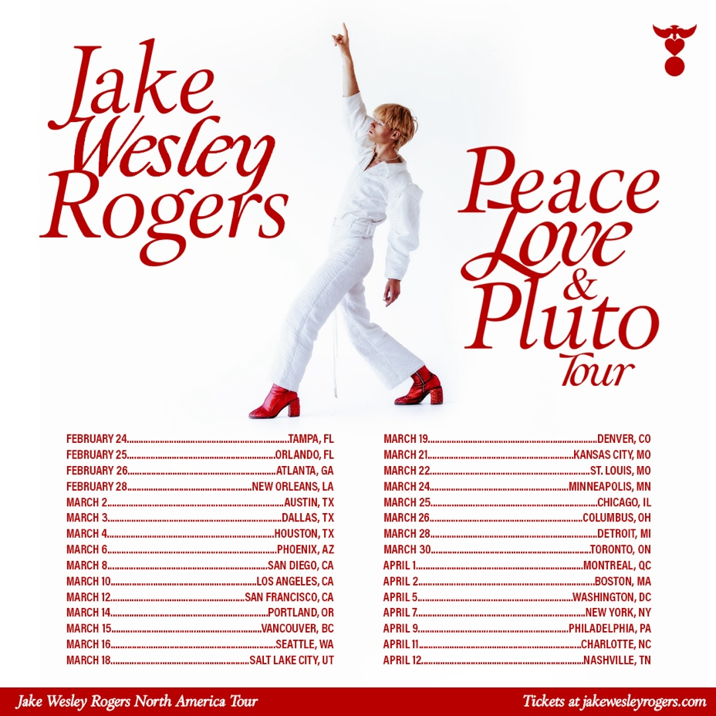

Hi-Res image HERE

October 26, 2022 (Los Angeles, CA) – Today, rising pop artist Jake Wesley Rogers announces Peace, Love & Pluto Tour, his first headlining tour of North America. The genre-blurring hitmaker kicks off the live trek co-produced by Live Nation and Emporium on Feb. 24, 2023 in Tampa FL at Crowbar, before criss-crossing the U.S. and Canada. Pre-sale tickets and VIP Packages are available on Oct. 26 at 12 p.m. EST, with General Admission to follow on Oct. 28 at 10 a.m. EST. Get your tickets HERE.

The announcement comes a week after the arrival of Rogers’ critically acclaimed LOVE EP. A collection of audacious and heartfelt pop anthems, the six-song set showcases his signature, bluesy bravado on hits like “Dark Bird” and “Lavender Forever” as well as two new tracks, “Call It Love” and “My Mistake.” To mark the occasion, a visual for the latter accompanied the EP release, offering fans a peek at the pop powerhouse’s creative process.

Rogers showcased his larger-than-life stage presence while opening for Panic! At The Disco during the North American leg of their Viva Las Vengeance Tour, which winds up in Chicago on Oct. 28. The buzzing artist previously made show-stealing appearances at Austin City Limits, Lollapalooza, BottleRock Napa Valley, and Elton John’s 30th annual Oscars viewing party where he shared the stage with six-time Grammy winner Brandi Carlile. In 2021, he sold out shows at famed venues like The Troubadour in Los Angeles and the Mercury Lounge in New York City.

Discovered by Justin Tranter in 2020, the singer-songwriter’s rise to stardom began last year when Apple Music’s Zane Lowe debuted “Middle of Love” and called Rogers “wildly talented.” That opinion was shared by a wide array of tastemakers including People, Billboard, Rolling Stone, American Songwriter, PAPER, and Vogue. He then made a whole new army of fans with the release of his 2021 ‘Pluto’ EP and unforgettable performances on Good Morning America, The Late Late Show With James Corden, Late Night With Seth Meyers, The Ellen DeGeneres Show and Legendary.

The 25-year-old will warm up for his hotly anticipated headlining tour by giving a very special performance in his hometown of Springfield, MO on Dec. 17, 2022. With his unique vision and indelible voice, Rogers will bring his wholly original brand of whimsical pop to fans across North America in 2023. Tickets HERE.

Jake Wesley Rogers Tour Dates:
February 24, 2023 Tampa, FL Crowbar*
February 25, 2023 Orlando, FL The Social*
February 26, 2023 Atlanta, GA The Masquerade (Hell)
February 28, 2023 New Orleans, LA Parish Room at House of Blues
March 2, 2023 Austin, TX Scoot Inn
March 3, 2023 Dallas, TX Cambridge Room at House of Blues
March 4, 2023 Houston, TX Peacock Room at House of Blues
March 6, 2023 Phoenix, AZ Valley Bar
March 8, 2023 San Diego, CA Voodoo Room at House of Blues
March 10, 2023 Los Angeles, CA The Belasco
March 12, 2023 San Francisco, CA Bimbo’s 365 Club*
March 14, 2023 Portland, OR McMenamins Mission Theater
March 15, 2023 Vancouver, BC The Biltmore Cabaret
March 16, 2023 Seattle, WA Neumos
March 18, 2023 Salt Lake City, UT Kilby Court
March 19, 2023 Denver, CO Meow Wolf*
March 21, 2023 Kansas City, MO Madrid Theatre
March 22, 2023 St. Louis, MO Old Rock House*
March 24, 2023 Minneapolis, MN Amsterdam Bar and Hall
March 25, 2023 Chicago, IL Lincoln Hall*
March 26, 2023 Columbus, OH A&R Music Bar*
March 28, 2023 Detroit, MI The Shelter
March 30, 2023 Toronto, ON The Opera House
April 1, 2023 Montreal, QC Bar Le Ritz*
April 2, 2023 Boston, MA Brighton Music Hall
April 5, 2023 Washington, D.C. Union Stage
April 7, 2023 New York, NY Irving Plaza
April 9, 2023 Philadelphia, PA The Foundry at The Fillmore
April 11, 2023 Charlotte, NC The Underground
April 12, 2023 Nashville, TN Brooklyn Bowl
*Not A Live Nation show

About Live Nation Entertainment
Live Nation Entertainment (NYSE: LYV) is the world’s leading live entertainment company comprised of global market leaders: Ticketmaster, Live Nation Concerts, and Live Nation Sponsorship. For additional information, visit www.livenationentertainment.com [livenationentertainment.com].
###

Follow Jake Wesley Rogers:
Official Site | TikTok | Instagram | Twitter | Facebook | YouTube | Press Materials

For further information, please contact:

Jake Wesley Rogers:
Darren Baber | Warner Records | 818-953-3751
Darren.Baber@warnerrecords.com

Live Nation Concerts:
Monique Sowinski
Moniquesowinski@livenation.com

