NEIL YOUNG ANNOUNCES 50TH ANNIVERSARY EDITION OF ICONIC
1972 ALBUM HARVEST SET FOR DECEMBER 2ND RELEASE
VIA REPRISE RECORDS

Set Includes Previously Unreleased Outtakes, 1971 BBC Performance, Harvest Time Documentary, Commemorative Book with Never-Before-Seen Photographs, and More

LISTEN HERE / WATCH HERE

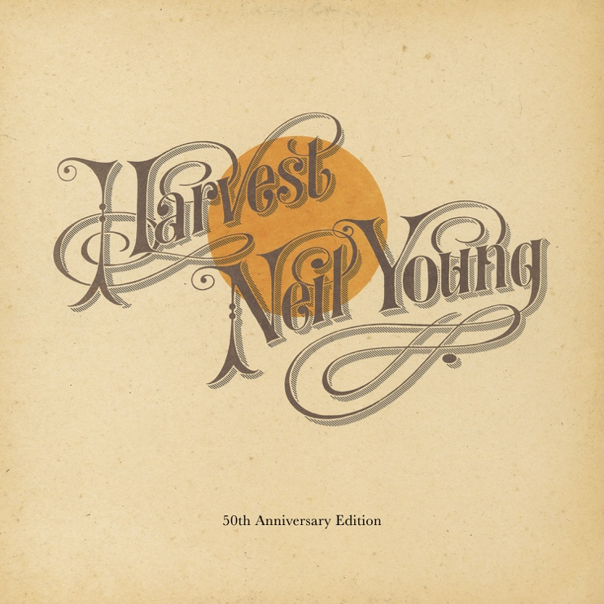

(Click HERE for Hi-res Image)

October 14, 2022 — (Los Angeles, CA) Today, NEIL YOUNG announces plans to release his 1972 album Harvest with a 50th Anniversary Edition. Young’s fourth solo album remains one of the most beloved in his catalog and is dense with songs that have long-permeated radio waves. The 50th Anniversary Edition Box Sets will be released December 2nd on Vinyl and CD, boasting the original album, three studio outtakes on CD/7” vinyl, an unreleased live 1971 BBC solo performance on CD, LP and DVD. The film Harvest Time is a previously unseen 2-hour documentary filmed in 1971, documenting the Harvest sessions. Also included in the package is a hardbound book and fold-out poster. The vinyl box sets include a lithograph print. Click HERE to pre-order/pre-save via The Greedy Hand Store at Neil Young Archives (NYA) and indie retailers. Pre-order today and receive and instant download of a previously unreleased live version of “Heart Of Gold,” from the 1971 BBC Concert followed by the unreleased Harvest outtake of “Journey Through The Past” on November 4th. Click HERE to stream “Heart Of Gold,” HERE to view and share the video.

Fans of the record will receive a new glimpse into Harvest through the two DVDs included in the box set. The first is Harvest Time, an unreleased two-hour film shot during the making of Harvest, with footage from Young’s ‘Harvest Barn’ sessions in Northern California, recording sessions in Nashville and London. The second is a film of the unreleased solo BBC Concert recorded on February 23, 1971. Also included are three outtakes tracks from the original Harvest sessions: “Bad Fog of Loneliness,” “Journey Through The Past,” and “Dance Dance Dance.” Additionally, the hardbound book will include never-before-seen photos along with extensive liner notes by photographer Joel Bernstein.

On December 2nd the Harvest 50th Anniversary Edition will also be available digitally at Neil Young Archives, most DSPs and at all music retailers. All Greedy Hand Store purchases of Harvest 50th Anniversary Edition come with free hi-res digital audio downloads from the Xstream Store © at NYA

Harvest 50th Anniversary track listing:

CD 1/LP 1 - Harvest
- Out On The Weekend
- Harvest
- A Man Needs A Maid
- Heart Of Gold
- Are You Ready For The Country?
- Old Man
- There’s A World
- Alabama
- The Needle And The Damage Done
- Words (Between The Lines Of Age)

CD 2/LP 2 - Neil Young Live In Concert at the BBC, February 1971
- Out On The Weekend
- Old Man
- Journey Through The Past
- Heart of Gold
- Don’t Let It Bring You Down
- A Man Needs A Maid
- Love in Mind
- Dance Dance Dance

CD 3/7” vinyl - Harvest outtakes
- Bad Fog Of Loneliness
- Journey Through The Past
- Dance Dance Dance

DVD 1:
Harvest Time (2-hour film)

DVD 2:
Neil Young Live In Concert at the BBC
# # #

For further information, contact Rick Gershon at Warner Records:
818-953-3473 / Rick.Gershon@warnerrecords.com

Official Site/NYA:
neilyoungarchives.com

Press Materials:
https://press.warnerrecords.com/neilyoung/

