BREAKOUT POP STAR BENSON BOONE DROPS HEARTFELT NEW BALLAD “BEFORE YOU”
LISTEN HERE

DECEMBER WEST COAST TOUR DATES SOLD OUT!

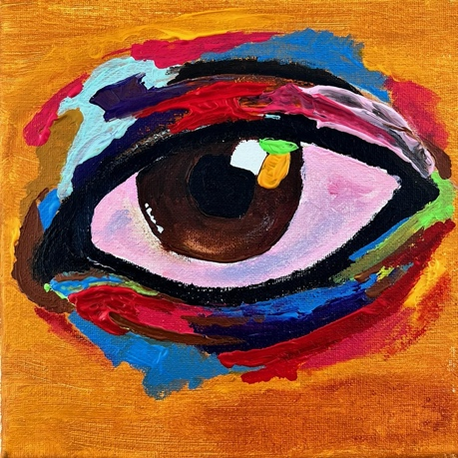

October 28, 2022 (Los Angeles, CA) – Today, rising pop artist Benson Boone releases the tender new ballad “Before You.” Listen HERE via Night Street Records/Warner Records.

With the singer’s powerful vocals soaring over solemn piano, the new single is about finding true love. No doubt, “Before You” will be one of the highlights of Boone’s live set when he heads out on a special sold-out west coast tour in December. Get your tickets HERE.

“Darling, if you don’t mind, I’ll take your hand tonight,” the 20-year-old sings over a delicate piano arrangement on the chorus. “We could just slow down time, let me adore you.” Boone then raises the romance factor even higher: “From the moment I looked in those dark brown eyes, I can’t remember life before you.” With its slow build and emotional delivery, “Before You” is a love song for the ages.

Of the powerful new track, Boone says, “I know I have gained a reputation for writing sad songs, but I'm hoping ‘Before You’ changes that.” After a string of break-up anthems, his latest is brimming with hope and optimism. “It’s about being in love with someone that you truly believe is everything to you. I hope this song can become as special to you as it is for me. Boone even painted the striking artwork himself.

The soaring ballad comes a matter of months after Boone released his Walk Me Home… EP, which was preceded by “In The Stars,” “ROOM FOR 2,” and “GHOST TOWN.” The pop star also recently performed “In The Stars” on The Late Late Show with James Corden and also delivered a dazzling rendition of the song and “GHOST TOWN” in Norway — the country where he notched his first-ever #1 hit — in front of 50,000 screaming fans. In the US, “GHOST TOWN” became Boone’s first entry on the Billboard Hot 100 and entered Top 25 at both Top 40 and Hot AC radio and has since been RIAA-certified Gold.

First discovered by Imagine Dragons frontman Dan Reynolds, Boone was quickly signed to Reynolds’ Night Street Records in partnership with Warner Records. The young singer has garnered nearly over 725 million global streams to date, as well as praise from Billboard, who lauded his “restrained vocals” and Consequence, who dubbed the newcomer “an exciting new voice.” Now, with “Before You,” Boone confirms his status as one of pop music’s most undeniable talents.

Upcoming Benson Boone West Coast Tour Dates:
Dec 1, 2022 – Salt Lake City, UT
Dec 2, 2022 – Provo, UT
Dec 3, 2022 – Provo, UT
Dec 5, 2022 – Seattle, WA
Dec 8, 2022 – Phoenix, AZ
Dec 9, 2022 – Santa Ana, CA

###

FOLLOW BENSON BOONE:
TikTok | Instagram | Twitter | Facebook | YouTube

For more information, please contact:
Darren Baber | Warner Records
Darren.Baber@warnerrecords.com

