JOSHUA BASSETT RELEASES INTIMATE NEW EP SAD SONGS IN A HOTEL ROOM – LISTEN HERE

WATCH SOUL-BARING VIDEO FOR “LIFELINE” HERE

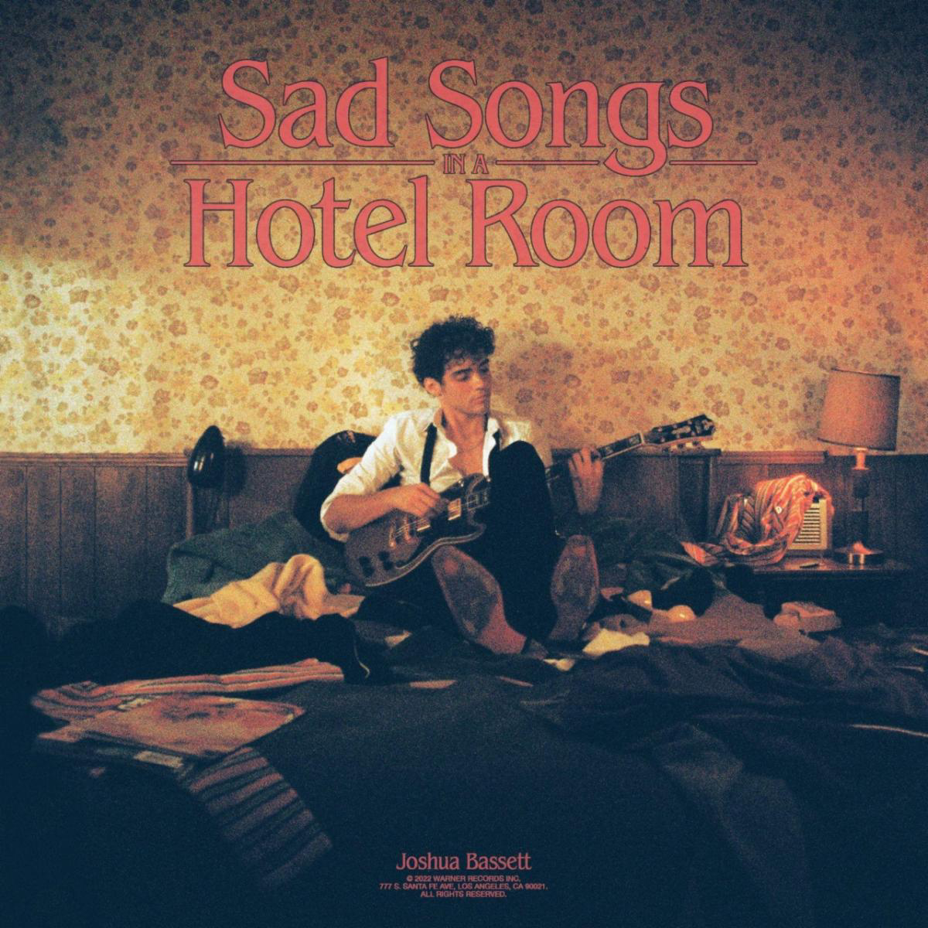

September 23, 2022 (Los Angeles, CA) – Today, singer, songwriter, and actor Joshua Bassett showcases the full scope of his artistry on the deeply personal Sad Songs In A Hotel Room EP. Listen HERE via Warner Records. The 6-song set includes recent single “Smoke Slow” as well as staggering new material like “Lifeline,” which is accompanied by an intimate video, which finds Bassett delivering the poignant lyrics straight to camera. Watch it HERE.

“Sad Songs In A Hotel Room comes from a transient period of my life, when I was constantly moving from hotel to Airbnb to a friend’s place, while also juggling some intense personal growth and change,” Bassett says of the project. “Each song on this EP tells a different part of the story from that time. In some ways, these songs feel like a bridge from one chapter of my life to the next, and I felt an urgency to put them out as I finish my debut album.”

The EP continues Bassett’s blockbuster 2022. He released the deeply emotional tracks “Doppelgänger” earlier this year and “Smoke Slow” last month, and delivered a knockout performance of the latter on Today. Earlier this year, Bassett also made his feature film debut in Disney+’s Better Nate Than Ever. His hit Disney+ original series High School Musical: The Musical: The Series just finished its third season and is currently in production for season four. He took home the 2022 Kids’ Choice Award for Favorite Kids Male TV Star for his role as Ricky, and was named on Variety’s 2022 Power Of Young Hollywood Impact List.

Bassett recently sold out two nights at New York’s iconic Bowery Ballroom and is set to headline two nights at The Troubadour in Los Angeles on October 16th and 17th. The new EP follows his 2021 critically acclaimed three song set “Crisis/ Secret/ Set Me Free.” Those songs, along with gems like “Feel Something” and his self-titled 2020 debut EP, have brought Bassett’s total global streams to over 350 million.

With Sad Songs In A Hotel Room, Bassett continues to bare his soul, inviting listeners into a world filled with bittersweet memories and big, bold dreams for the future.

###

FOLLOW JOSHUA BASSETT:
TikTok | Instagram | Twitter | Facebook | YouTube | Press Materials

For more information, please contact:
Darren Baber | Warner Records
Darren.Baber@warnerrecords.com

