RISING POP STAR NESSA BARRETT RELEASES STUNNING DEBUT ALBUM YOUNG FOREVER - LISTEN HERE

WATCH THE SELF DIRECTED AND EDITED VISUAL
FOR “DEAR GOD” HERE

PLAYING LIVE AT WHEN WE WERE YOUNG OCT 22, 23 & 29 AND HEADLINING SOLD OUT EL REY IN LOS ANGELES ON OCT 25

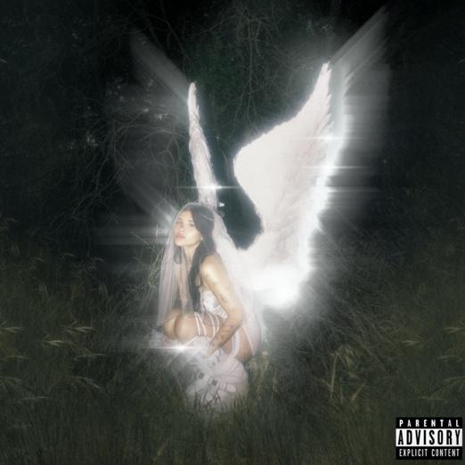

October 14th, 2022 (Los Angeles, CA) – Today, pop phenomenon Nessa Barrett releases her remarkable debut album young forever. Listen HERE via Warner Records. The raw and empowering project showcases the newcomer’s knack for crafting emotionally bruising pop anthems laced with hard truths. To celebrate the release, Barrett shares a self-directed and edited visual for album highlight “dear god.” Watch it HERE.

With young forever, the 20-year-old turns the mirror upon herself, dissecting the music scene, L.A. and the fame game as well as her own struggles as she comes of age. On album opener “tired of california,” which dropped last week, for example, Nessa playfully mocks the City of Angels, where everything is a little too perfect. Watch the mysterious video HERE.

She then broadens her scope on “dear god” and “lovebomb,” examining her intimate relationships. Other stand-out tracks on the album include “gaslight,” “too hot to cry” and “fuckmarrykill.” Nessa partnered on young forever with frequent collaborator Evan Blair, who also executive produced Barrett’s 2020 debut EP pretty poison.

About young forever, Nessa explains, "Each and every song on this album is so personal to me. Music is how I cope and writing this album was my therapy. I’ve questioned why I had to go through so much pain in life and always felt like it was a curse. But now I’ve realized it was so I could make songs like these to help others go through theirs."

Fans will have a chance to meet Nessa during release week at special in-store signings In New York on Oct 16th and 17th and in Long Beach, CA on Oct. 19th. A limited amount of signed CDs can also be purchased at Nessa’s merch store HERE.

In addition Nessa will play songs from young forever live for the first time when she hits the stage at the When We Were Young Festival in Las Vegas on October 22, 23, and 29. She will also headline the famed El Rey theater in Los Angeles on October 25 for a special one off sold out album release show YOUNG FOREVER LIVE!.

After being named as one of Billboard’s “21 Under 21” — as well being among Ones to Watch’s list of “25 Artists to Watch in 2022”, on Uproxx’s “Next Hitmakers List” and People Magazine’s Emerging Artist List — Nessa has gone on to accumulate close to one billion streams. She was also nominated for Push Performance of the Year at the 2022 MTV Video Music Awards. As her star rises, the singer-songwriter is determined to use her fame for good.

From February 2021’s Gold-certified smash “la di die” featuring jxdn and Travis Barker on drums to February’s “dying on the inside,” released to raise awareness about eating disorders, Nessa has only become more dedicated to using her platform as a source of healing. With young forever, she confirms that she has the courage and the talent to share her message with the masses.

In-Store CD Signing Dates

10/16 – New York City, NY (Rough Trade Signing)
10/17 – Long Island, NY (Looney Tunes Signing)
10/19 – Long Beach, CA (Fingerprints Signing)

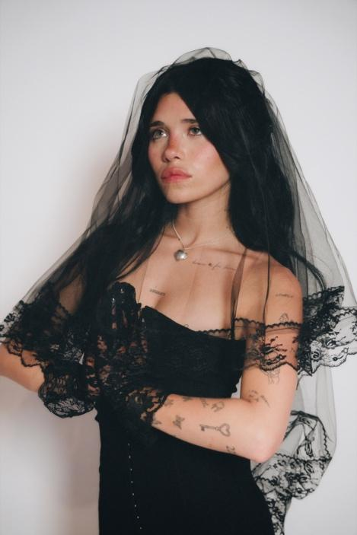
photo credit: Beth Saravo

Follow Nessa Barrett:
Official | TikTok | Instagram | Twitter | Facebook | YouTube | Press Materials | Store

Nessa Barrett contact:
Darren Baber | Warner Records
Darren.Baber@warnerrecords.com

