BREAKOUT POP STAR NESSA BARRETT ANNOUNCES YOUNG FOREVER TOUR

BUY TICKETS HERE

STREAM YOUNG FOREVER (EXTENDED) HERE

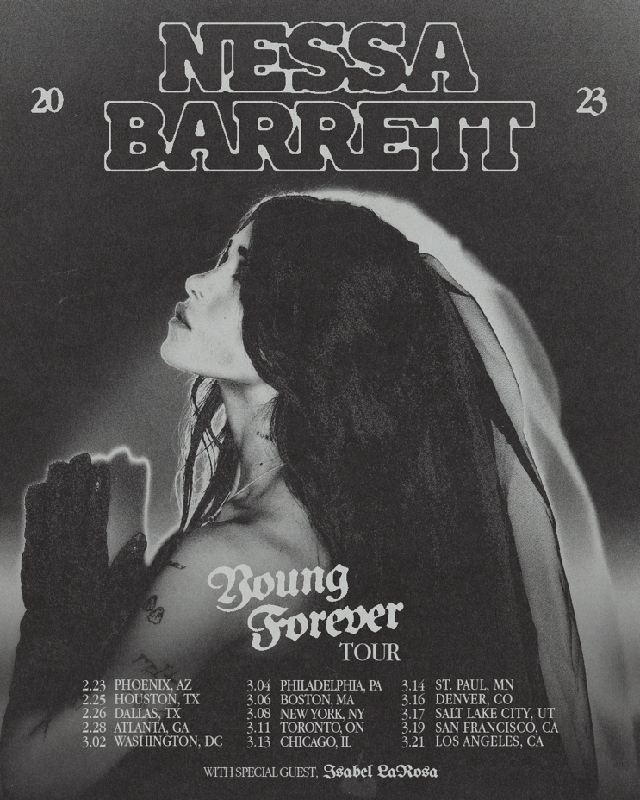

December 13, 2022 (Los Angeles, CA) – Today, rising pop artist Nessa Barrett announces the young forever tour, her first-ever headlining tour of North America in support of her similarly titled debut album. The 15-date trek kicks off in Phoenix, AZ on February 23, followed by stops in Atlanta, Nashville, Boston, New York, and Chicago. The tour draws to a close in Los Angeles, CA on March 21 at the historic Fonda Theater. General on-sale will take place on December 16th at 12pm local time. Buy tickets HERE and see all the dates below.

The announcement comes on the heels of the 20-year-old releasing the extended edition of young forever. Listen HERE via Warner Records. It boasts five new tracks including a striking cover of Arctic Monkeys’ newly viral “505,” which trades in the group’s understated swagger for an ethereal rendition dripping in sex appeal. The other four tracks, all originals, range from the darkly upbeat “deathmatch” to the gorgeously haunting “god’s favorite.”

After being named as one of Billboard’s “21 Under 21” — as well as being featured on Ones to Watch’s list of “25 Artists to Watch in 2022”, Uproxx’s “Next Hitmakers List” and People Magazine’s Emerging Artist List — Barrett has gone on to accumulate more than one billion streams. She was also nominated for Push Performance of the Year at the 2022 MTV VMAs. As her star rises, the singer-songwriter is determined to use her fame for good.

With songs like February’s “dying on the inside,” released to raise awareness about eating disorders, Barrett is dedicated to using her platform as a source of healing. In recent months, the singer-songwriter has played prestigious shows in preparation for her tour, including When We Were Young festival and a one-off performance at LA’s El Rey Theatre. Barrett is now ready to take the show on the road and make new fans at each and every stop along the way.

Nessa Barrett’s 2023 young forever Tour:

Feb 23 – Phoenix, AZ @ Crescent Ballroom
Feb 25 – Houston, TX @ RISE Rooftop
Feb 26 – Dallas, TX @ HOB – Cambridge Room/Echo Lounge & Music Hall
Feb 28 – Atlanta, GA @ Terminal West
Mar 1 – Nashville, TN @ Brooklyn Bowl
Mar 3 – Washington, DC @ The Howard
Mar 4 – Philadelphia, PA @ Theatre of The Living Arts
Mar 6 – Boston, MA @ Paradise
Mar 8 – New York, NY @ Irving Plaza
Mar 11 – Toronto, ON @ Axis
Mar 13 – Chicago, IL @ Lincoln Hall
Mar 14 – Minneapolis, MN @ Fine Line
Mar 16 – Denver, CO @ Bluebird Theater
Mar 17 – Salt Lake City, UT @ Grand at The Complex
Mar 19 – San Francisco, CA @ August Hall
Mar 21 – Los Angeles, CA @ The Fonda Theatre

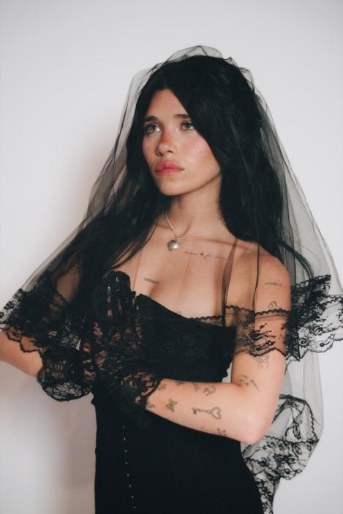
Photo credit: Beth Saravo

Follow Nessa Barrett:
Official | TikTok | Instagram | Twitter | Facebook | YouTube | Press Materials | Store

Nessa Barrett contact:
Darren Baber | Warner Records
Darren.Baber@warnerrecords.com

