THE FLAMING LIPS YOSHIMI BATTLES THE PINK ROBOTS 20TH-ANNIVERSARY CD BOX SET IS AVAILABLE NOW
THE COLLECTION FEATURES 2002 ALBUM ALONG WITH EPs, B-SIDES, DEMOS, RADIO SESSIONS, LIVE RECORDINGS & MORE WITH OVER 50 TRACKS NEVER RELEASED IN CD BOX SET
STREAM THE FLAMING LIPS SPACE BUBBLE FILM ON THE CRITERION CHANNEL NOW
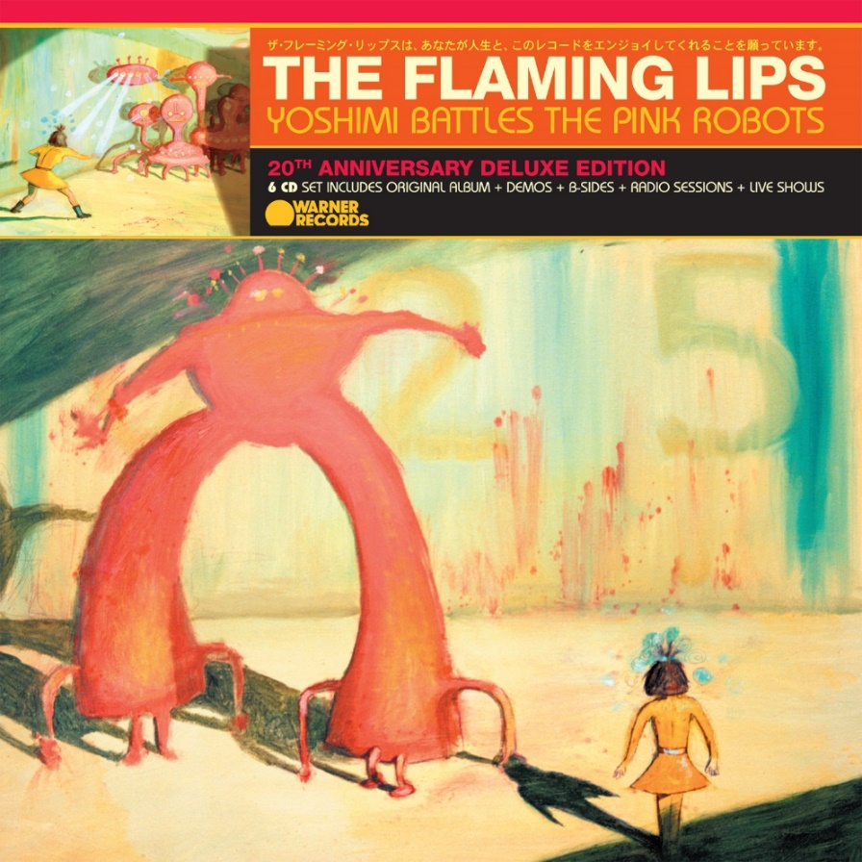
(Download Hi-Res artwork HERE)

November 25, 2022 — (Los Angeles, CA): Today, The Flaming Lips celebrate the 20th-anniversary of their classic 2002 album, Yoshimi Battles the Pink Robots, with the release of an expansive box set that also includes B-sides, demos, remixes, radio sessions, two concerts, and other assorted rarities from the era. The CD set includes over 50 tracks never released and dozens of rare tracks. The LP box set has 40 tracks never released on vinyl and over 30 previously unreleased tracks. Yoshimi Battles the Pink Robots: 20th Anniversary Edition will be available, via Warner Records, on all streaming services and as a 6 CD box set (featuring 100 tracks) on November 25 to mark the 20th anniversary year.

A 5 LP package (featuring 56 tracks) will land on April 14, 2023– released later than the CD box set due to the long vinyl production timeline. Additionally, there will be a limited edition D2C exclusive edition of the 20th Anniversary Deluxe 5 LP Vinyl box set pressed on Baby Pink vinyl – also released on April 14. Over the course of 2023, all the material released in the 6 CD box set will also make their way to vinyl. The two live albums included in the set, and the 25-minute demo “Psychedelic Hypnotist Daydream” will be available as separate vinyl releases. Additionally, the Ego Tripping at the Gates of Hell and Fight Test EPs will be released on vinyl for the first time in Spring 2023.

Order the 6 CD and 5 LP box sets of Yoshimi Battles the Pink Robots: 20th Anniversary Edition HERE, and order new Yoshimi T-shirts designed for the 20th Anniversary HERE.

In other LIPS news, THE FLAMING LIPS SPACE BUBBLE FILM is featured exclusively on The Criterion Channel now. This concert documentary, directed by Wayne Coyne and Blake Studdard chronicles the logistical challenges of putting on a show at the height of the pandemic filmed in the band’s hometown of Oklahoma City in 2020. The Space Bubble Concerts would feature both band and audience encased in individual transparent, prophylactic Space Bubbles to insure a Covid-safe live LIPS experience connecting in a in a joyous, safe and socially distanced communal way never tried before.

As previously announced, The Flaming Lips have announced shows in London and Washington, DC that will feature the album performed in its entirety. A show in Chicago has just been confirmed. Click HERE for information.

*Indicates newly added date
April 28 London, UK Eventim Apollo
*May 05 Chicago, IL The Salt Shed
May 25 Washington, DC The Anthem

Released in July 2002, Yoshimi Battles the Pink Robots remains the commercial high-water mark in The Flaming Lips ‘wild four-decade journey, giving the GRAMMY® award-winners their first RIAA certified Gold Record. As the eagerly awaited follow-up to 1999’s masterwork, The Soft Bulletin, Yoshimi proved that singer/guitarist Wayne Coyne, and multi-instrumentalist Steven Drozd had yet another masterpiece in them.

Yoshimi Battles the Pink Robots is a sci-fi-themed quasi-concept album that cast The Flaming Lips’ most playful and profound songs to date in a wondrous swirl of ambient electronics, digital beats, and psychedelic splendor. The record yielded the band’s top-streamed track, “Do You Realize??” (a timeless stargazing anthem that, in 2009, was named the Official Rock Song of the band’s native Oklahoma) and also landed the Lips their first-ever Grammy Award® win for the cosmic album-closing instrumental “Approaching Pavonis Mons by Balloon (Utopia Planitia).” Click HERE to view and share “Wayne listening to the multi-tracks for “Do You Realize??”

The 20th Anniversary Deluxe Edition provides a complete 360-degree view of the band’s creativity during this period. Several unheard demos show a rare peak at the band’s creative process. The box set also collects B-sides and outtakes, from epic fan favorites like “Assassination of the Sun” to fun, folky serenades like “Thank You Jack White (For the Fiber-Optic Jesus You Gave Me).” There is also a treasure trove of radio sessions including idiosyncratic overhauls of Pink Floyd’s “Lucifer Sam” and “Breathe,” Radiohead’s “Knives Out,” and Kylie Minogue’s “Can’t Get You Out of My Head.” In addition, the set includes a lush instrumental version of “Do You Realize??,” that has been requested by fans to play at both weddings and funerals.

Of special note are the two concert discs, which showcase the two sides of The Flaming Lips’ ever-enlarging brain: the endearing, intimate storytellers (captured in a banter-heavy 2002 private show for a small crowd of radio-contest winners in Boston) and the masters of thundering, confetti-strewn stage spectacle (as heard in an electrifying 2003 performance at The Forum in London). As a whole Yoshimi Battles the Pink Robots: 20th Anniversary Deluxe Edition is an essential portrait of rock’s most restlessly creative band at the peak of their powers.

Yoshimi Battles the Pink Robots: 20th Anniversary Deluxe Edition track list:
6 CD Box Set

CD 1: Original Album, plus demos
- Fight Test
- One More Robot/Sympathy 3000-21
- Yoshimi Battles The Pink Robots Part 1
- Yoshimi Battles The Pink Robots Part 2
- In The Morning Of The Magicians
- Ego Tripping At The Gates of Hell
- Are You A Hypnotist
- It's Summertime
- Do You Realize??
- All We Have Is Now
- Approaching Pavonis Mons By Balloon
- All My Life - Morning Of The Magicians (Demo)
- Ego Tripping Part 2 or 3 (Demo)
- Yoshimi Battles The Pink Robots (Demo)
- Hypnotist: Early Version (Demo)
- Epic Systems Delirium (Demo)
- In The Morning Of The Magicians (Demo)
- Do You Realize?? (1st Chords Wayne) (Demo)
- Do You Realize?? (Steven New Part) (Demo)

CD 2 - Fight Test and Ego Tripping at the Gates of Hell EPs

Fight Test EP:
- Fight Test
- Can't Get You Out Of My Head (Live on KEXP)
- The Golden Age (Live on CD 101)
- Knives Out (Live on KCRW)
- Do You Realize?? (Scott Hardkiss Remix)
- The Strange Design of Conscience
- Thank You Jack White (For The Fiber-Optic Jesus That You Gave Me)

Ego Tripping at the Gates of Hell EP:
- Assassination Of The Sun
- I'm a Fly in a Sunbeam (Following the Funeral Procession of a Stranger)
- Sunship Balloons
- Do You Realize?? (T.P.S. Remix)
- Ego Tripping (Ego in Acceleration) (Jason Bentley Remix)
- Ego Tripping (Self Admiration with Blow-up Mix)
- A Change at Christmas (Say It Isn’t So)
- Ego Tripping at The Gates of Hell (Utah Saints Remix)

CD 3 - Non-LP+
- Yoshimi Battles The Pink Robots (Japanese Language Version From The Japanese Edition of Yoshimi Battles The Pink Robots)
- SpongeBob & Patrick Confront The Psychic Wall Of Energy (From The Spongebob SquarePants Movie)
- Seven Nation Army (from LateNightTales: The Flaming Lips)
- Go (Sparklehorse with The Flaming Lips) (Alternate Version From The Flaming Lips Archives)
- Do You Realize?? (Live on CD 101)
- Yoshimi Battles The Pink Robots (AOL Session)
- Waitin' For A Superman (Live on WXPN)
- In The Morning Of The Magicians (Live on KCRW)
- White Christmas (Live on WXPN)
- The Golden Path (The Chemical Brothers, feat. The Flaming Lips)
- If I Go Mad/Funeral In My Head (B-Side of Do You Realize?? UK CD 1)
- Syrtis Major (B-Side of Do You Realize?? UK CD 1)
- Up Above The Daily Hum (B-Side of Do You Realize?? UK CD 2)
- Xanthe Terra (B-Side of Do You Realize?? UK CD 2)
- The Deterioration Of The Fight Or Flight Response (B-Side of Fight Test UK CD 1)
- Fight Test (Live on WXRT, May 2nd, 2003)
- Duck Dodgers Theme (Duck Dodgers Demo: With Wayne Scratch Vocal)
- I Know I’ve Got To Make That Dream The Real Thing (demo)
- Do You Realize?? (Instrumental)
- Fight Test: Primitive Demo With Helium Voice (B-Side of Fight Test UK CD 2)

CD 4 - Radio Sessions
- Suspicious Minds (Live on Cover-ed)
- Assassination Of The Sun (Live on BBC Radio 1) (Maida Vale Session July 2002)
- Can't Get You Out Of My Head (Live on BBC Radio 1) (Maida Vale Session July 2002)
- Do You Realize?? (Live on BBC Radio 1) (Maida Vale Session July 2002)
- One More Robot (Live on BBC Radio 1) (Maida Vale Session July 2002)
- Do You Realize?? (Live on KEXP) (August 5, 2002)
- One More Robot (Live on KEXP) (August 5, 2002)
- Yoshimi Battles The Pink Robots (Live on KEXP) (August 5, 2002)
- Do You Realize?? (Live on XFM) (July 11, 2002)
- One More Robot (Live on XFM) (July 11, 2002)
- Can't Get You Out Of My Head (Live on XFM) (July 11, 2002)
- Fight Test (Live on XFM) (June 26, 2003)
- Thank You Jack White (Live on XFM) (June 26, 2003)
- Breathe (Live on XFM) (June 26, 2003)
- Ego Tripping At The Gates of Hell (Live on XFM, November 11th, 2003)
- Sunship Balloons (Live on XFM, November 11th, 2003)
- Ego Tripping At The Gates of Hell (Live on BBC Radio 1) (Oct 31, 2003 Janice Long Show)
- Yoshimi Battles The Pink Robots (Live on BBC Radio 1) (Oct 31, 2003 Janice Long Show)
- Sunship Balloons (Live on BBC Radio 1) (Oct 31, 2003 Janice Long Show)

CD 5 - Live 2002+: Radio Broadcast WBOS (Live at the Paradise Lounge, Boston, October 27 2002), plus Yoshimi Demo
1. Introduction
2. The Golden Age
3. Wayne Intro 1
4. Lucifer Sam
5. Wayne Intro 2
6. Do You Realize??
7. Wayne Intro 3
8. Yoshimi Battles The Pink Robots
9. Wayne Intro 4
10. Fight Test Intro
11. Fight Test
12. Psychedelic Hypnotist Daydream (Demo)

CD 6 - Live 2003: Radio Broadcast BBC (Live at The Forum, London, UK, January 22, 2003)
1. Introduction
2. Race For The Prize
3. Fight Test
4. Lucifer Sam
5. Yoshimi Battles The Pink Robots
6. Lightning Strikes The Postman
7. In The Morning Of The Magicians
8. Happy Birthday
9. She Don't Use Jelly
10. All We Have Is Now
11. Do You Realize??
12. Waitin' For A Superman
13. A Spoonful Weighs A Ton
14. What Is The Light?
15. The Observer (Fade Out)

5 LP Vinyl Box Set
LP 1 - Original Album
Side 1
- Fight Test
- One More Robot/Sympathy 3000-21
- Yoshimi Battles The Pink Robots Part 1
- Yoshimi Battles The Pink Robots Part 2
- In The Morning Of The Magicians
Side 2
- Ego Tripping At The Gates of Hell
- Are You A Hypnotist
- It's Summertime
- Do You Realize??
- All We Have Is Now
- Approaching Pavonis Mons By Balloon

LP 2 - Demos+
Side 3
- All My Life - Morning Of The Magicians (Demo)
- Ego Tripping Part 2 or 3 (Demo)
- Yoshimi Battles The Pink Robots (Demo)
- Hypnotist: Early Version (Demo)
- Epic Systems Delirium (Demo)
- In The Morning Of The Magicians (Demo)
Side 4
- Do You Realize?? 1st Chords Wayne (Demo)
- Do You Realize?? Steven New Part (Demo)
- Fight Test: Primitive Demo With Helium Voice
- If I Go Mad/Funeral In My Head (B-Side of Do You Realize?? UK CD 1)
- Syrtis Major (B-Side of Do You Realize?? UK CD 1)

LP 3 - Non-LP+
Side 5
- Yoshimi Battles The Pink Robots (Japanese Version)
- SpongeBob & Patrick Confront The Psychic Wall Of Energy (From The Spongebob SquarePants Movie)
- Seven Nation Army (From LateNightTales: The Flaming Lips)
- Go (Sparklehorse with The Flaming Lips) (Alternate Version From the Flaming Lips Archives)
- The Deterioration Of The Fight Or Flight Response (B-Side of Fight Test UK CD 1)
- Fight Test (Live on WXRT)
Side 6
- Do You Realize?? (Live on CD 101)
- Yoshimi Battles The Pink Robots (AOL Session)
- Waitin' For A Superman (Live on WXPN)
- In The Morning Of The Magicians (Live on KCRW)
- White Christmas (Live on WXPN)
- The Golden Path (The Chemical Brothers, feat. The Flaming Lips)

LP 4 - Radio Sessions
Side 7
- Suspicious Minds (Live on Cover-ed)
- Assassination Of The Sun (Live on BBC Radio 1) Maida Vale Session July 2002
- Can't Get You Out Of My Head (Live on BBC Radio 1) Maida Vale Session July 2002
- Do You Realize?? (Live on BBC Radio 1) Maida Vale Session July 2002
- One More Robot (Live on BBC Radio 1) Maida Vale Session July 2002
Side 8
- Do You Realize?? (Live on KEXP) Aug 5, 2002
- One More Robot (Live on KEXP) Aug 5, 2002
- Can't Get You Out Of My Head (Live on KEXP) Aug 5, 2002
- Yoshimi Battles The Pink Robots (Live on KEXP) Aug 5, 2002
- Breathe (Live on XFM) June 26 2003
- Ego Tripping At The Gates of Hell (Live on XFM) Nov 11, 2003
- Sunship Balloons (Live on XFM) Nov 11, 2003

LP 5 - Radio Sessions+
Side 9
- Fight Test (Live on XFM) June 26 2003
- Thank You Jack White (Live on XFM) June 26 2003
- Do You Realize?? (Live on XFM) July 11, 2002
- One More Robot (Live on XFM) July 11, 2002
- Can't Get You Out Of My Head (Live on XFM) July 11, 2002
Side 10
- Ego Tripping At The Gates of Hell (Live on BBC Radio 1) Oct 31, 2003 BBC Janice Long Show
- Yoshimi Battles The Pink Robots (Live on BBC Radio 1) Oct 31, 2003 BBC Janice Long Show
- Sunship Balloons (Live on BBC Radio 1) Oct 31, 2003 BBC Janice Long Show
- Up Above The Daily Hum (B-Side of Do You Realize?? UK CD 2)
- Xanthe Terra (B-Side of Do You Realize?? UK CD 2)

About The Flaming Lips:
Formed in Oklahoma City, OK in 1983, The Flaming Lips have since become one of the most iconic, influential, unpredictable, and vital forces in American alternative rock music. The band has garnered three GRAMMY® Awards, a Tony nomination, and an RIAA Gold-certified Record for Yoshimi Battles the Pink Robots. Q Magazine named them one of the “50 Bands to See Before You Die.” The band has made countless late night television appearances, appeared in a Super Bowl commercial, contributed to many film soundtracks, and collaborated with artists such as Miley Cyrus, Coldplay’s Chris Martin, Kacey Musgraves, Yoko Ono, The Chemical Brothers, and so many more. They have set countless records, broken records, created spectacular interactive audio/visual events now regarded as legendary. Front man Wayne Coyne has been recognized for works of art that graced many LIPS album covers along with his traveling art exhibit “The King’s Mouth,” an audiovisual art installation that has been featured in many contemporary art museums around the US. Their latest LP, American Head, marks a return to a more melodic and song-oriented body of work and has critically been lauded as their best work in years placing on several Year End/Best Of lists around the world. Evan after a combination of 22 studio recordings, 16 singles, 11 compilations, 11 EP’s and 11 self-released experimental collaborative oddities released in various forms, quantities and unique mediums, The Flaming Lips remain in a creative apex that has no bounds. To that end, they have become an American Treasure and created a genre all to themselves.

# # #

For further information, contact Rick Gershon at Warner Records:
818-953-3473 / Rick.Gershon@warnerrecords.com

Official Site:
flaminglips.com

Official Web Store:
https://store.flaminglips.com/

Press Materials:
https://press.warnerrecords.com/flaminglips

