COUNTRY STAR WARREN ZEIDERS RETURNS FOR BIGGEST HEADLINER YET, PRETTY LITTLE POISON TOUR, IN 2023

NEW SINGLE & MUSIC VIDEO “RIDE IT HARD” OUT NOW

LISTEN HERE / WATCH HERE

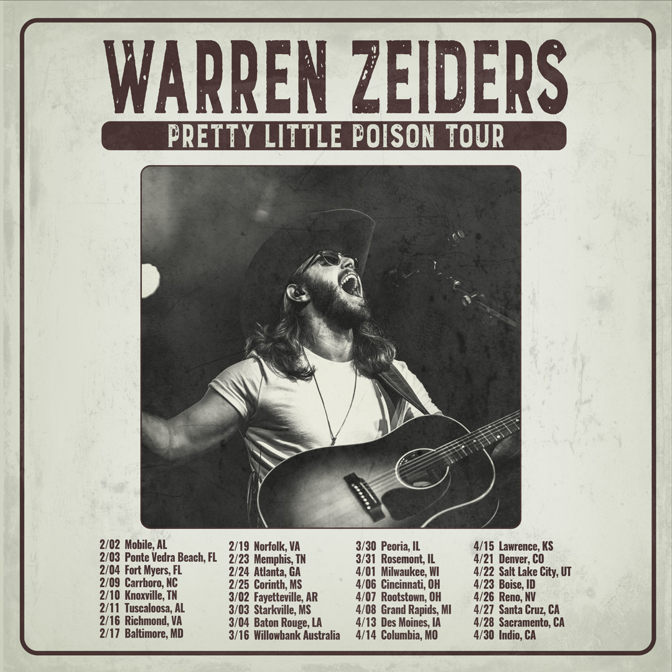

November 4, 2022 (Los Angeles, CA) – Country music’s fastest rising star Warren Zeiders will launch his biggest headline run to date, the Pretty Little Poison Tour, in 2023. Tickets just went on sale today, get them HERE. Canvasing North America for nearly three months, it kicks off in Mobile, AL on February 2, visits major markets coast-to-coast, and concludes with what promises to be a show-stopping set at Stagecoach Festival 2023 in Indio, CA on April 30. Additionally, he jets down to Australia for CMC Rocks QLD in Ipswich on March 16 and graces the stage at The Country Fest in North Lawrence, OH on June 16.

In other big news, Warren will perform on CMT Campfire Sessions on November 22. Be sure to check it out!

He just teamed up with multiplatinum genre-breaking force Sueco on an anthemic new single and music video entitled “Ride It Hard” available now via 717 Tapes/Warner Records. Listen HERE and watch the hilarious music video HERE.

Right out of the gate, it has already generated 805K Spotify streams and 271K YouTube views on the music video. Anticipation ran high in advance of the track’s arrival. Zeiders and Sueco initially teased it on TikTok gathering a total of 4.5 million views within 24 hours of posting. Fans worldwide clamored for this “Country Punk” hybrid with Zeiders’ “The Cowboy & Emo Kid,” emerging as his most popular post all year as it re-capped the making of the song in high fashion.

“Ride It Hard” landed in the wake of his 717 Tapes: The Album, which has impressively generated over half-a-billion streams and counting thus far.

717 Tapes: The Album notably collected all of Zeiders’ critically acclaimed 717 Tapes singles, EP tracks and a few new songs in a single package including his recently released “Up To No Good, ” and “One Hell Of An Angel,” propelling him to the next chapter of his career and cementing the 717 Tapes legacy.

This year, Zeiders made his Grand Ole Opry debut—a rite of passage for country’s best and brightest. The legendary institution welcomed him into the fold over the summer. Surprising noting that the 23-year-old burst onto the country music scene only a few years ago, emerging as one of the genre’s fastest rising success stories in recent history that has garnered over 1 billion views on TikTok that led People Magazine to observe “Warren Zeiders is a ‘Wild Horse’ who sings about "the truth.’"

Zeiders is currently on his Up To No Good Tour armed with a full band. Click HERE for tickets & concert details.

2023 Pretty Little Poison Tour Dates:
Feb 02 Mobile, AL
Feb 03 Ponte Vedra Beach, FL
Feb 04 Fort Myers, FL
Feb 09 Carrboro, NC
Feb 10 Knoxville, TN
Feb 11 Tuscaloosa, AL
Feb 16 Richmond, VA
Feb 17 Baltimore, MD
Feb 19 Norfolk, VA
Feb 23 Memphis, TN
Feb 24 Atlanta, GA
Feb 25 Corinth, MS
Mar 02 Fayetteville, AR
Mar 03 Starkville, MS
Mar 04 Baton Rouge, LA
Mar 16 Willowbank, Australia
Mar 30 Peoria, IL
Mar 31 Rosemont, IL
Apr 01 Milwaukee, WI
Apr 06 Cincinnati, OH
Apr 07 Rootstown, OH
Apr 08 Grand Rapids, MI
Apr 13 Des Moines, IA
Apr 14 Columbia, MO
Apr 15 Lawrence, KS
Apr 21 Denver, CO
Apr 22 Salt Lake City, UT
Apr 23 Boise, ID
Apr 26 Reno, NV
Apr 27 Santa Cruz, CA
Apr 28 Sacramento, CA
Apr 30 Indio, CA
Jun 16 North Lawrence, OH

CURRENT TOUR
2022 Up To No Good Tour Dates:
Nov 04 Columbus, OH Newport Music Hall
Nov 05 Pittsburgh, PA Stage AE
Nov 11 Minneapolis, MN Varsity Theater
Nov 12 Madison, WI Majestic Theatre
Nov 13 Indianapolis, IN Deluxe at Old National Centre
Nov 16 Nashville, TN Brooklyn Bowl
Nov 17 Athens, GA Georgia Theatre
Nov 18 Birmingham, AL Iron City
Nov 19 Huntsville, AL Mars Music Hall

ABOUT Warren Zeiders:
Warren Zeiders was just 22 years old when he signed his first recording contract with Warner Records Los Angeles office. At that point, fresh out of school, the second song he’s ever written called “Ride The Lightning” had seemingly exploded overnight into the socials conciseness of young country music fans. After a series of live covers, “Ride The Lightning” caught fire and ignited a community of true believers before he’d ever toured or played outside his hometown of Hershey, PA. Hundreds of TikTok posts turned into thousands and then millions. Zeiders’ distinctive, high energy country music is powered by a steady supply of youthful grit, honesty, muscle, and then, there’s that voice; a world-weary, lived-in, honeyed growl that belie his young years. Hailing from central Pennsylvania, the now 23-year-old singer/songwriter delivers outlaw sermons in his unmistakable authenticity. His music is suited more to the vast wilderness of his home state than the bright lights of the big city injecting a healthy dose of Heartland ethos into his stories of real life and the pitfalls of temptation. He walks a fine line but it’s that space he lives in—between lonesome outsider and magnetic performer—that helps him relate to listeners from all walks of life through songs fueled by unshakeable soul-searching. His original solo acoustic version of “Ride The Lightning” became an instant hit with fans that has resonated around the world. Since then, Zeiders has released a string a rockin’ but heartfelt tracks on his own 717 Tapes platform along with “Dark Night,” “Burn It Down,” “Wild Horse,” “Up To No Good” and the raucous “One Hell of an Angel” that led People Magazine to surmise “Warren Zeiders is a wild horse who single about the truth.” Following a pair of well-received EP’s, Zeiders hit the road for this first-ever tour with all dates selling out in under 72 hours. To date, Warren Zeiders has amassed over 790 million global TikTok views, in excess of 492 million audio streams and well over 39 million video plays on the heels of his recently released debut album 717 Tapes: The Album this past September. The album gathers up his 717 Tapes releases along with a handful of new tracks. Zeiders has hit the road again, this time with a full band, selling out every show as he moves into larger venues to accommodate his ever-growing legion of fans.

# # #
Warner Records Contacts:
Rick Gershon | rick.gershon@warnerrecords.com

FOLLOW WARREN ZEIDERS:
Facebook | Instagram | Twitter | TikTok | YouTube | Spotify

