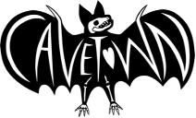
CAVETOWN & FRIENDS ANNOUNCE FIRST ANNUAL THIS IS HOME PROJECT BENEFIT CONCERT

LINEUP INCLUDES MXMTOON, CHLOE MORIONDO, AND MORE

ALL PROCEEDS DONATED TO NEW ALTERNATIVES

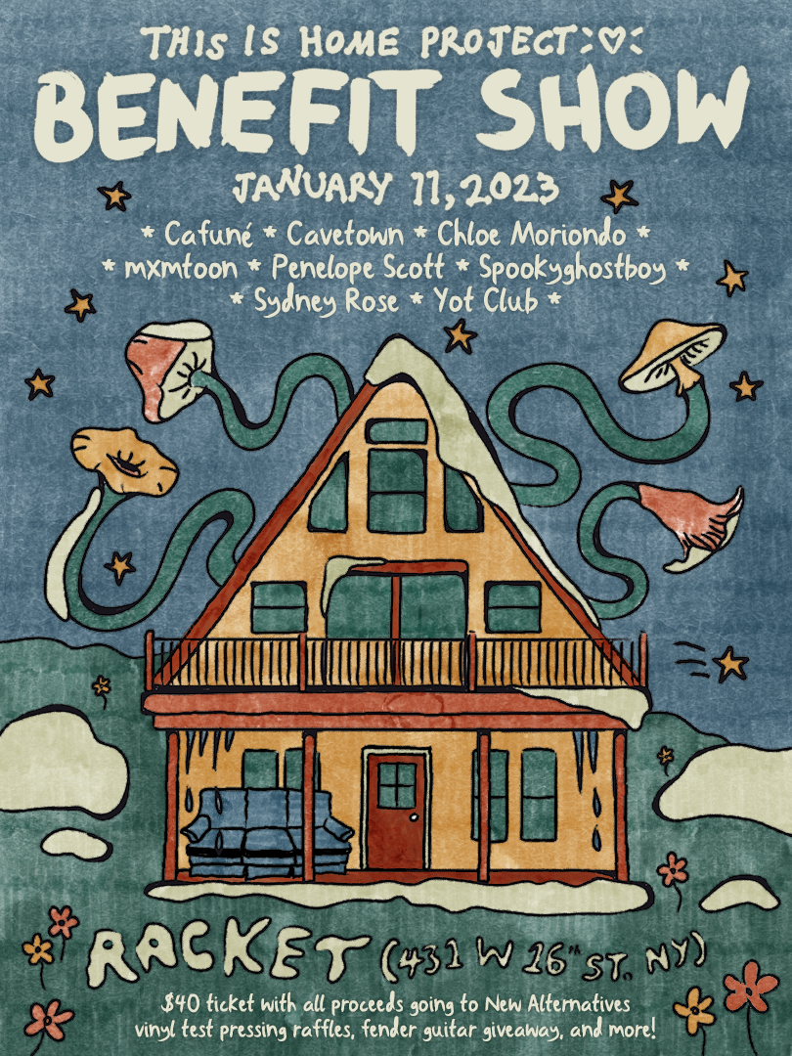

Los Angeles, CA (January 3rd, 2023) - Today, multi-RIAA Platinum and Gold certified singer/songwriter and producer Cavetown, also known as Robin Skinner, announces the inaugural benefit concert for his non-profit organization, This Is Home Project. The concert is slated to take place on January 11th at Racket in New York City. Tickets are on sale now - find tickets HERE.

Cavetown will be joined by an impressive bill of other bedroom-pop and DIY artists, with performances from mxmtoon, Chloe Moriondo, and more. In addition to the music, attendees can also expect raffles and additional onsite activations. All proceeds from the event will be donated to New Alternatives, a New York City charity focused on ending homelessness for LGBTQIA+ youth. The organization focuses on long-term support, harm reduction, and addressing aspects critical to the healthy development of children and teens.

Full Lineup:
cavetown
mxmtoon
Chloe Moriondo
Cafuné
Penelope Scott
Yot Club
Sydney Rose
Spookyghostboy

This is Home Project, created by Skinner in October 2022, provides funding to foundations whose focus is to help LGBTQIA+ youth in need. Through this project, Skinner continues to aim to increase access to LGBTQIA+ related physical and mental healthcare, safe housing, and much more, both on a broader and more personal scale. Since its creation, This Is Home Project has benefited the Black LGBTQIA+ Migrant Project, True Colors United, Trans Lifeline, BTFA Collective, and Stonewall. Over the next three years, This Is Home Project will donate a minimum of $1 million.

In November, Cavetown released his fifth studio album, worm food, the writing process of which is detailed in a New York Times feature piece. The album is arguably his most elaborately realized body of work to date, shaping his idiosyncratic storytelling into songs that ultimately give voice to our own most intimate emotions. In February, he released the single “Fall In Love With A Girl” with beabadoobee, which was featured in Billboard’s “The 25 Best Pride Songs of 2022 (So Far).” Cavetown embarked on a nearly sold-out headlining tour across Europe and the UK in support of the album, including his largest headlining show to date in front of over 5,000 fans at the Eventim Apollo in London. Earlier in 2022, Cavetown embarked on his U.S. tour, selling over 50,000 tickets and performing at iconic sold-out venues such as Los Angeles’s Hollywood Palladium and Terminal 5 in New York City.

Download Press Photo HERE | Credit: Kane Layland

FOLLOW CAVETOWN:
Press Assets | Website | Facebook | Twitter | Instagram | YouTube | TikTok

Cavetown US Press Contacts:

The Oriel Co
Chloë Walsh
chloe@theoriel.co
Amy Fennie
amy@theoriel.co

Warner Records
Patrice Compere
patrice.compere@warnerrecords.com

