GREEN DAY RELEASE NIMROD 25 – 25th ANNIVERSARY EDITION
INCLUDES UNRELEASED DEMOS & ‘97 LIVE SET FROM PHILADELPHIA

5-LP VINYL BOX & 3-CD BOX OUT NOW

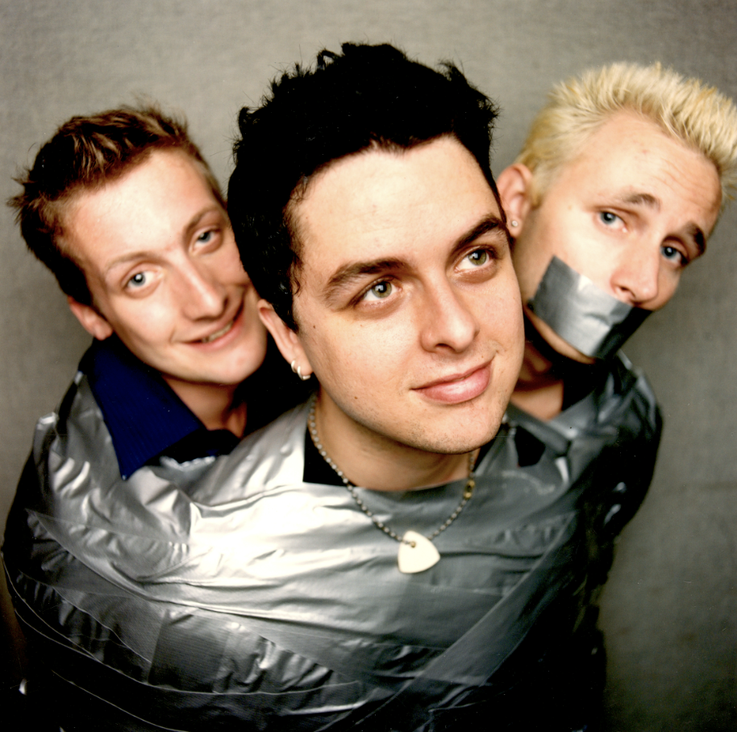

Hi-Res Press Photos HERE

January 27, 2023 (Los Angeles, CA) – Today, five-time GRAMMY® Award-winning band Green Dayrelease Nimrod 25 the 25th Anniversary Edition box set. Nimrod 25 includes the original album, one disc of previously unreleased demos, and a live set from Philadelphia’s Electric Factory recorded on November 14, 1997 one month after Nimrod’s release. The 14 track demos disc includes two unreleased Green Day songs (“You Irritate Me” and “Tre Polka”) plus a cover of the classic Elvis Costello song “Alison” (previously unreleased). Nimrod has now sold over 3 million copies.

Listen to Nimrod 25 here: https://GreenDay.lnk.to/Nimrod25

Nimrod was originally released on October 14, 1997. The Billboard Top 10 LP was driven by the hit singles “Hitchin’ A Ride”, “Redundant”, “Nice Guys Finish Last” and “Good Riddance (Time of Your Life)” the latter of which has sold 5 million copies in the US alone. The song was written as a spiteful ballad and has evolved into the soundtrack of everyone’s seminal life moments; even being featured in the Seinfeld series finale. The album certified triple platinum in the US and has been certified multi-platinum, platinum or gold in several other countries, including the UK, Japan, Canada, Australia and Spain. In retrospect, KERRANG!asserted, “If Dookie was the album that put the band on centre stage, Nimrod was a multifaceted spreading of wings that saw them begin to master what to do now they were there,” and Alternative Press cited it as “a game-changer.”

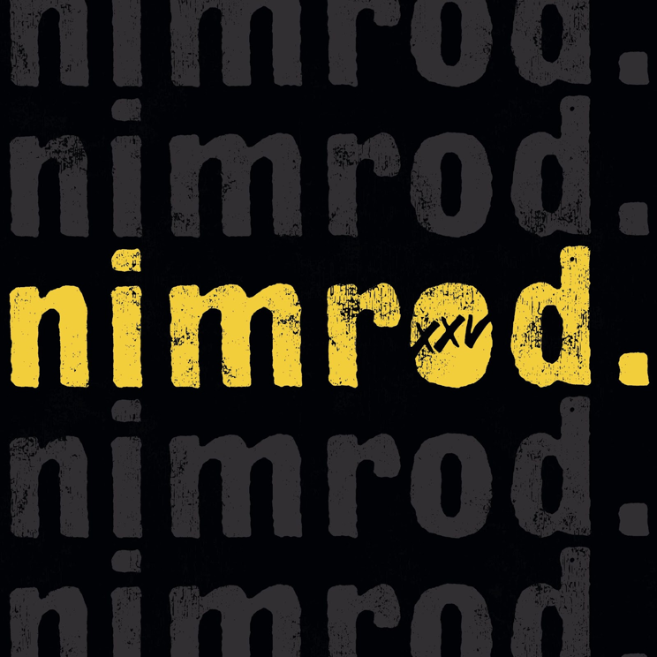

The Rock and Roll Hall of Fame band brought their sold-out Hella Mega headline stadium run to the UK and Europe this past summer, as well as, headlining festivals including Innings, Shaky Knees, Lollapalooza, Outside Lands, Rock In Rio, Sea Hear Now, & Firefly. Green Day played Formula 1 Grand Prix’s in Austin and Singapore Grand Prix performing to over 65,000 fans, the largest crowd at the event in over three years.

NIMROD 25 - 25th Anniversary Edition Tracklisting
Vinyl Box (5 LPs):
LP 1 & 2: Nimrod
LP 3: Nimrod Demos
LP 4 & 5: Live at The Electric Factory 1997

CD Box (3 CDs):
CD 1: Nimrod
CD 2: Nimrod Demos
CD 3: Live at The Electric Factory 1997

Nimrod:
1. Nice Guys Finish Last
2. Hitchin’ A Ride
3. The Grouch
4. Redundant
5. Scattered
6. All The Time
7. Worry Rock
8. Platypus (I Hate You)
9. Uptight
10. Last Ride In
11. Jinx
12. Haushinka
13. Walking Alone
14. Reject
15. Take Back
16. King For A Day
17. Good Riddance (Time of Your Life)
18. Prosthetic Head

Nimrod Demos
1. Nice Guys Finish Last
2. Place Inside My Head
3. The Grouch
4. Walking Alone
5. Jinx
6. Alison
7. Espionage
8. You Irritate Me
9. Tre Polka
10. When It’s Time
11. Desensitized
12. Chain Saw
13. Reject
14. Black Eyeliner

Live at the Electric Factory, Philadelphia
November 14 1997
1. Going To Pasalacqua
2. Welcome To Paradise
3. Geek Stink Breath
4. Nice Guys Finish Last
5. Hitchin’ A Ride
6. The Grouch
7. Chump
8. Longview
9. 2000 Light Years Away
10. Brainstew
11. Jaded
12. Knowledge
13. Basket Case
14. She
15. Fuck Off And Die
16. Paper Lanterns
17. Scattered
18. Prosthetic Head
19. When I Come Around
20. Good Riddance

ABOUT GREEN DAY:
Formed in 1986 in Berkeley, CA, Green Day is one of the world’s best-selling bands of all time, with more than 75 million records sold worldwide and 10 billion cumulative audio/visual streams. The five-time Grammy Award-winning Rock and Roll Hall of Fame inductees released their breakout album Dookie in 1994, which sold over 10 million and achieved diamond status, is widely credited with popularizing and reviving mainstream interest in punk rock, catapulting a career-long run of #1 hit singles. Entertainment Weekly calls Green Day, “The most influential band of their generation,” while Rolling Stone attests, “Green Day have inspired more young bands to start than any act this side of KISS, and that doesn't seem to be changing.” In 2004, Green Day released the rock opera American Idiot which captured the nation’s attention, selling more than 8 million copies in the U.S. alone and taking home the Grammy Award for Best Rock Album. Mojodeclared “It's exhilarating stuff, the kind of record that sets new parameters as to what is possible from a punk rock'n'roll band in the 21st century.” In 2010, a stage adaptation of American Idiot debuted on Broadway to critical and commercial acclaim. Released in 2020, Green Day’s thirteenth studio album Father Of All... (Reprise/Warner Records) debuted at #1 on Billboard’s Album Sales Chart and #1 in both the U.K. and Australia. Pitchfork declared, “Green Day’s most fetching and youthful songs in ages. The trio sounds reinvigorated, more like hungry newcomers staking their claim.” In July 2021, Green Day embarked on The Hella Mega Tour (w/ Fall Out Boy & Weezer). The U.S. leg included 20 sold out stadium gigs – including renowned venues like Chicago’s Wrigley Field, Boston’s Fenway Park and Los Angeles’ Dodger Stadium – and a total attendance of more than 630,000 fans.

FOLLOW GREEN DAY
Facebook | Twitter | TikTok | Instagram | YouTube | Press Site | Website

