

POP PHENOMENON BEBE REXHA ANNOUNCES NORTH AMERICAN SUMMER TOUR

BUY TICKETS HERE

STREAM NEW HIT “HEART WANTS WHAT IT WANTS” HERE

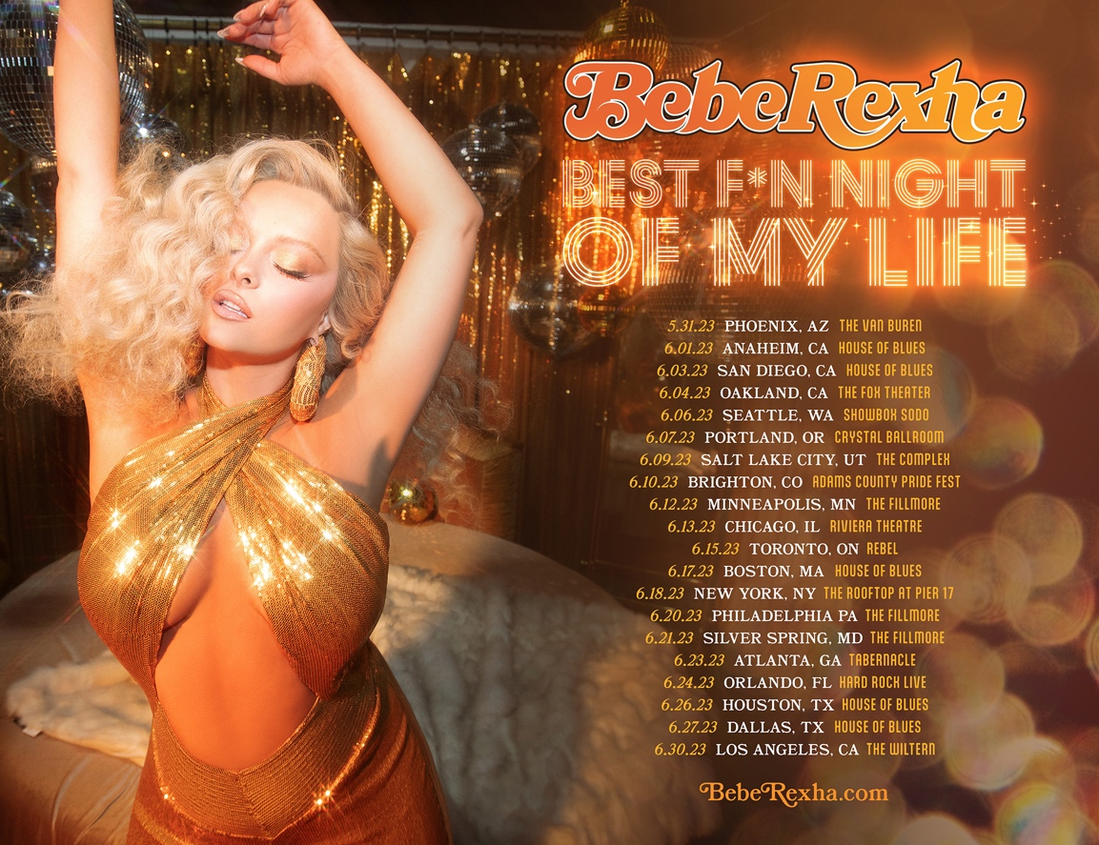

February 21, 2023 (Los Angeles, CA) – Today, global hitmaker Bebe Rexha announces 2023 North American tour dates. The news follows the recent arrival of the multi-platinum artist’s ‘70s-infused single “Heart Wants What It Wants” and the ongoing chart domination of David Guetta collaboration “I’m Good (Blue).” Destined to be one of the summer’s hottest tickets, the tour kicks off in Phoenix, AZ on May 31 and stops in most major cities, before winding up at The Wiltern in Los Angeles, CA on June 30. See all dates below.

Artist Presale and VIP Packages for Rexha’s exhilarating live show will go on sale on Wednesday, February 22 at 10 a.m. local with the general on-sale following on Friday, February 23 at 10 a.m. local. Purchase tickets HERE.

“Heart Wants What It Wants” is the hotly anticipated follow-up to the global smash “I’m Good (Blue)” — a reunion with super-producer David Guetta that riffs on Eiffel 65’s seminal “Blue (Da Ba Dee).” After a snippet went viral on TikTok in late 2022, the banger topped the charts in more than 20 countries and has amassed over 1.1 billion streams. It reached #1 at Top 40, Hot AC and Dance radio and was nominated for a GRAMMY® Award along with winning an MTV European Music Award.

After cutting her teeth as an in-demand songwriter (she penned Eminem and Rihanna’s “The Monster,” among other hits), Rexha started churning out smashes of her own including multi-platinum G-Eazy collaboration “Me, Myself & I” and Martin Garrix-produced club sensation “In The Name Of Love.” In 2017, she struck gold with “Meant To Be,” a country duet with Florida Georgia Line that was certified Diamond (10x Platinum). Rexha has since garnered over 16 billion cumulative streams.

“Meant To Be” earned Rexha a nomination for Best Country Duo/Group Performance at the 61st Annual GRAMMY® Awards, where she was also up for Best New Artist. The pop star has released two critically acclaimed albums, 2018’s Expectations and 2021’s Better Mistakes. Expect to hear beloved hits from all of those project’s on Rexha’s upcoming tour as well as recent smashes like “Heart Wants What It Wants.”

Bebe Rexha 2023 North American Tour:

May 31 — Phoenix, AZ — The Van Buren
June 1 — Anaheim, CA — House of Blues
June 3 — San Diego, CA — House of Blues
June 4 — Oakland, CA — The Fox Theater
June 6 — Seattle, WA — Showbox SoDo
June 7 — Portland, OR — Crystal Ballroom
June 9 — Salt Lake City, UT — The Complex
June 10 — Brighton, CO — Adams County Pride Fest
June 12 — Minneapolis, MN — The Fillmore
June 13 — Chicago, IL — Riviera Theatre
June 15 — Toronto, ON — Rebel
June 17 — Boston, MA — House of Blues
June 18 — New York, NY — The Rooftop at Pier 17
June 20 — Philadelphia, PA — The Fillmore
June 21 — Washington, D.C. — The Fillmore
June 23 — Atlanta, GA — Tabernacle
June 24 — Orlando, FL — Hard Rock Live
June 26 — Houston, TX — House of Blues
June 27 — Dallas, TX — House of Blues
June 30 — Los Angeles, CA — The Wiltern

FOLLOW BEBE REXHA:
Official | Twitter | Instagram | Facebook | TikTok

For more information on Bebe Rexha, please contact:
Darren Baber | Warner Records
darren.baber@warnerrecords.com



