THE BLESSED MADONNA AND JAMIE PRINCIPLE COLLABORATE ON BRAND NEW SINGLE
“WE STILL BELIEVE”

LISTEN HERE

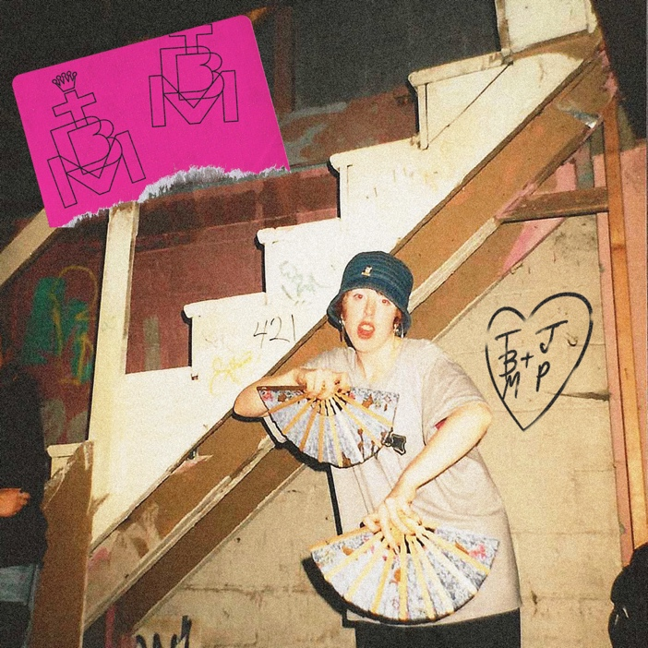
Download hi-res artwork here

February 17th, 2023 (Los Angeles, CA) — Today, Marea Stamper, aka Kentucky-born, London-based artist, DJ, producer and club culture iconoclast The Blessed Madonna, releases new single “We Still Believe,” a collaboration with house legend Jamie Principle. Stream the track HERE. Strutting and uplifting, the pair pay tribute to the embryonic years of house music with pinpoint accuracy — a love letter to the sweatbox warehouses of Chicago where communal euphoria reigns.

On “We Still Believe,” The Blessed Madonna says:

“I wrote and recorded a version of this song that shares a name with the party alone in my attic over a decade ago, writing the lyrics on the back of a record sleeve and recording them into my Blackberry under a blanket. I distorted my own vocals on the original, but imagined that the song would someday be performed by Jamie Principle, arguably the first real writer in house music, and my hero. Eventually, years later, Jamie and I met and became beloved friends. Jamie kindly agreed to re-record the song I wrote for him before I knew him, and here we are, writing the next chapter together and doing it the way I imagined it all those years ago. Soulwax chimed in on the final version, and the result is absolutely fresh”

Meanwhile, The Blessed Madonna returns to Chicago this Sunday, February 19th to perform as part of her residency at the city’s legendary Smartbar. For full details of the night, head here.

An overnight sensation two decades in the making, The Blessed Madonna is an artist whose career is woven into the fabric of dance music past, present and future. Whether promoting illegal raves to 50 people in sweaty Kentucky basements as a teenager, headlining the biggest stages and festivals around the world, working alongside house legends like Frankie Knuckles or fearlessly taking on one of the most improbable, ambitious remix projects in recent times with Club Future Nostalgia (her collaborative album with pop icon Dua Lipa), The Blessed Madonna is synonymous with inclusive, unifying, cathartic dance music.
In recent years, The Blessed Madonna has channeled the emotions of millions as the vocalist on Fred again..’s lockdown anthem, “Marea (We Lost Dancing)”, become the voice of Saturday night radio, been immortalised as a GTA5 character and provided remixes for the likes of The Chemical Brothers, Florence & The Machine and, improbably, Elton John. With “We Still Believe” and her previous single, “Serotonin Moonbeams,” she is set to usher in a whole new era. A stop-you-in-your-tracks moment in its own right, it’s also the starting pistol for a run of new releases over the coming months; the first results from a year’s worth of blood, sweat, tears and joy in the studio for 50 hours a week with some of her best friends. There are even rumors of a debut album. Watch this space.

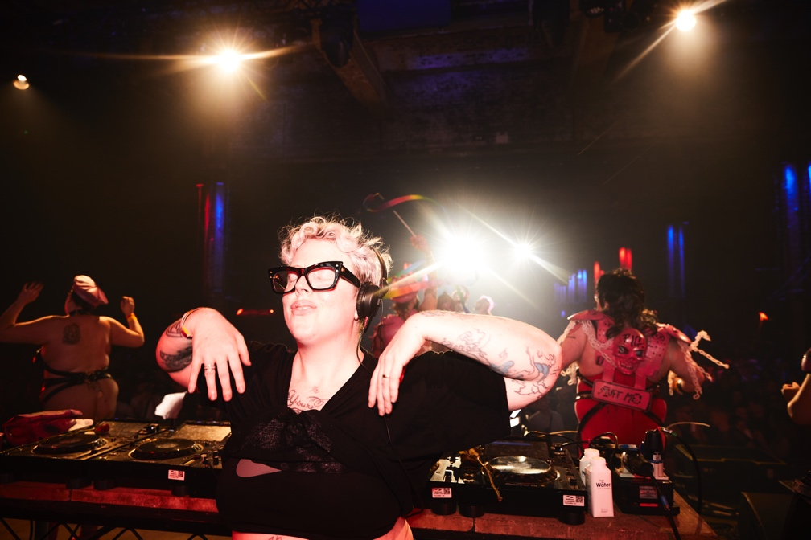
Credit: Eva Pentel | Download high-res here

FOLLOW THE BLESSED MADONNA:
Official | Instagram | Facebook | Twitter

For more information, please contact:

Darren Baber | Warner Records
Darren.Baber@warnerrecords.com

Judy Miller Silverman | Motormouth Media
Judy@motormouthmedia.com

