BEBE REXHA TEAMS UP WITH SNOOP DOGG FOR DISCO-INSPIRED STONER ANTHEM “SATELLITE”

WATCH THE OUT-OF-THIS-WORLD ANIMATED VIDEO HERE

HOTLY ANTICIPATED ALBUM BEBE OUT APRIL 28

BEBE LAUNCHES BEBE’S MOTHERSHIP HOT BOX ON TERRAZERO INTRAVERSE

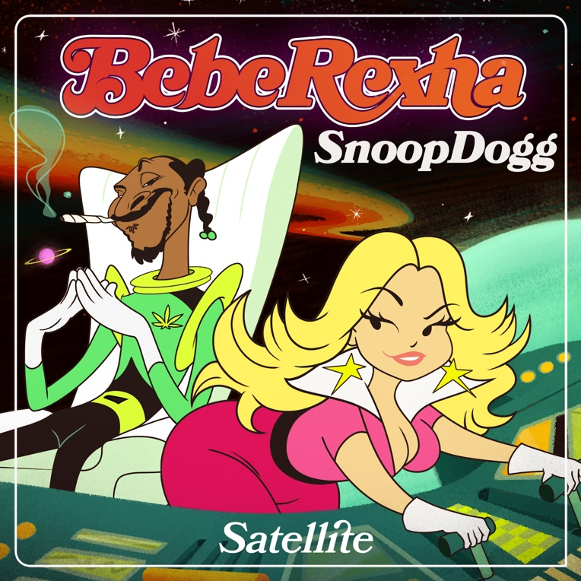
Hi-Res download HERE

April 20, 2023 (Los Angeles, CA) – Today, multi-platinum pop sensation Bebe Rexha releases the infectious stoner anthem “Satellite” featuring rap legend Snoop Dogg just in time for 4/20. Listen HERE. Alongside the track, which boasts dreamy disco beats and a stratospheric chorus, comes an animated video — watch it HERE. To mark the release, Rexha also launches Bebe’s Mothership Hot Box, an interactive space filled with games and a special preview of her upcoming BEBE album, out April 28 via Warner Records.

“Rolling on the sofa, smoke another bowl ‘til I blackout, floating on the ceiling, sinking to the feeling I’m spinning out,” Rexha sings over bouncy beats and funky bass, adding at the chorus: “Last night I got higher than a satellite — I took a one-way ticket, it's a one-man mission to paradise.” The track is accompanied by an animated video, which finds the music icons in space, that harkens back to the beloved Hanna-Barbera shows of yesteryear such as The Jetsons.

Fans will be able to immerse themselves even further in the "Satellite" universe with Bebe’s Mothership Hot Box. After logging on to the TerraZero Intraverse space, which delivers a higher fidelity experience that’s also mobile-accessible, visitors can explore vintage environments, dive into Rexha’s new music, seek out a very special prize, and of course, smoke a virtual blunt to blast off to the mothership! The activation was built by TerraZero using their Intraverse technology—the debut of the technology for TerraZero and the first use of the technology for Warner and the music industry.

After cutting her teeth as an in-demand songwriter (she penned Eminem and Rihanna’s “The Monster,” among other hits), Rexha started churning out smashes of her own including multi-platinum G-Eazy collaboration “Me, Myself & I” and Martin Garrix-produced club sensation “In The Name Of Love.” In 2017, she struck gold with “Meant To Be,” a country duet with Florida Georgia Line that was certified Diamond (10x Platinum).

She earned her third Grammy nomination this year with “I’m Good (Blue),” competing for Best Dance/Electronic Recording. The Platinum-certified global hit just won Dance Song of the Year at the 2023 iHeart Radio Music Awards and won Best Collaboration at the 2023 MTV EMAs.

Now, with unstoppable pop anthems like “Satellite” as well as her upcoming album and summer tour, Rexha’s 2023 takeover is complete.

Best F*n Night of My Life Tour Dates:

May 31 — Phoenix, AZ — The Van Buren
June 1 — Anaheim, CA — House of Blues
June 3 — San Diego, CA — House of Blues
June 4 — Oakland, CA — The Fox Theater
June 6 — Seattle, WA — Showbox SoDo
June 7 — Portland, OR — Crystal Ballroom
June 9 — Salt Lake City, UT — The Complex
June 10 — Brighton, CO — Adams County Pride Fest
June 12 — Minneapolis, MN — The Fillmore
June 13 — Chicago, IL — Riviera Theatre
June 15 — Toronto, ON — Rebel
June 17 — Boston, MA — House of Blues
June 18 — New York, NY — The Rooftop at Pier 17
June 20 — Philadelphia, PA — The Fillmore
June 21 — Washington, D.C. — The Fillmore
June 23 — Atlanta, GA — Tabernacle
June 24 — Orlando, FL — Hard Rock Live
June 26 — Houston, TX — House of Blues
June 27 — Dallas, TX — House of Blues
June 30 — Los Angeles, CA — The Wiltern
July 1 — Los Angeles, CA — The Wiltern

About TerraZero Technologies Inc.:
TerraZero Technologies Inc. ("TerraZero") is a vertically integrated Metaverse development group and leading web3 technology company specializing in helping brands create immersive experiences. The Company's Metaverse-agnostic vision is to develop and implement products and services with scalable commercial applications to flourish engagement across gamified experiences where enterprise- level businesses, Metaverse platforms, and web3 creators can seamlessly bridge and actionably grow their virtual world and the physical world endeavors together as one. TerraZero owns digital real estate for brands to establish presence in existing virtual worlds and can also offer brands their own private worlds to provide offices and services to those interested in the Metaverse. Furthermore, TerraZero acquires, designs, builds, and operates virtual assets and solutions to monetize the Metaverse ecosystem. The Company's businesses are segmented into five (5) divisions which include: (1) Products; (2) Advisory & Strategy; (3) Studio; (4) Analytics Platform; and (5) Infrastructure. TerraZero aims to support the community, foster innovation, and drive adoption. For more information, please visit www.terrazero.com or contact hello@terrazero.com.

FOLLOW BEBE REXHA:
Official | Twitter | Instagram | Facebook | TikTok | Press Site

For more information on Bebe Rexha, please contact:
Darren Baber | Warner Records
darren.baber@warnerrecords.com

