

BEBE REXHA DROPS EMPOWERING NEW
SINGLE “CALL ON ME”
LISTEN HERE

HOTLY ANTICIPATED ALBUM BEBE COMING APRIL 28

LONGEST CHARTING FEMALE ARTIST IN THE HISTORY OF BILLBOARD HOT COUNTRY AND BILLBOARD DANCE/ELECTRONIC CHARTS

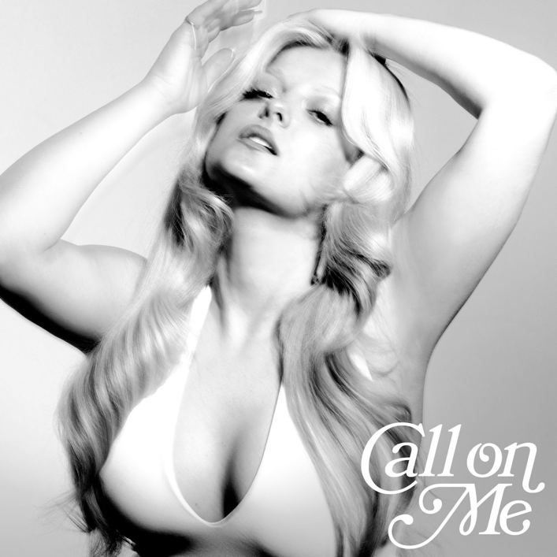
Hi-Res download HERE

March 31, 2023 (Los Angeles, CA) – Today, multi-platinum hitmaker Bebe Rexha releases the infectious new single “Call On Me.” Listen HERE via Warner Records. Propulsive and polished, the club anthem boasts soaring vocals, dizzying house production, and self-empowering lyrics. It's the latest offering from the pop star's recently announced upcoming album Bebe, out April 28. Pre-order HERE.

“God only knows how long I’ve waited for this, it’s been the longest time,” Rexha sings over cascading synths, chugging guitar, and tinkling piano keys. “If I need a lover, someone to save me, someone to set me free—I call on me.”

The epic track arrives on the heels of Rexha’s recent single, the ‘70s-inspired “Heart Wants What It Wants.” Between singles, she also announced that she will be hitting the road this summer for the the 20-date Best F*n Night of My Life Tour, which kicks off in Phoenix on May 31. Get tickets HERE and see all tour dates below.

Having garnered 16 billion cumulative streams, Rexha is the longest charting female artist in the history of Billboard Hot Country and, this week, became the longest charting female at the Billboard Dance/Electronic chart with the David Guetta collaboration “I’m Good (Blue).” She spent 50 career weeks at #1 on the Hot Country Songs chart and just reached 38 weeks at #1 on the Dance/Electronic Songs chart.

After cutting her teeth as an in-demand songwriter (she penned Eminem and Rihanna’s “The Monster,” among other hits), Rexha started churning out smashes of her own including multi-platinum G-Eazy collaboration “Me, Myself & I” and Martin Garrix-produced club sensation “In The Name Of Love.” In 2017, she struck gold with “Meant To Be,” a country duet with Florida Georgia Line that was certified Diamond (10x Platinum).

She earned her third Grammy nomination this year with “I’m Good (Blue),” competing for Best Dance/Electronic Recording. The Platinum-certified global hit just won Dance Song of the Year at the 2023 iHeart Radio Music Awards and won Best Collaboration at the 2023 MTV EMAs.

Bebe follows her critically acclaimed albums, Expectations and Better Mistakes.

Best F*n Night of My Life Tour Dates:

May 31 — Phoenix, AZ — The Van Buren
June 1 — Anaheim, CA — House of Blues
June 3 — San Diego, CA — House of Blues
June 4 — Oakland, CA — The Fox Theater
June 6 — Seattle, WA — Showbox SoDo
June 7 — Portland, OR — Crystal Ballroom
June 9 — Salt Lake City, UT — The Complex
June 10 — Brighton, CO — Adams County Pride Fest
June 12 — Minneapolis, MN — The Fillmore
June 13 — Chicago, IL — Riviera Theatre
June 15 — Toronto, ON — Rebel
June 17 — Boston, MA — House of Blues
June 18 — New York, NY — The Rooftop at Pier 17
June 20 — Philadelphia, PA — The Fillmore
June 21 — Washington, D.C. — The Fillmore
June 23 — Atlanta, GA — Tabernacle
June 24 — Orlando, FL — Hard Rock Live
June 26 — Houston, TX — House of Blues
June 27 — Dallas, TX — House of Blues
June 30 — Los Angeles, CA — The Wiltern

FOLLOW BEBE REXHA:
Official | Twitter | Instagram | Facebook | TikTok | Press Site

For more information on Bebe Rexha, please contact:
Darren Baber | Warner Records
darren.baber@warnerrecords.com



