CHER ANNOUNCES DELUXE LIMITED-EDITION OF FAN FAVORITE ALBUM
IT’S A MAN’S WORLD – AVAILABLE ON VINYL FOR THE FIRST TIME EVER!
PRE-ORDER HERE

PREVIOUSLY UNRELEASED DIRECTOR’S CUT OF CLASSIC “WALKING IN MEMPHIS” MUSIC VIDEO OUT NOW

LISTEN HERE – WATCH VIDEO HERE

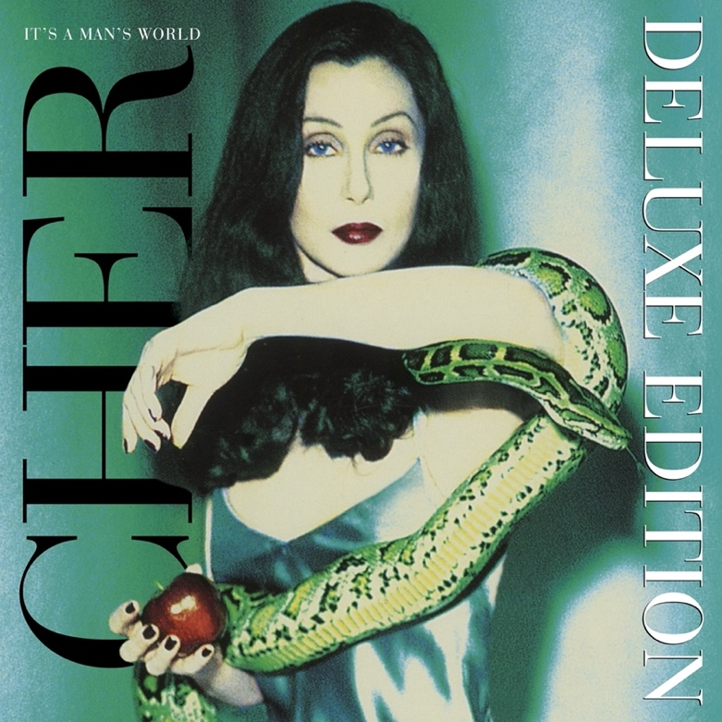

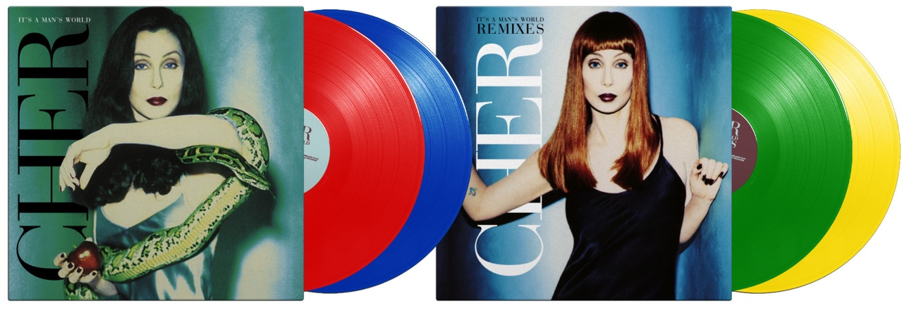
Download hi-res HERE

June 1, 2023 (Los Angeles, CA) Cher's critically-acclaimed classic album It's A Man's World is being reimagined as a special deluxe limited-edition vinyl box set that features a remastered version of the original 14-track UK album on 2 LPs, as well as a newly compiled double LP containing eleven rare remixes including "Walking In Memphis (Shut Up and Dance Vocal Mix),” available HERE, and “One By One (JR’s Pride Mix),” available June 23rd. A previously unreleased and HD remastered director’s cut of the “Walking In Memphis” music video is out now – watch HERE.

The 4 LPs in the limited-edition box are each pressed on a different colored vinyl (red, blue, green and yellow). The box includes an exclusive, numbered lithograph of an iconic photograph of Cher. The D2C version, sold via Cher’s official site, features its own exclusive lithograph. The deluxe album will also be released digitally and as a 2-CD set. The majority of the remixes are available digitally and on vinyl for the first time.

First recorded in London and released in 1995, It’s A Man’s World rocketed to the top 10 in the UK where it was certified Gold. Long considered by Cher superfans as one of her best albums of all time, It’s a Man’s World featured the singles “Walking In Memphis,” “One By One,” “Not Enough Love In the World,” “The Sun Ain’t Gonna Shine Anymore” and “Paradise Is Here.” AllMusic's Jose Promis praised the album as “one of the singer’s finest as well as one of her most overlooked and underappreciated works to date.”

It’s A Man’s World – CD 1 and LPs 1&2

- Walking In Memphis
- Not Enough Love In the World
- One By One
- I Wouldn’t Treat a Dog (The Way You Treated Me)
- Angels Running
- Paradise Is Here
- I’m Blowin’ Away
- Don’t Come Around Tonite
- What About the Moonlight
- The Same Mistake
- The Gunman
- The Sun Ain’t Gonna Shine Anymore
- Shape of Things To Come
- It’s a Man’s Man’s Man’s World

It’s a Man’s World – Deluxe CD 2 and LPs 3&4

- One By One (JF Vasquez Club Vocal Mix)
- One By One (JR’s Pride Mix)
- One By One (Piano Dub)
- One By One (With Melle Mel)
- The Sun Ain’t Gonna Shine Anymore (Trevor Horn Remix)
- Walking In Memphis (Shut Up and Dance Vocal Mix)
- Walking In Memphis (Baby Doc Mix)
- Paradise Is Here (Garage Revival Mix)
- Paradise Is Here (Sunrise Mix)
- Paradise Is Here (Runaway Mix)
- Paradise Is Here (Glow Stick Mix)

Follow Cher:
Website | Twitter | Instagram | TikTok | Facebook | YouTube | Spotify | Apple Music

For further information, please contact:

Laura Swanson // Laura.Swanson@warnerrecords.com

Liz Rosenberg // liz@lizrosenbergmedia.com

