ILLENIUM DROPS STUNNING SCI-FI FILM STARFALL FEATURING MUSIC FROM HIS FIFTH STUDIO ALBUM

ILLENIUM DEBUTED AT #1 ON DANCE/ELECTRONIC
ALBUMS CHART

LISTEN TO ILLENIUM HERE

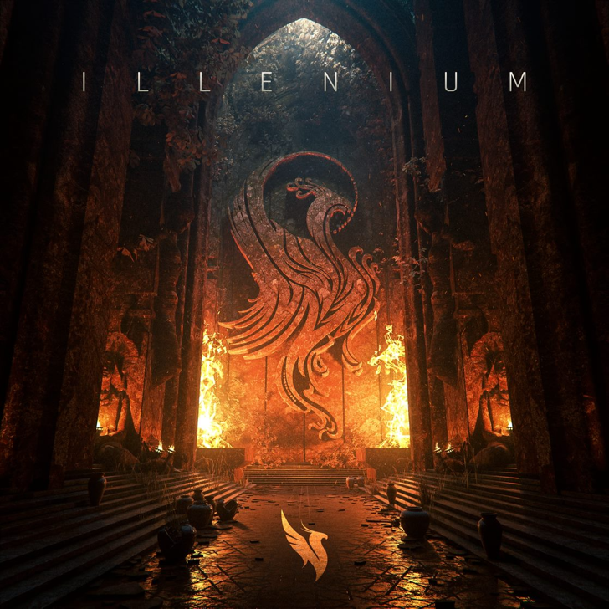
Download hi-res artwork HERE

May 23, 2023 (Los Angeles, CA) – Today, Grammy-nominated producer ILLENIUM unleashes the dizzying film Starfall featuring music from his self-titled fifth studio album, which recently debuted at #1 on the Top Dance/Electronic Albums chart. Watch Starfall HERE and listen to ILLENIUM HERE via Warner Records. An animated sci-fi adventure, the 30-minute movie boasts cinematic imagery inspired by gaming and anime, adding a whole new dimension to the star-studded record. It will prime fans to experience ILLENIUM in person when his tour kicks off at the end of the month. See dates below.

ILLENIUM’s fifth studio album arrived in April and is already gunning for dance/electronic album of the year. It is his third album to debut at #1 on the Top Dance/Electronic Albums chart, following 2021’s Fallen Embers and 2019’s Ascend.

The 16-track set includes the #1 dance hits “All That Really Matters” with Teddy Swims and “Luv Me A Little” with Nina Nesbitt. That’s just the tip of the iceberg as he collaborates with an all-star lineup including Avril Lavigne, Travis Barker, Vera Blue, All Time Low, JVKE, and more to take the album to the next level.

In just a matter of weeks, fans and newcomers alike will be able to see ILLENIUM perform when the ILLENIUM LIVE Tour kicks off cruising through throughout North America, Europe, and Australia. “The music, and a whole new live show, should be unlike anything anyone has ever seen or heard before,” ILLENIUM promises. One stop along the way will be the biggest show of his career: Trilogy: Colorado, at Empower Field at Mile High in Denver, CO on Saturday, June 17. There, he will be performing three unique sets over one night. For the tour, he will also be partnering with the non-profit End Overdose, an organization close to his heart. Tickets for all dates are on sale HERE.

Listen to ILLENIUM, get lost in the frenetic imagery of Starfall, and prepare to be dazzled when ILLENIUM comes to town.

ILLENIUM LIVE 2023 TOUR DATES

NORTH AMERICA
May 27 – George, WA @ The Gorge
May 28 – George, WA @ The Gorge
Jun 1 – San Francisco, CA @ Bill Graham
Jun 2 – San Francisco, CA @ Chase Center
Jun 3 – San Francisco, CA @ Chase Center
Jun 4 – Lake Tahoe, NV @ Lake Tahoe Outdoor Arena at Harveys
Jun 8 – Bonner Springs, KS @ Azura Amphitheater
Jun 9 – Minneapolis, MN @ The Armory
Jun 10 – Minneapolis, MN @ The Armory
Jun 11 – Minneapolis, MN @ The Armory
Jun 16 – Denver, CO @ Mission Ballroom (Trilogy Pre-Party)
Jun 17 – Denver, CO @ Empower Field at Mile High
Jun 20 – Cleveland, OH @ Jacobs Pavilion
Jun 21 – Newport, KY @ MegaCorp Pavilion Outdoor
Jun 23 – Rothbury, MI @ Electric Forest
Jun 27 – St. Louis, MO @ The Factory
Jun 28 – Huntsville, AL @ The Orion Amphitheater
Jun 30 – Austin, TX @ Moody Center
Jul 1 – Dallas, TX @ Dos Equis Pavilion
Jul 2 – Houston, TX @ 713 Music Hall
Jul 7 – Atlanta, GA @ Lakewood Amphitheatre
Jul 8 – Orlando, FL @ Orlando Amphitheater
Jul 9 – Hollywood, FL @ Hard Rock Live
Jul 13 – Pittsburgh, PA @ Stage AE Outdoors
Jul 14 – Brooklyn, NY @ Barclays Center
Jul 15 – Columbia, MD @ Merriweather Post Pavilion
Jul 20 – Indianapolis, IN @ TCU Amphitheater at White River State Park
Jul 21 – Detroit, MI @ Masonic Temple Theatre
Jul 22 – Bridgeview, IL @ SeatGeek Stadium
Aug 4 – Toronto, ON @ Veld Music Festival

EUROPE
Oct 11 – Barcelona, Spain @ Razzmatazz
Oct 13 – Milan, Italy @ Fabrique
Oct 14 – Warsaw, Poland @ Progresja
Oct 18 – Paris, France @ Elysée Montmartre
Oct 20 – Amsterdam, Netherlands @ MELKWEG
Oct 21 – Brussels, Belgium @ La Madeleine
Oct 26 – London, England @ Electric Brixton
Oct 27 – London, England @ Electric Brixton

AUSTRALIA
Nov 25 – Sydney, Australia @ Hordern Pavillion
Dec 1 – Melbourne, Australia @ John Cain Arena
Dec 2 – Brisbane, Australia @ The Fortitude Music Hall

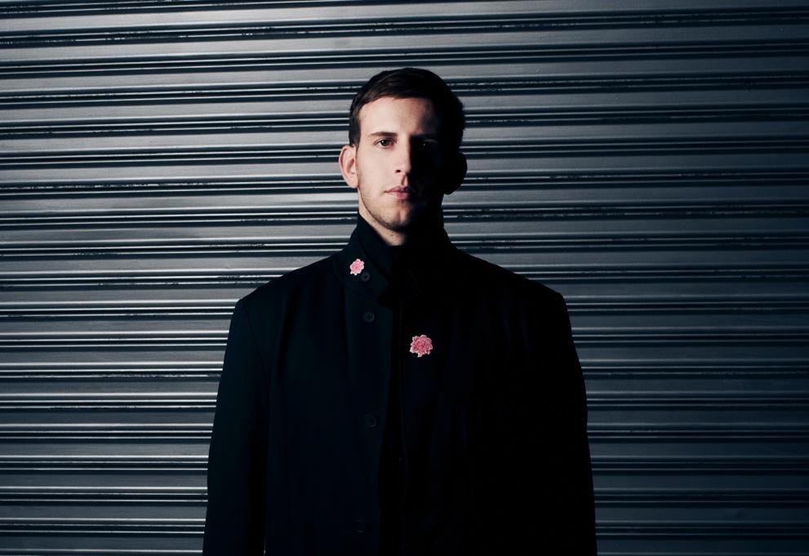
Credit: Lindsey Byrnes | Hi-Res Download HERE

FOLLOW ILLENIUM:
Website | Twitter | Instagram | Facebook | YouTube

For more information, please contact:
Darren Baber | Darren.Baber@warnerrecords.com

